UNITED STATES

SECURITIES AND EXCHANGE COMMISSION

Washington, D.C. 20549

FORM 10-Q

(Mark One)

- QUARTERLY REPORT PURSUANT TO SECTION 13 OR 15(d) OF THE SECURITIES EXCHANGE ACT OF 1934

For the quarterly period ended March 31, 2024

OR

- TRANSITION REPORT PURSUANT TO SECTION 13 OR 15(d) OF THE SECURITIES EXCHANGE ACT OF 1934

For transition period from | to
Commission File Number 001-39687

 | CompoSecure, Inc.
 | (Exact name of registrant as specified in its charter)
Delaware | 85-2749902
(State or other jurisdiction of |  | (I.R.S. Employer
incorporation or organization) |  | Identification Number)
 | 309 Pierce St.
 | Somerset, NJ 08873
 | (908) 518-0500

(Address, including zip code, and telephone number, including area code, of registrant’s principal executive offices)

Securities registered pursuant to Section 12(b) of the Act:

 | Title of each class |  | Trading Symbol |  |  | Name of each exchange on which registered
Class A Common Stock, $0.0001 par value per share |  |  |  | CMPO |  | The Nasdaq Global Market
Redeemable Warrants, each whole warrant exercisable for one share of Class A Common Stock |  |  |  | CMPOW |  | The Nasdaq Global Market

Indicate by check mark whether the Registrant (1) has filed all reports required to be filed by Section 13 or 15(d) of the Securities Exchange Act of 1934 during the preceding 12 months (or for such shorter period that the Registrant was required to file such reports), and (2) has been subject to such filing requirements for the past 90 days. Yes ☒ No ☐

Indicate by check mark whether the Registrant has submitted electronically every Interactive Data File required to be submitted pursuant to Rule 405 of Regulation S-T (§232.405 of this chapter) during the preceding 12 months (or for such shorter period that the Registrant was required to submit such files). Yes ☒ No ☐

Indicate by check mark whether the registrant is a large accelerated filer, an accelerated filer, a non-accelerated filer, a smaller reporting company or an emerging growth company. See the definitions of “large accelerated filer,” “accelerated filer,” “smaller reporting company” and “emerging growth company” in Rule 12b-2 of the Exchange Act.

Large accelerated filer | ☐ | Accelerated filer | ☒
Non-accelerated filer | ☐ | Smaller reporting company | ☒
 |  | Emerging growth company | ☒

If an emerging growth company, indicate by check mark if the registrant has elected not to use the extended transition period for complying with any new or revised financial accounting standards provided pursuant to Section 7(a)(2)(B) of the Securities Act. ☐

Indicate by check mark whether the registrant is a shell company (as defined in Rule 12b-2 of the Exchange Act): Yes ☐ No ☒

As of May 01, 2024, there were 20,632,837 shares of the registrant's Class A common stock outstanding and 59,958,422 shares of the registrant's Class B common stock outstanding.

COMPOSECURE, INC.

 |  |  |  |  |  |  |  |  |  |  |  |  |  |  |  |  |  |  |  |  |  |  |  | Table of Contents
 |  |  |  |  |  |  |  |  |  |  |  |  |  |  |  |  |  |  |  |  |  |  |  |  |  | Page
Part I. |  |  |  |  |  | Financial Information
 |  |  |  |  |  |  |  |  |  |  |  |  |  |  |  |  |  |  |  |  |  |  |  |  |  | 2
 |  |  |  |  | Item 1. |  |  | Financial Statements |  |  |  |  |  |  |  |  |  |  |  |  |  |  |  |  |  | 2
 |  |  |  |  |  |  |  | Consolidated Balance Sheets (Unaudited) |  |  |  |  |  |  |  |  |  |  |  |  |  |  |  |  |  | 3
 |  |  |  |  |  |  |  | Consolidated Statements of Operations (Unaudited) |  |  |  |  |  |  |  |  |  |  |  |  |  |  |  |  |  | 4
 |  |  |  |  |  |  |  | Consolidated Statements of Comprehensive Income (Unaudited) |  |  |  |  |  |  |  |  |  |  |  |  |  |  |  |  |  | 5
 |  |  |  |  |  |  |  | Consolidated Statements of Stockholders’ Deficit (Unaudited) |  |  |  |  |  |  |  |  |  |  |  |  |  |  |  |  |  | 6
 |  |  |  |  |  |  |  | Consolidated Statements of Cash Flows (Unaudited) |  |  |  |  |  |  |  |  |  |  |  |  |  |  |  |  |  | 7
 |  |  |  |  |  |  |  | Notes to Consolidated Financial Statements (Unaudited) |  |  |  |  |  |  |  |  |  |  |  |  |  |  |  |  |  | 8
 |  |  |  |  | Item 2. |  |  | Management's Discussion and Analysis of Financial Condition and Results of Operations |  |  |  |  |  |  |  |  |  |  |  |  |  |  |  |  |  | 24
 |  |  |  |  | Item 3. |  |  | Quantitative and Qualitative Disclosures About Market Risk |  |  |  |  |  |  |  |  |  |  |  |  |  |  |  |  |  | 31
 |  |  |  |  | Item 4. |  |  | Controls and Procedures |  |  |  |  |  |  |  |  |  |  |  |  |  |  |  |  |  | 32
Part II. |  |  |  |  |  | Other Information |  |  |  |  |  |  |  |  |  |  |  |  |  |  |  |  |  |  |  | 34
 |  |  |  |  | Item 1. |  |  | Legal Proceedings |  |  |  |  |  |  |  |  |  |  |  |  |  |  |  |  |  | 34
 |  |  |  | Item 1A. |  |  |  | Risk Factors |  |  |  |  |  |  |  |  |  |  |  |  |  |  |  |  |  | 34
 |  |  |  |  | Item 2. |  |  | Unregistered Sales of Equity Securities and Use of Proceeds |  |  |  |  |  |  |  |  |  |  |  |  |  |  |  |  |  | 55
 |  |  |  |  | Item 3. |  |  | Defaults Upon Senior Securities |  |  |  |  |  |  |  |  |  |  |  |  |  |  |  |  |  | 56
 |  |  |  |  | Item 4. |  |  | Mine Safety Disclosures |  |  |  |  |  |  |  |  |  |  |  |  |  |  |  |  |  | 56
 |  |  |  |  | Item 5. |  |  | Other Information |  |  |  |  |  |  |  |  |  |  |  |  |  |  |  |  |  | 56
 |  |  |  |  | Item 6. |  |  | Exhibits |  |  |  |  |  |  |  |  |  |  |  |  |  |  |  |  |  | 56
 |  | Signatures |  |  |  |  |  |  |  |  |  |  |  |  |  |  |  |  |  |  |  |  |  |  |  | 57

CAUTIONARY NOTE REGARDING FORWARD-LOOKING STATEMENTS

This report, and the documents incorporated by reference herein, may contain forward-looking statements as defined by the Private Securities Litigation Reform Act of 1995. These statements are based on the beliefs and assumptions of management. Although the Company believes that its plans, intentions, and expectations reflected in or suggested by these forward- looking statements are reasonable, the Company cannot assure you that it will achieve or realize these plans, intentions, or expectations. Forward-looking statements are inherently subject to risks, uncertainties, and assumptions. Generally, statements that are not historical facts, including statements concerning the Company’s possible or assumed future actions, business strategies, events, or results of operations, are forward- looking statements. In some instances, these statements may be preceded by, followed by or include the words “believes,” “estimates,” “expects,” “projects,” “forecasts,” “may,” “will,” “should,” “seeks,” “plans,” “scheduled,” “anticipates” or “intends” or the negatives of these terms or variations of them or similar terminology.

Forward-looking statements are not guarantees of performance. You should not put undue reliance on these statements which speak only as of the date hereof. You should understand that the following important factors, among others, could affect the Company’s future results and could cause those results or other outcomes to differ materially from those expressed or implied in the Company’s forward-looking statements:

- the ability of the Company to grow and manage growth profitably, maintain relationships with customers, compete within its industry and retain its key employees;

- the possibility that the Company may be adversely impacted by other global economic, business, and/or competitive factors;

- the outcome of any legal proceedings that may be instituted against the Company or others;

- future exchange and interest rates; and

- other risks and uncertainties indicated in this report, including those under “Risk Factors” herein, and other filings that have been made or will be made with the SEC.

These and other factors that could cause actual results to differ from those implied by the forward-looking statements in this report are more fully described in the “Risk Factors” section. The risks described in “Risk Factors” are not exhaustive. New risk factors emerge from time to time and it is not possible for us to predict all such risk factors, nor can the Company assess the impact of all such risk factors on its business or the extent to which any factor or combination of factors may cause actual results to differ materially from those contained in any forward-looking statements. All forward-looking statements attributable to the Company or persons acting on its behalf are expressly qualified in their entirety by the foregoing cautionary statements. The Company undertakes no obligations to update or revise publicly any forward-looking statements, whether as a result of new information, future events or otherwise, except as required by law.

Part I - Financial Statements

Item 1. Financial Statements

2

COMPOSECURE, INC.

Consolidated Balance Sheets

($ in thousands, except par value and share amounts)

 | March 31, |  |  |  | December 31,
 | 2024 |  |  |  | 2023
 | Unaudited
ASSETS
CURRENT ASSETS
Cash and cash equivalents | $ | 55,146 |  | $ | 41,216
Accounts receivable, net |  | 35,110 |  |  | 40,488
Inventories |  | 55,197 |  |  | 52,540
Prepaid expenses and other current assets |  | 5,252 |  |  | 5,133
Total current assets |  | 150,705 |  |  | 139,377
Property and equipment, net |  | 24,604 |  |  | 25,212
Right of use assets, net |  | 6,964 |  |  | 7,473
Deferred tax asset |  | 25,529 |  |  | 23,697
Derivative asset - interest rate swap |  | 5,745 |  |  | 5,258
Deposits and other assets |  | 24 |  |  | 24
Total assets | $ | 213,571 |  | $ | 201,041
LIABILITIES AND STOCKHOLDERS' DEFICIT
CURRENT LIABILITIES
Accounts payable |  | 4,747 |  |  | 5,193
Accrued expenses |  | 13,473 |  |  | 11,986
Commission payable |  | 5,442 |  |  | 4,429
Bonus payable |  | 3,405 |  |  | 5,616
Current portion of long-term debt |  | 11,875 |  |  | 10,313
Current portion of lease liabilities |  | 1,988 |  |  | 1,948
Current portion of tax receivable agreement liability |  | 1,425 |  |  | 1,425
Total current liabilities |  | 42,355 |  |  | 40,910
Long-term debt, net of deferred finance costs |  | 192,299 |  |  | 198,331
Convertible notes |  | 127,959 |  |  | 127,832
Derivative liability - convertible notes redemption make-whole provision |  | 722 |  |  | 425
Warrant liability |  | 15,691 |  |  | 8,294
Lease liabilities, operating |  | 5,655 |  |  | 6,220
Tax receivable agreement liability |  | 23,949 |  |  | 23,949
Earnout consideration liability |  | 2,312 |  |  | 853
Total liabilities |  | 410,942 |  |  | 406,814
Commitments and contingencies (Note 13)
Redeemable non-controlling interest |  | 596,587 |  |  | 596,587
Preferred stock, $0.0001 par value; 10,000,000 shares authorized, no shares issued and outstanding |  | — |  |  | —
Class A common stock, $0.0001 par value; 250,000,000 shares authorized, 20,598,246 and 19,415,123 shares issued and outstanding as of March 31, 2024 and December
31, 2023, respectively. |  | 2 |  |  | 2
Class B common stock, $0.0001 par value; 75,000,000 shares authorized, 59,958,422 shares issued and outstanding as of March 31, 2024 and December 31, 2023,
respectively. |  | 6 |  |  | 6
Additional paid-in capital |  | 40,494 |  |  | 39,466
Accumulated other comprehensive income |  | 5,443 |  |  | 4,991
Accumulated deficit |  | (839,903) |  |  | (846,825)
Total stockholders' deficit |  | (793,958) |  |  | (802,360)
TOTAL LIABILITIES AND STOCKHOLDERS' DEFICIT | $ | 213,571 |  | $ | 201,041

The accompanying notes are an integral part of these unaudited consolidated financial statements.

3

COMPOSECURE, INC.

Consolidated Statements of Operations (Unaudited)

($ in thousands, except per share amounts)

 | Three Months Ended March 31,
 | 2024 |  |  | 2023
Net sales | $ | 104,010 |  | $ | 95,316
Cost of sales |  | 48,797 |  |  | 41,962
Gross profit |  | 55,213 |  |  | 53,354
Operating expenses:
Selling, general and administrative expenses |  | 24,077 |  |  | 23,944
Income from operations |  | 31,136 |  |  | 29,410
Other (expense):
Revaluation of earnout consideration liability |  | (1,459) |  |  | (1,973)
Revaluation of warrant liability |  | (7,397) |  |  | (10,759)
Change in fair value of derivative liability - convertible notes redemption make-whole provision |  | (297) |  |  | (708)
Interest expense, net |  | (5,419) |  |  | (5,929)
Amortization of deferred financing costs |  | (327) |  |  | (567)
Total other (expense), net |  | (14,899) |  |  | (19,936)
Income before income taxes |  | 16,237 |  |  | 9,474
Income tax benefit |  | 836 |  |  | 1,263
Net income | $ | 17,073 |  | $ | 10,737
Net income attributable to redeemable non-controlling interests | $ | 13,048 |  | $ | 8,408
Net income attributable to CompoSecure, Inc. | $ | 4,025 |  | $ | 2,329
Net income per share attributable to Class A common stockholders - basic | $ | 0.20 |  | $ | 0.13
Net income per share attributable to Class A common stockholders - diluted | $ | 0.17 |  | $ | 0.11
Weighted average shares used to compute net income per share attributable to Class A common stockholders - basic (in
thousands) |  | 20,567 |  |  | 17,632
Weighted average shares used to compute net income per share attributable to Class A common stockholders - diluted (in
thousands) |  | 96,235 |  |  | 94,736

The accompanying notes are an integral part of these unaudited consolidated financial statements.

4

COMPOSECURE, INC.

Consolidated Statements of Comprehensive Income (Unaudited)

($ in thousands)

 | Three Months Ended March 31,
 | 2024 |  |  | 2023
Net income | $ | 17,073 |  | $ | 10,737
Other comprehensive (loss) income, net:
Unrealized gain (loss) on derivative - interest rate swap, (net of tax) |  | 452 |  |  | (1,649)
Total other comprehensive income (loss), net |  | 452 |  |  | (1,649)
Comprehensive income | $ | 17,525 |  | $ | 9,088

The accompanying notes are an integral part of these unaudited consolidated financial statements.

5

COMPOSECURE, INC.

Consolidated Statements of Stockholders' Deficit (Unaudited)

($ in thousands, except share data)

 | Class A Common Stock |  |  |  |  | Class B Common Stock |  |  |  |  |  | Additional Paid-in |  |  | Accumulated Other |  |  | Accumulated |  | Total Stockholders' |  |  |  | Redeemable Non-
 |  |  |  |  |  |  |  |  |  |  |  |  |  |  | Comprehensive |  |  |  |  |  |  |  |  | Controlling
 |  |  |  |  |  |  |  |  |  |  |  | Capital |  |  | Income |  |  | Deficit |  |  | Deficit |  |  | Interest
 | Shares |  |  | Amount |  | Shares |  |  | Amount |  |  |  |  |  |  |  |  |  |  |  |  |  |  | Interest
Balance as of December 31, 2023 | 19,415,123 |  |  | 2 |  | 59,958,422 |  |  | 6 |  |  | 39,466 |  |  | 4,991 |  |  | (846,825) |  |  | (802,360) |  |  | 596,587
Distributions to non-controlling interests | — |  |  | — |  | — |  |  | — |  |  | — |  |  | — |  |  | (10,151) |  |  | (10,151) |  |  | —
Stock-based compensation | — |  |  | — |  | — |  |  | — |  |  | 4,397 |  |  | — |  |  | — |  |  | 4,397 |  |  | —
Proceeds from employee stock purchase plan and exercises of options | — |  |  | — |  | — |  |  | — |  |  | 107 |  |  | — |  |  | — |  |  | 107 |  |  | —
Net income | — |  |  | — |  | — |  |  | — |  |  | — |  |  | — |  |  | 4,025 |  |  | 4,025 |  |  | 13,048
Class A common stock issued pursuant to equity awards, net of shares | 1,183,123 |  |  | — |  | — |  |  | — |  |  | — |  |  | — |  |  | — |  |  | — |  |  | —
withheld for taxes, and ESPP transactions | 1,183,123 |  |  |  |  |  |  |  |  |  |  |  |  |  |  |  |  |  |  |  |  |  |  | —
Class A common stock withheld related to net share settlement of equity | — |  |  | — |  | — |  |  | — |  |  | (3,476) |  |  |  |  |  |  |  |  | (3,476) |  |  | —
awards |  |  |  |  |  |  |  |  |  |  |  | (3,476) |  |  |  |  |  |  |  |  | (3,476) |  |  | —
Class A common stock issued pursuant to Class B common stock | — |  |  | — |  | — |  |  | — |  |  | — |  |  | — |  |  | — |  |  | — |  |  | —
exchanges |  |  |  |  |  |  |  |  |  |  |  |  |  |  |  |  |  |  |  |  |  |  |  | —
Unrealized loss on derivative - interest rate swap | — |  |  | — |  | — |  |  | — |  |  | — |  |  | 452 |  |  | — |  |  | 452 |  |  | —
Adjustment of redeemable non-controlling interests to redemption value | — |  |  | — |  | — |  |  | — |  |  | — |  |  | — |  |  | 13,048 |  |  | 13,048 |  |  | (13,048)
Balance as of March 31, 2024 | 20,598,246 |  |  | 2 |  | 59,958,422 |  |  | 6 |  |  | 40,494 |  |  | 5,443 |  |  | (839,903) |  |  | (793,958) |  |  | 596,587
 | Class A Common Stock |  |  |  |  | Class B Common Stock |  |  |  |  |  | Additional Paid-in |  |  | Accumulated Other |  |  | Accumulated |  | Total Stockholders' |  |  |  | Redeemable Non-
 |  |  |  |  |  |  |  |  |  |  |  | Additional Paid-in |  |  | Comprehensive |  |  |  |  |  |  |  |  | Controlling
 | Shares |  |  | Amount |  | Shares |  |  | Amount |  |  | Capital |  |  | Income |  |  | Deficit |  |  | Deficit |  |  | Interest
Balance as of December 31, 2022 | 16,446,748 |  | $ | 2 |  | 60,325,057 |  | $ | 6 |  | $ | 24,107 |  | $ | 8,283 |  | $ | (924,630) |  | $ | (892,232) |  | $ | 600,234
Distributions to non-controlling interests | — |  |  | — |  | — |  |  | — |  |  | — |  |  | — |  |  | (9,714) |  |  | (9,714) |  |  | —
Stock-based compensation | — |  |  | — |  | — |  |  | — |  |  | 4,022 |  |  | — |  |  | — |  |  | 4,022 |  |  | —
Net income | — |  |  | — |  | — |  |  | — |  |  | — |  |  | — |  |  | 2,329 |  |  | 2,329 |  |  | 8,408
Class A common stock issued pursuant to equity awards, net of shares | 1,564,956 |  |  | — |  | — |  |  | — |  |  | — |  |  | — |  |  | — |  |  | — |  |  | —
withheld for taxes, and ESPP transactions | 1,564,956 |  |  |  |  |  |  |  |  |  |  |  |  |  |  |  |  |  |  |  |  |  |  | —
Proceeds from employee stock purchase plan and exercises of options | — |  |  | — |  | — |  |  | — |  |  | 146 |  |  | — |  |  | — |  |  | 146 |  |  | —
Class A common stock withheld related to net share settlement of equity | — |  |  | — |  | — |  |  | — |  |  | (2,409) |  |  | — |  |  | — |  |  | (2,409) |  |  | —
awards |  |  |  |  |  |  |  |  |  |  |  | (2,409) |  |  |  |  |  |  |  |  | (2,409) |  |  | —
Class A common stock issued pursuant to Class B common stock | 366,635 |  |  | — |  | (366,635) |  |  | — |  |  |  |  |  | — |  |  | — |  |  | — |  |  | —
exchanges | 366,635 |  |  |  |  | (366,635) |  |  |  |  |  |  |  |  |  |  |  |  |  |  |  |  |  | —
Unrealized loss on derivative - interest rate swap | — |  |  | — |  | — |  |  | — |  |  | — |  |  | (1,649) |  |  | — |  |  | (1,649) |  |  | —
Tax receivable agreement liability | — |  |  | — |  | — |  |  | — |  |  | (290) |  |  | — |  |  | — |  |  | (290) |  |  | —
Adjustment of redeemable non-controlling interests to redemption value | — |  |  | — |  | — |  |  | — |  |  | — |  |  | — |  |  | 12,055 |  |  | 12,055 |  |  | (12,055)
Balance as of March 31, 2023 | 18,378,339 |  | $ | 2 |  | 59,958,422 |  | $ | 6 |  | $ | 25,576 |  | $ | 6,634 |  | $ | (919,960) |  | $ | (887,742) |  | $ | 596,587

The accompanying notes are an integral part of these unaudited consolidated financial statements.

6

COMPOSECURE, INC.

Consolidated Statements of Cash Flows (Unaudited)

($ in thousands)

Three Months Ended

March 31,

 | 2024 |  |  |  | 2023
Cash flows from operating activities:
Net income | $ | 17,073 |  | $ | 10,737
Adjustments to reconcile net income to net cash provided
by operating activities
Depreciation and amortization |  | 2,221 |  |  | 2,040
Stock-based compensation expense |  | 4,397 |  |  | 4,022
Amortization of deferred finance costs |  | 345 |  |  | 559
Change in fair value of earnout consideration liability |  | 1,459 |  |  | 1,973
Revaluation of warrant liability |  | 7,397 |  |  | 10,759
Change in fair value of derivative liability |  | 297 |  |  | 708
Deferred tax (benefit) expense |  | (1,867) |  |  | (2,034)
Changes in assets and liabilities
Accounts receivable |  | 5,378 |  |  | (1,915)
Inventories |  | (2,657) |  |  | (8,901)
Prepaid expenses and other assets |  | (119) |  |  | (373)
Accounts payable |  | (446) |  |  | 8,367
Accrued expenses |  | 1,486 |  |  | 2,069
Other liabilities |  | (1,213) |  |  | (3,114)
Net cash provided by operating activities |  | 33,751 |  |  | 24,897
Cash flows from investing activities:
Purchase of property and equipment |  | (1,613) |  |  | (3,666)
Net cash used in investing activities |  | (1,613) |  |  | (3,666)
Cash flows from financing activities:
Proceeds from employee stock purchase plan and exercises of equity awards |  | 107 |  |  | 146
Payments for taxes related to net share settlement of equity awards |  | (3,476) |  |  | (2,409)
Payment of term loan |  | (4,688) |  |  | (330)
Distributions to non-controlling interest |  | (10,151) |  |  | (9,714)
Net cash used in financing activities |  | (18,208) |  |  | (12,307)
Net increase in cash and cash equivalents |  | 13,930 |  |  | 8,924
Cash and cash equivalents, beginning of period |  | 41,216 |  |  | 13,642
Cash and cash equivalents, end of period | $ | 55,146 |  | $ | 22,566
Supplementary disclosure of cash flow information:
Cash paid for interest expense | $ | 4,175 |  | $ | 4,567
Supplemental disclosure of non-cash financing activities:
Derivative asset - interest rate swap | $ | 452 |  | $ | (1,649)

The accompanying notes are an integral part of these unaudited consolidated financial statements.

7

COMPOSECURE, INC.

Notes to Consolidated Financial Statements - Unaudited

("$ in thousands" - except share data)

1. DESCRIPTION OF ORGANIZATION AND BUSINESS OPERATIONS

CompoSecure, Inc. (“CompoSecure” or the “Company”) is a manufacturer and designer of complex metal, composite and proprietary financial transaction cards. The Company was founded and commenced operations in 2000. It provides products and services primarily to global financial institutions, plastic card manufacturers, system integrators, and security specialists. The Company is located in Somerset, New Jersey. Since its inception, CompoSecure has established itself as a technology partner to market leaders, fintechs and consumers enabling trust for millions of people around the globe. The Company combines elegance, simplicity and security to deliver exceptional experiences and peace of mind in the physical and digital world. The Company’s innovative payment card technology and metal cards with Arculus secure authentication and digital asset storage capabilities deliver unique, premium branded experiences, enable people to access and use their financial and digital assets, and ensure trust at the point of a transaction.

The Company creates newly innovated, highly differentiated and customized quality financial payment products for banks and other payment card issuers to support and increase their customer acquisition, customer retention and organic customer spend. The Company’s customers consist primarily of leading international and domestic banks and other payment card issuers primarily within the United States (“U.S.”), with additional direct and indirect customers in Europe, Asia, Latin America, Canada, and the Middle East. The Company is a platform for next generation payment technology, security, and authentication solutions. The Company maintains trusted, highly-embedded and long-term customer relationships with an expanding set of global issuers. The Company has established a niche position in the financial payment card market through nearly over 20 years of innovation and experience and is focused primarily on this attractive subsector of the financial technology market. The Company serves a diverse set of direct customers and indirect customers, including some of the largest issuers of credit cards in the U.S.

CompoSecure is operated as an umbrella partnership C corporation (“Up-C”) meaning that the sole asset of CompoSecure, Inc. is its interest in CompoSecure Holdings, L.L.C. ("Holdings") and the related deferred tax asset. Holdings is an entity taxed as a partnership for U.S. federal income tax purposes and owned by both the historical owners and CompoSecure, Inc. By virtue of our control of the board of managers of Holdings, CompoSecure, Inc. operates and controls the business and affairs of CompoSecure. As a result, we consolidate the financial results of Holdings and report a non-controlling interest related to the Holdings units not owned by CompoSecure, Inc.

- SUMMARY OF SIGNIFICANT ACCOUNTING POLICIES Basis of Presentation
The accompanying consolidated financial statements are presented in conformity U.S. GAAP and pursuant to the rules and regulations of the Securities and Exchange Commission (“SEC”). Any reference in these notes to applicable guidance is meant to refer to U.S. GAAP as found in the Accounting Standards Codification (“ASC”) and Accounting Standards Updates (“ASU”) promulgated by the Financial Accounting Standards Board (“FASB”). The accompanying consolidated financial statements include the results of operations of the Company and its subsidiaries. All intercompany accounts and transactions have been eliminated in consolidation. Certain reclassifications have been made to conform to the current year presentation. All dollar amounts are in thousands, unless otherwise noted. Share and per share amounts are presented on a post-conversion basis for all periods presented, unless otherwise noted.

Our significant accounting policies are detailed in our Annual Report on Form 10-K for the year ended December 31, 2023 filed with the SEC.

Interim Financial Statements

The accompanying consolidated financial statements have been prepared in accordance with U.S. GAAP and Article 10 of Regulation S-X of the SEC for interim financial information. and should be read in conjunction with the Company’s Annual Report on Form 10-K for the year ended December 31, 2023. The financial statements presented in this Quarterly Report on Form 10-Q are unaudited; however, in the opinion of management, the Financial Statements reflect all

8

COMPOSECURE, INC.

Notes to Consolidated Financial Statements - Unaudited

("$ in thousands" - except share data)

adjustments, consisting solely of normal, recurring adjustments, necessary for the fair presentation of the financial statements for the periods presented. The results disclosed in the Consolidated Statements of Operations for the three months period ended March 31, 2024 are not necessarily indicative of the results to be expected for the full year.

Use of Estimates

The preparation of the consolidated financial statements requires management to make a number of estimates and assumptions relating to the reported amount of assets and liabilities at the date of the consolidated financial statements and the reported amounts of revenues and expenses during the period. The Company bases its estimates on historical experience, current business factors and various other assumptions believed to be reasonable under the circumstances, all of which are necessary in order to form a basis for determining the carrying values of assets and liabilities. Actual results may differ from those estimates and assumptions. The Company evaluates the adequacy of its reserves and the estimates used in calculations on an on-going basis. Significant areas requiring management to make estimates include the valuation of equity instruments, measurement of changes in the fair value of earnout consideration liability, estimates of derivative liability associated with the Exchangeable Notes, which are marked to market each quarter based on a Lattice model approach, derivative asset for the interest rate swap, changes in the fair value of warrant liabilities, valuation allowances on deferred tax assets which are based on an assessment of recoverability of the deferred tax assets against future taxable income and estimates of the inputs used to calculate the tax receivable agreement liability.

Revenue Recognition

The Company recognizes revenue in accordance with ASC 606 when the performance obligations under the terms of the Company’s contracts with its customers have been satisfied. This occurs at the point in time when control of the specific goods or services as specified by each purchase order are transferred to customers. Specific goods refers to the products offered by the Company, including metal cards, high security documents, and pre-laminated materials. Transfer of control passes to customers upon shipment or upon receipt, depending on the agreement with the specific customers. ASC 606 requires entities to record a contract asset when a performance obligation has been satisfied or partially satisfied, but the amount of consideration has not yet been received because the receipt of the consideration is conditioned on something other than the passage of time. ASC 606 also requires an entity to present a revenue contract as a contract liability in instances when a customer pays consideration, or an entity has a right to an amount of consideration that is unconditional (e.g. receivable), before the entity transfers a good or service to the customer. The Company did not have any contract assets or liabilities as of March 31, 2024 or December 31, 2023.

The Company invoices its customers at the time at which control is transferred, with payment terms ranging between 15 and 60 days depending on each individual contract. As the payment is due within 90 days of the invoice, a significant financing component is not included within the contracts.

The majority of the Company’s contracts with its customers have the same performance obligation of manufacturing and transferring the specified number of cards to the customer. Each individual card included within an order constitutes a separate performance obligation, which is satisfied upon the transfer of goods to the customer. The contract term as defined by ASC 606 is the length of time it takes to deliver the goods or services promised under the purchase order or statement of work. As such, the Company's contracts are generally short term in nature.

Revenue is measured in an amount that reflects the consideration the Company expects to receive in exchange for those products or services. Revenue is recognized net of variable consideration such as discounts, rebates, and returns.

The Company’s products do not include an unmitigated right of return unless the product is non-conforming or defective. If the goods are non-conforming or defective, the defective goods are replaced or reworked or, in certain instances, a credit is issued for the portion of the order that was non-conforming or defective. A provision for sales returns and allowances is recorded based on experience with goods being returned. Most returned goods are re-worked and subsequently re-shipped to the customer and recognized as revenue. Historically, returns have not been material to the Company.

9

COMPOSECURE, INC.

Notes to Consolidated Financial Statements - Unaudited

("$ in thousands" - except share data)

Additionally, the Company has a rebate program with certain customers allowing for a rebate based on achieving a certain level of shipped sales during the calendar year. This rebate is estimated and updated throughout the year and recorded against revenues and the related accounts receivable.

Segment Information

The Company is managed and operated as one business as the entire business is managed by a single management team that reports to the Chief Executive Officer and President. The Company's chief operating decision-maker ("CODM") is its Chief Executive Officer and President, who makes resource allocation decisions and assesses performance based on financial information presented on an aggregate basis. The Company does not operate separate lines of business with respect to any of its products and does not review discrete financial information to allocate resources to separate products or by location. Accordingly, the Company views its business as one reportable operating segment.

Characteristics of the organization which were relied upon in making the determination that the Company operates in one reportable segment include the similar nature of all of the products that the Company sells, the functional alignment of the Company’s organizational structure, and the reports that are regularly reviewed by the CODM for the purpose of assessing performance and allocating resources.

Net Income Per Share

The Company complies with accounting and disclosure requirements of FASB ASC Topic 260, “Earnings Per Share”. Net income per common share is computed by dividing net income attributable to controlling interest by the weighted average number of common shares outstanding for the period. The weighted-average number of common shares outstanding during the period includes Class A common stock but is exclusive of Class B common stock as these shares have no economic or participating rights.

Diluted net income per share is computed by dividing the net income allocated to potential dilutive instruments attributable to controlling interest by the basic weighted-average number of common shares outstanding during the period, adjusted for the potentially dilutive shares of common stock equivalents resulting from the assumed exercise of the warrants, payment of the earnouts, exercise of the equity awards, exchange of the Class B units and Exchangeable Notes ("securities") only if the effect is not anti-dilutive.

Recent Accounting Pronouncements – Adopted in current fiscal year

On December 2023, the FASB issued ASU 2023-09, Improvements to Income Tax Disclosures, applies to all

entities subject to income taxes. For public business entities (PBEs), the new requirements will be effective for annual periods beginning after December 15, 2024. For entities other than public business entities (non-PBEs), the requirements will be effective for annual periods beginning after December 15, 2025. The guidance will be applied on a prospective basis with the option to apply the standard retrospectively. Early adoption is permitted. The amendments in this Update require that public business entities on an annual basis disclose specific categories in the rate reconciliation and provide additional information for reconciling items that meet a quantitative threshold if the effect of those reconciling items is equal to or greater than five percent of the amount computed by multiplying pretax income (or loss) by the applicable statutory income tax rate. The new guidance focuses on two specific disclosure areas: the rate reconciliation and income taxes paid. The rate reconciliation disclosure requirements differ for PBEs as compared to non-PBEs. The income taxes paid disclosures are the same for all entities. The adoption of these ASUs did not have a material impact to the Company's consolidated financial statements.

10

COMPOSECURE, INC.

Notes to Consolidated Financial Statements - Unaudited

("$ in thousands" - except share data)

3. INVENTORIES
The major classes of inventories were as follows:
 | March 31, 2024 |  |  |  | December 31, 2023
Raw materials | $ | 52,680 |  | $ | 50,867
Work in process |  | 5,397 |  |  | 4,110
Finished goods |  | 357 |  |  | 662
Inventory reserve |  | (3,237) |  |  | (3,099)
 | $ | 55,197 |  | $ | 52,540

We monitor inventory costs relative to selling prices and perform physical cycle count procedures on inventories throughout the year to determine if a lower of cost or net realizable value reserve is necessary. The Company reviews inventory for slow-moving or obsolete amounts based on expected product sales volume and provides reserves against the carrying amount of inventory as appropriate. This reserve may fluctuate as our assumptions change due to new information, discrete events, or changes in our business, such as entering new markets or discontinuing a specific product.

4. PROPERTY AND EQUIPMENT
Property and equipment consisted of the following:
 |  | Useful Life |  |  | March 31, 2024 |  |  |  |  | December 31, 2023
Machinery and equipment |  | 5 - 10 years |  | $ | 76,910 |  |  |  | $ | 72,538
Furniture and fixtures |  | 3 - 5 years |  |  | 987 |  |  |  |  | 987
Computer equipment |  | 3 - 5 years |  |  | 927 |  |  |  |  | 927
Leasehold improvements | Shorter of lease term or estimated |  |  |  | 15,370 |  |  |  |  | 14,981
 |  | useful life
Vehicles |  | 5 years |  |  | 264 |  |  |  |  | 264
Software |  | 1 - 3 years |  |  | 2,924 |  |  |  |  | 2,924
Construction in progress |  |  |  |  | 1,041 |  |  |  |  | 4,189
Total |  |  |  |  | 98,423 |  |  |  |  | 96,810
Less: Accumulated depreciation and amortization |  |  |  |  | (73,819) |  |  |  |  | (71,598)
Property and equipment, net |  |  |  | $ | 24,604 |  |  |  | $ | 25,212

Depreciation and amortization expense on property and equipment was $2,221 and $2,040 for the three months ended March 31, 2024 and 2023, respectively.

5. DEBT

Exchangeable Senior Notes

On April 19, 2021, concurrent with the execution of the Merger Agreement for the Business Combination, the Company and its subsidiary, Holdings, entered into subscription agreements (the “Note Subscription Agreements”) with certain investors ("Notes Investors") pursuant to which such Notes Investors, severally and not jointly, purchased on the Closing Date of the Business Combination, senior notes (the “Exchangeable Notes”) issued by Holdings and guaranteed by its operating subsidiaries, CompoSecure, L.L.C. and Arculus Holdings, L.L.C., in an aggregate principal amount of up to $130,000 that are exchangeable into shares of Class A common stock at a conversion price of $11.50 per share, subject to the terms and conditions of an Indenture entered by the Company and its subsidiary, Holdings, and the trustee under the Indenture. The Exchangeable Notes bear interest at a rate of 7% per year, payable semiannually in arrears on each June 15 and December 15, commencing on June 15, 2022, to holders of record at the close of business on the preceding June 1 and December 1 (whether or not such day is a Business Day), respectively. The Exchangeable Notes mature in five years on

11

COMPOSECURE, INC.

Notes to Consolidated Financial Statements - Unaudited

("$ in thousands" - except share data)

December 27, 2026. The Company will settle any exchange of the Exchangeable Notes in shares of Class A Common Stock, with cash payable in lieu of any fractional shares. In connection with the issuance of the Exchangeable Notes, the Company entered into a Registration Rights Agreement, pursuant to which the Notes Investors received certain registration rights with respect to the Class A Common Stock.

After the three-year anniversary of the Closing Date, the Exchangeable Notes will be redeemable at any time and from time to time by the Company, in whole or in part, (i) if the Last Reported Sale Price of the Class A Common Stock exceeds 130% of the exchange price as defined in Indenture then in effect for at least 20 trading days (whether or not consecutive) during any 30 consecutive trading day period (including the last trading day of such period) ending on, and including, the trading day immediately preceding the date on which the Company provides notice of redemption and (ii) so long as a registration statement registering the resale of all Exchange Shares is effective and available for use by holders of

Exchangeable Notes during the entirety of the period from and including the date notice of redemption is given to and including the date of redemption. The notice period for any redemption will be no less than 30 scheduled trading days. The redemption price in any such redemption shall be equal to (a) 100% of the principal amount of the Exchangeable Notes to be redeemed, plus (b) accrued and unpaid interest to, but excluding, the redemption date. The redemption price is payable in cash.

Per the terms of the indenture, holders of Exchangeable Notes in connection with any such redemption will receive a make-whole payment equal to the aggregate dollar value of all interest payable from the date the Company delivers notice of such redemption through the maturity of the Exchangeable Notes. The redemption Make-Whole Amount is payable, at the Company’s option, in cash or through an increase in the exchange rate then applicable to the Exchangeable Notes by an amount equal to (i) the redemption Make-Whole Amount divided by (ii) the five day Volume Weighed Average Price ("VWAP") with regard to the Class A Common Stock during the five trading period beginning on the trading day immediately following the notice of redemption.

Holders of Exchangeable Notes may exchange their notes in whole or in part, at any time or from time to time, for shares of the Company’s Class A Common Stock, par value $0.0001 per share up, to a maximum exchange rate of 99.9999 shares per $1,000 principal amount after adjustments as defined in the indenture.

The Exchangeable Notes contain customary anti-dilution adjustments, taking into account the agreed terms in the Indenture. To avoid doubt, among other customary adjustments, this includes anti-dilution protections for dividends and distributions of the Company's capital stock, assets and indebtedness. Per the terms of the Indenture, the following are the anti-dilution adjustments of the Exchange Rate:

- If the Company exclusively issues shares of common stock as a dividend or distribution on shares of the common stock, or if the Company effects a share split or share combination;

- If the Company issues to all or substantially all holders of the common stock any rights, options or warrants (other than pursuant to a stockholders rights plan) entitling them, for a period of not more than 45 calendar days after the announcement date of such issuance, to subscribe for or purchase shares of the common stock at a price per share that is less than the average of the last reported sale prices of the common stock for the 10 consecutive trading day period ending on, and including, the trading day immediately preceding the date of announcement of such issuance;

- If the Company distributes shares of its capital stock, evidences of its indebtedness, other assets or property of the Company or rights, options or warrants to acquire its capital stock or other securities of the Company, to all or substantially all holders of the common stock;

- If any cash dividend or distribution is made to all or substantially all holders of the common stock;

- If the Company or any of its Subsidiaries make a payment in respect of a tender or exchange offer for the common Stock, to the extent that the cash and value of any other consideration included in the payment per share of the

12

COMPOSECURE, INC.

Notes to Consolidated Financial Statements - Unaudited

("$ in thousands" - except share data)

common stock exceeds the average of the last reported sale prices of the common stock over the 10 consecutive trading day period commencing on, and including, the trading day next succeeding the last date on which tenders or exchanges may be made pursuant to such tender or exchange offer.

The exchange rate will in no event be adjusted down pursuant to the provisions described above, except to the extent a tender or exchange offer is announced but not consummated.

If the Company undergoes a “fundamental change” (as defined in the Indenture), subject to certain conditions, the Exchange Rate will be adjusted per the adjustment table included in the Indenture. If a fundamental change occurs at any time prior to the maturity date, each holder shall have the right, at such holder’s option, to require the Company to repurchase for cash all of such holder’s Exchangeable Notes at a repurchase price equal to 100% of the principal amount of the Exchangeable Notes to be repurchased, plus accrued and unpaid interest thereon. There is no make-whole payment associated with a fundamental change redemption.

Holders of Exchangeable Notes will be entitled to the resale registration rights under the resale Registration Rights Agreement. If a Registration default occurs, additional interest will accrue, equal to 0.25% in the first 90 days and 0.50% after the 91st day after the Registration Default (which includes that the Registration Statement has not been filed, or deemed effective or ceases to be effective).

The Indenture contains customary terms and covenants and events of default. Upon an event of default as defined in the Indenture, the trustee or the holders of at least 25% in aggregate principal amount of the Exchangeable Notes may declare 100% of the principal of, and accrued and unpaid interest on, all the Exchangeable Notes to be due and payable immediately, and upon any such declaration, the same shall become and shall automatically be immediately due and payable. Upon an event of default in the payment of interest, the Company may elect the sole remedy to be the payment of additional interest of 0.25% for the first 90 days after the occurrence of such an event of default and 0.50% for day s 91-180 after the occurrence of such an event of default.

The Company assessed all of the terms and features of the Exchangeable Notes in order to identify any potential embedded features that would require bifurcation. As part of this analysis, the Company assessed the economic characteristics and risks of the Exchangeable Notes, including the conversion, put and call features. In consideration of these provisions, the Company determined that the optional redemption with a make-whole provision feature required bifurcation as it is a derivative. The fair value of this derivative was determined based on the difference between the fair value of the Exchangeable Notes with the redemption with a make-whole provision feature and the fair value of the Exchangeable Notes without the redemption with a make-whole provision feature. The Company employed a Lattice model to determine the fair value of the derivative upon issuance of the Exchangeable Notes was $552 and recorded this amount as derivative liability with an offsetting amount as a debt discount as a reduction to the carrying value of the Exchangeable Notes on the Closing Date, or December 27, 2021. The optional redemption with a make-whole provision feature is measured at fair value on a quarterly basis and the change in the fair value for the period is recorded on the consolidated statements of operations. The Company determined that the change in fair value from December 27, 2021 to December 31, 2021 was not material. The Company performed a valuation of the derivative liability and determined that the fair value of the derivative liability was $722 at March 31, 2024 and $425 at December 31, 2023. The Company recorded an unfavorable change in fair value of $297 and $708 for the three months ended March 31, 2024 and March 31, 2023, respectively.

The expected term of the Exchangeable Notes was equal for the period through December 27, 2026 as this represents the point at which the Exchangeable Notes will mature unless earlier converted in accordance with their terms prior to such date. For the quarter ended March 31, 2024 and March 31, 2023, the Company recognized $2,396 and $2,362 of interest expense related to the Exchangeable Notes at the effective interest rate of 7.4%. The fair value of the Company’s Exchangeable Notes without the make-whole feature, was approximately $126,000 and $118,000, as of March 31, 2024 and December 31, 2023 respectively.

13

COMPOSECURE, INC.

Notes to Consolidated Financial Statements - Unaudited

("$ in thousands" - except share data)

In connection with the issuance of the Exchangeable Notes, the Company incurred approximately $2,600 of debt issuance costs, which primarily consisted of underwriting fees, and allocated these costs to the liability component and recorded as a reduction in the carrying amount of the debt liability on the balance sheet. The portion allocated to the Exchangeable Notes is amortized to interest expense over the expected term of the Exchangeable Notes using the effective interest method.

Term Loan

In November of 2020, the Company through its subsidiary, Holdings, entered into a new agreement

with JPMC to refinance its then existing July 2019 credit facility, increasing the maximum aggregate amount available under the term loan to $240,000 bringing total credit facility to $300,000. In addition, the maturity date of both the revolver and term loan was amended to November 5, 2023. This amendment was accounted for as a modification and approximately $3,200 of additional costs incurred in connection with the modification were capitalized as debt issuance costs.

In December 2021, the Company entered into a new agreement with JPMC to refinance its then existing November 2020 credit facility (the "2021 Credit Facility"), increasing the maximum aggregate amount available under the term loan to $250,000 bringing total credit facility to $310,000. In addition, the maturity dates of both the revolver and term loan were amended to December 16, 2025. This amendment was accounted for as a modification and approximately $1,800 of additional costs incurred in connection with the modification were capitalized as debt issuance costs.

In February 2023, the Company amended the 2021 Credit Facility to transition from bearing interest based on LIBOR to SOFR or the Alternate Base Rate (as defined in the 2021 Credit Facility), at the election of the Company, plus an applicable margin, and to reflect the waiver of a technical default under the 2021 Credit Facility, related to the delayed delivery of a pledge of its interests in Holdings by the parent company (i.e., CompoSecure, Inc.). Holdings had already pledged all of its assets in favor of the lenders as per the terms of the debt agreement. After the amendment on February 28, 2023, the interest rate spreads and fees under the 2021 Credit Facility are based on a quoted SOFR plus a SOFR adjustment of 0.10% and an applicable margin ranging from 1.75% to 2.75% as determined by the Company’s prevailing Leverage Ratio for the revolving and term loan Term Benchmark and RFR Spread debt (as each term is defined in the 2021 Credit Facility).

In May 2023, certain lenders under the Company's 2021 Credit Facility transferred their debt to certain other

lenders. Approximately $257 of additional costs incurred by the Company in connection with the transfers were capitalized as debt issuance costs. In addition, approximately $589 deferred finance fees incurred by the Company at the inception of the 2021 Credit Facility and relating to the transferring lenders were written off by the Company at the time of the transfers.

In March 2024, the Company and the lenders entered into a further amendment to the Credit Facility. This amendment allowed the Company (or the applicable subsidiary) to repurchase outstanding shares of common stock, outstanding warrants to purchase shares of common stock and/or outstanding exchangeable notes in an aggregate amount not to exceed $40,000,000 at any time.

Interest on the Revolver and Term Loan are based on the outstanding principal amount during the interest period multiplied by the fluctuating bank prime rate plus the applicable margin of 1.75% or for portions of the debt converted to Term Benchmark Loan, the quoted SOFR rate plus the applicable margin of 2.75%. At March 31, 2024 and 2023, the effective interest rate on the Revolver and Term Loan was 7.80% and 7.99% per year, respectively. Interest is payable monthly in arrears or upon maturity of the Euro loans that can run 30, 90, 120, 180 day time periods. The Company must pay quarterly an annual commitment fee of 0.35% on the unused portion of the $60,000 Revolver.

The credit facility is secured by substantially all of the assets of the Company. The Company recognized $4,459 and $5,161 of interest expense related to the Revolver and the Term Loan for the quarter ended March 31, 2024 and 2023, respectively.

The terms of the credit facilities contain certain financial covenants including a minimum interest coverage ratio, a maximum total debt to EBITDA ratio and a minimum fixed charge coverage ratio. At March 31, 2024 and December 31, 2023, the Company was in compliance with all financial covenants. The fair value of the Company's debt approximates the carrying value for all periods presented.

14

COMPOSECURE, INC.

Notes to Consolidated Financial Statements - Unaudited

("$ in thousands" - except share data)

As of March 31, 2024 and December 31, 2023, there were no balances outstanding on the Revolver. At March 31, 2024, there was $60,000 available for borrowing under the Revolver.

The balances payable under all borrowing facilities are as follows:

 |  |  | March 31, |  |  |  |  | December 31,
 |  |  | 2024 |  |  |  |  | 2023
 | Term Loan |  | Exchangeable Notes |  | Total debt |  | Term Loan | Exchangeable Notes |  | Total debt

Loan Balance $

Less: current portion of term loan (scheduled payments)

Less: net deferred financing costs

Total Long Term debt $

Derivative liability - redemption with make-whole provision

205,625 | $ | 130,000 |  | $ | 335,625 |  | $ | 210,313 |  | $ | 130,000 |  |  | $340,313
(11,875) |  | — |  |  | (11,875) |  |  | (10,313) |  |  | — |  |  | (10,313)
(1,451) |  | (2,041) |  |  | (3,492) |  |  | (1,669) |  |  | (2,168) |  |  | (3,837)
192,299 | $ | 127,959 |  | $ | 320,258 |  | $ | 198,331 |  | $ | 127,832 |  | $ | 326,163
 | $ | 722 |  |  |  |  |  |  |  | $ | 425

The maturity of all the borrowings facilities is as follows:
Remainder of 2024 | $ | 5,625
2025 |  | 200,000
2026 |  | 130,000
Total debt | $ | 335,625

The Company is exposed to interest rate risk on variable interest rate debt obligations. To manage interest rate risk, the Company had entered into an interest rate swap agreement on November 5, 2020 to hedge forecasted interest rate payments on its variable rate debt. In January 2022, the Company cancelled the November 2020 swap agreement and entered into a new interest rate swap agreement. At March 31, 2024, the Company’s interest rate swap contract outstanding had a notional amount of $125,000 maturing in December 2025. The Company has designated the interest rate swap agreement as a cash flow hedge for accounting purposes, that was determined to be effective. The Company determined the fair value of the interest rate swap to be zero at the inception of the agreement and $5,745 and $5,258 at March 31, 2024 and December 31, 2023, respectively. The Company reflects the realized gains and losses of the actual monthly settlement activity of the interest rate swap through interest income or expense in its consolidated statements of operations. The Company reflects the unrealized changes in fair value of the interest rate swap at each reporting period in other comprehensive income and a derivative asset or liability will be recognized at each reporting period in the Company’s financial statements. The interest rate swap converted to SOFR from LIBOR at the same time as the amendment of 2021 Credit Facility in February 2023.

- EQUITY STRUCTURE Shares Authorized

As of March 31, 2024, the Company had authorized a total of 250,000,000 shares for issuance designated as Class A common stock, 75,000,000 designated as Class B common stock and 10,000,000 shares designated as preferred stock. As of March 31, 2024, there were 20,598,246 shares of Class A Common Stock issued and outstanding, 59,958,422 shares of Class B Common Stock issued and outstanding and no shares of Preferred Stock issued and outstanding.

Issuance of Common Stock

In the quarter ended March 31, 2024, the Company issued 1,183,123 new shares of class A common stock pursuant primarily to the vesting of certain restricted stock units ("RSUs"), and exercises of stock options, as well as

15

COMPOSECURE, INC.

Notes to Consolidated Financial Statements - Unaudited

("$ in thousands" - except share data)

employee stock purchase plan transactions ("ESPP") during the quarter. The Class A common stock issued pursuant to the vesting of RSUs were issued net of shares withheld for applicable taxes. Warrants

As of March 31, 2024, the Company had 22,415,389 public warrants outstanding. Until the expiration date of December 26, 2026, each public warrant entitles the registered holder to purchase one share of the Company’s Class A Common Stock at a price of $11.50 per share, subject to adjustment, at any time commencing 30 days after the completion of the Business Combination. Pursuant to the warrant agreement, a warrant holder may exercise its warrants only for a whole number of shares.

Non-Controlling Interest

Non-controlling interests represent direct interests held in Holdings other than by the Company immediately after the Business Combination. The non-controlling interests in the Company are represented by Class B Units, or such other equity securities in the Company as the Board may establish in accordance with the terms hereof. Since the potential cash redemptions of the non-controlling interests are outside the control of the Company, such non-controlling interests are classified as temporary equity on the consolidated balance sheet in accordance with ASC 480. Income tax benefit or expense is applied to the income attributable to the controlling interest as the income attributable to the non-controlling interest is pass-through income. The non-controlling interest has been adjusted to redemption value as of March 31, 2024, in accordance with ASC 480-10. This measurement adjustment results in a corresponding adjustment to shareholders’ deficit through adjustments to additional paid-in capital and retained earnings. The redemption value of the Class B Units was $596,587 on March 31, 2024. The redemption value was calculated by multiplying the 59,958,422 Class B Units outstanding at March 31, 2024 by the $9.95 trading price of our Class A common stock on December 27, 2021.

7. STOCK-BASED COMPENSATION

The following table summarizes share-based compensation expense included in Selling, general and administrative expenses within the consolidated statements of operations:

 | Three Months Ended March 31,
 | 2024 |  |  | 2023
Stock option expense | $ | 3 |  | $ | 90
Restricted stock unit expense |  | 4,193 |  |  | 3,481
Performance stock unit expense |  | 173 |  |  | 408
Employee stock purchase plan |  | 28 |  |  | 43
Total stock-based compensation expense | $ | 4,397 |  | $ | 4,022

The following table sets forth the options activity under the Holdings' equity plan, which was assumed by the Company, for the three month period ended March 31, 2024:

16

COMPOSECURE, INC.

Notes to Consolidated Financial Statements - Unaudited

("$ in thousands" - except share data)

Stock Option Activity
 |  |  |  |  |  | Weighted Average
 |  |  |  |  |  | Remaining |  |  |  |  | Aggregate
 |  |  |  | Weighted Average Exercise |  | Contractual Term |  |  |  |  | Intrinsic Value
 | Number of Shares |  |  | Price Per Shares |  | (years) |  |  |  |  | (in thousands)
Outstanding at January 1, 2024 | 3,278,463 |  | $ | 1.88 |  |  |  | 2.9 |  | $ | 11,780
Granted | — |  |  | —
Exercised | 17,740 |  | $ | 0.01 |  |  |  | 1.1 |  | $ | 128
Outstanding at March 31, 2024 | 3,260,723 |  | $ | 1.90 |  |  |  | 2.7 |  | $ | 17,383
Vested and expected to vest at March 31, 2024 | 3,260,723 |  | $ | 1.90 |  |  |  | 2.7 |  | $ | 17,383
Exercisable at March 31, 2024 | 3,260,723 |  | $ | 1.90 |  |  |  | 2.7 |  | $ | 17,383
Restricted Stock Unit Activity
 |  |  |  |  |  |  |  | Number of Shares
Outstanding at January 1, 2024 |  |  |  |  |  |  |  |  |  |  | 5,651,895
Granted |  |  |  |  |  |  |  |  |  |  | 1,900,678
Vested |  |  |  |  |  |  |  |  |  |  | (1,781,932)
Forfeited |  |  |  |  |  |  |  |  |  |  | (39,450)
Nonvested at March 31, 2024 |  |  |  |  |  |  |  |  |  |  | 5,731,191
Performance and Market based Stock Unit Activity
 |  |  |  |  |  |  |  | Number of Shares
Outstanding at January 1, 2024 |  |  |  |  |  |  |  |  |  |  | 1,107,536
Granted |  |  |  |  |  |  |  |  |  |  | 872,685
Vested |  |  |  |  |  |  |  |  |  |  | —
Nonvested at March 31, 2024 |  |  |  |  |  |  |  |  |  |  | 1,980,221
Earnouts
 |  |  |  |  |  |  |  | Number of Shares
Outstanding at January 1, 2024 |  |  |  |  |  |  |  |  |  |  | 657,160
Granted |  |  |  |  |  |  |  |  |  |  | —
Vested |  |  |  |  |  |  |  |  |  |  | —
Nonvested at March 31, 2024 |  |  |  |  |  |  |  |  |  |  | 657,160

Incentive Units

Upon consummation of the Business Combination on December 27, 2021, all of the incentive units, whether vested or unvested, outstanding immediately prior to the merger that were not settled as part of the transaction, were assumed by the Company and converted into Class B common stock and such shares of converted Class B common stock outstanding were 1,236,027 as of March 31, 2024.

Unrecognized compensation cost for restricted stock awards and performance and market based stock units as of March 31, 2024 totaled $41,842, and is expected to be recognized over a weighted average period of approximately 2.1 years. No unrecognized compensation expense remained for the incentive units as of March 31, 2024.

17

COMPOSECURE, INC.

Notes to Consolidated Financial Statements - Unaudited

("$ in thousands" - except share data)

- RETIREMENT PLANS Defined Contribution Plan

The Company has a 401(k) profit sharing plan for all full-time employees who have attained the age of 21 and completed 90 days of service. The Company matches 100% of the first 1% and then 50% of the next 5% of employee contributions. Retirement plan expense for the three months ended March 31, 2024 and 2023 was approximately $591 and $525, respectively.

9. FAIR VALUE MEASUREMENTS

In accordance with ASC 820-10, the Company evaluates assets and liabilities subject to fair value measurements on a recurring basis to determine the appropriate level at which to classify them for each reporting period. This determination requires significant judgments to be made by the Company.

The Company’s financial assets and liabilities measured at fair value on a recurring basis, consisted of the following types of instruments as of the following dates:

 |  | Level 1 |  |  | Level 2 |  |  | Level 3 |  |  |  | Total
March 31, 2024
Assets Carried at Fair Value:
Derivative asset - interest rate swap | $ |  | — |  | $ | 5,745 |  | $ | — |  | $ | 5,745
Liabilities Carried at Fair Value:
Public warrants | $ |  | 15,691 |  | $ | — |  | $ | — |  | $ | 15,691
Earnout consideration |  |  | — |  |  | — |  |  | 2,312 |  |  | 2,312
Derivative liability - redemption with make-whole provision |  |  | — |  |  | — |  |  | 722 |  |  | 722
December 31, 2023
Assets Carried at Fair Value:
Derivative asset - interest rate swap | $ |  | — |  | $ | 5,258 |  | $ | — |  | $ | 5,258
Liabilities Carried at Fair Value:
Public warrants | $ |  | 8,294 |  | $ | — |  | $ | — |  | $ | 8,294
Earnout consideration |  |  | — |  |  | — |  |  | 853 |  |  | 853
Derivative liability - redemption with make-whole provision |  |  | — |  |  | — |  |  | 425 |  |  | 425

Additional information is provided below about assets and liabilities remeasured at fair value on a recurring basis and for which the Company utilizes Level 3 inputs to determine fair value.

Derivative asset - interest rate swap

The Company is exposed to interest rate risk on variable interest rate debt obligations. To manage interest rate risk, the Company entered into an interest rate swap agreement on January 5, 2022. See Note 5.

Warrant liabilities

As a result of the Business Combination, the Company assumed warrant liability related to previously issued warrants in connection with Roman DBDR's initial public offering. The warrants were accounted for as liabilities in accordance with ASC 815-40 and are presented within warrant liabilities on our consolidated balance sheet. The warrant

18

COMPOSECURE, INC.

Notes to Consolidated Financial Statements - Unaudited

("$ in thousands" - except share data)

liabilities were remeasured at March 31, 2024, with changes in fair value presented within revaluation of warrant liabilities in the consolidated statement of operations.

The following table provides a reconciliation of the ending balances for the warrant liabilities remeasured at fair value:
 |  | Warrant Liabilities
Estimated fair value at December 31, 2023 | $ | 8,294
Change in estimated fair value |  | 7,397
Estimated fair value at March 31, 2024 | $ | 15,691

The Public warrants were valued using the quoted market price as the fair value at the end of each balance sheet date.

Earnout Consideration

Holdings' equity holders have the right to receive an aggregate of up to 7,500,000 additional (i) shares of the Company's class A common stock or (ii) Holdings Units (and a corresponding number of shares of the Company's class B common stock), as applicable, in earnout consideration based on the achievement of certain stock price thresholds. Earnout consideration (not including the holders under ASC 718) was determined to be a derivative instrument in accordance with ASC 815 and were accounted as derivative liabilities, initially valued at fair value in accordance with ASC 815-40-30-1. The liability for earnout consideration is remeasured at each reporting period at fair value, with changes in fair value recorded in earnings in accordance with ASC 815. The Company established the initial fair value for the earnout consideration at the closing date on December 27, 2021 using a Monte Carlo simulation model. The following table provides a reconciliation of the ending balances for the earnout consideration liabilities remeasured at fair value:

 | Earnout Consideration Liability
Estimated fair value at December 31, 2023 | $ |  | 853
Change in estimated fair value |  |  | 1,459
Estimated fair value at March 31, 2024 | $ |  | 2,312
The following assumptions were used to determine the fair value of the Earnout considerations as of March 31, 2024:
 |  |  | March 31, 2024
Common stock market value | $ |  | 7.23
Risk-free interest rate |  |  | 4.70% - 5.21%
Expected volatility |  |  | 37.5% - 40.0%
Expected dividends |  |  | 0 %
Expected term (years) |  |  | 0.7-1.7 years

The fair value of Earnouts has been classified as a Level 3 liability as its valuation requires substantial judgment and estimation of factors that are not currently readily observable in the market. If different assumptions were used for the various inputs to the valuation approach, the estimated fair value could be significantly higher or lower than the fair value determined.

10. GEOGRAPHIC INFORMATION AND CONCENTRATIONS

The Company headquarters and substantially all of its operations, including its long-lived assets, are located in the United States. Geographical sales information based on the location of the customer was as follows:

19

COMPOSECURE, INC.

Notes to Consolidated Financial Statements - Unaudited

("$ in thousands" - except share data)

 |  | Three Months Ended March 31,
 | 2024 |  |  |  | 2023
Net sales by region:
Domestic | $ | 92,790 |  | $ | 73,667
International |  | 11,220 |  |  | 21,649
Total | $ | 104,010 |  | $ | 95,316

The Company’s principal direct customers as of March 31, 2024 consist primarily of leading international and domestic banks and other payment card issuers primarily within the U.S., with additional direct and indirect customers in Europe, Asia, Latin America, Canada, and the Middle East. The Company periodically assesses the financial strength of these customers and establishes allowances for anticipated losses, if necessary.

Two customers individually accounted for more than 10% of the Company’s revenue or 73.2% combined, of total revenue for the three months ended March 31, 2024. Three customers individually accounted for more than 10% of the Company’s revenue or 77.6%, combined, of total revenue for the three months ended March 31, 2023. Four customers individually accounted for more than 10% of the Company’s accounts receivable or approximately 80% and two customers individually accounted for more than 10% or approximately 73% of total accounts receivable as of March 31, 2024 and December 31, 2023, respectively.

Two individual vendor accounted for more than 10% of purchases of supplies, or approximately 31% of total purchases, for the three months ended March 31, 2024. Three individual vendor accounted for more than 10% of purchases of supplies, or approximately 38% of total purchases, for the three months ended March 31, 2023.

11. INCOME TAXES

The Company recorded income tax benefit of $836 and $1,263 for the three months ended March 31, 2024, and March 31, 2023, respectively.

The Company is currently under audit by federal tax authorities for fiscal 2020. There have been no proposed adjustments at this stage of the examination. The examination is expected to be finalized in fiscal 2024. The Company does not expect any material impact to the financial statements due to settlement of this audit.

In calculating the provision for income taxes on an interim basis, the Company uses an estimate of the annual effective tax rate based upon currently known facts and circumstances and applies that rate to its year-to-date earnings or losses. The Company’s effective tax rate is based on expected income and statutory tax rates and takes into consideration permanent differences between financial statement and tax return income applicable to the Company in the various jurisdictions in which the Company operates. The effect of discrete items, such as changes in estimates, changes in enacted tax laws or rates or tax status, and unusual or infrequently occurring events, is recognized in the interim period in which the discrete item occurs. The accounting estimates used to compute the provision for income taxes may change as new events occur, additional information is obtained or as the result of new judicial interpretations or regulatory or tax law changes. The Company's interim effective tax rate, inclusive of any discrete items, was (5.10)% and (13.33)% for the three months ended March 31, 2024 and March 31, 2023, respectively. The Company’s effective income tax rate differs from the U.S. statutory rate primarily due to the non-controlling interest adjustment as the income attributable to the non-controlling interest is pass-through income.

12. EARNINGS PER SHARE

The following table sets forth the computation of net income used to compute basic and diluted net earnings per share of Class A common stock for the three months ended March 31, 2024 and March 31, 2023, respectively. Shares of Class B common stock do not participate in the Company's income or loss and are, therefore, not participating securities.

20

COMPOSECURE, INC.

Notes to Consolidated Financial Statements - Unaudited

("$ in thousands" - except share data)

Three Months Ended March 31,

 | 2024 |  |  |  | 2023
Basic and diluted:
Net income | $ | 17,073 | $ |  | 10,737
Less: Net income attributable to non-controlling interest |  | (13,048) |  |  | (8,408)
Net income attributable to Class A Common Stockholders - basic | $ | 4,025 | $ |  | 2,329
Plus: adjustment to net income due to net effect of equity awards, exchangeable notes and Class B units |  | 11,995 |  |  | 8,410
Net income attributable to Class A Common Stockholders after adjustment | $ | 16,020 | $ |  | 10,739
Weighted average common shares outstanding used in computing net income per share - basic |  | 20,566,970 |  |  | 17,632,000
Plus: net effect of dilutive equity awards, exchangeable notes and Class B units - diluted |  | 75,668,499 |  |  | 77,104,000
Weighted average common shares outstanding used in computing net income per share - diluted |  | 96,235,469 |  |  | 94,736,000
Net income per share—basic | $ | 0.20 | $ |  | 0.13
Net income per share—diluted | $ | 0.17 |  | $ | 0.11

Basic earnings per share for the three months ended March 31, 2024 was calculated by dividing net income attributable to Class A Common shareholders of $4,025 divided by 20,566,970 of weighted average Class A common shares outstanding at March 31, 2024. Diluted earnings per share for the three months ended March 31, 2024 was calculated by dividing net income adjusted for the net effect of dilutive equity awards and exchangeable notes of $16,020 divided by 96,235,469 of weighted average common shares after adjusting for the net effect of dilutive equity awards and exchangeable notes outstanding at March 31, 2024.

Basic earnings per share for the three months ended March 31, 2023 was calculated by dividing net income attributable to Class A Common shareholders of $2,329 divided by 17,632,000 of weighted average Class A common shares outstanding at March 31, 2023. Diluted earnings per share for the three months ended March 31, 2023 was calculated by dividing net income adjusted for the net effect of dilutive equity awards of $10,739, divided by 94,736,000 of weighted average common shares after adjusting for the net effect of dilutive equity awards outstanding at March 31, 2023.

Securities that could potentially be dilutive are excluded from the computation of diluted earnings per share when the exercise price exceeds the average closing price of the Company’s common stock during the period, because their inclusion would result in an antidilutive effect on per share amounts. The Company applied the if-converted method for the Exchangeable Notes to calculate diluted earnings per share in accordance with ASU 2020-06.

The following amounts were not included in the calculation of net earnings per diluted share because their effects were anti-dilutive:

Three Months Ended March 31,

 | 2024 |  |  | 2023
Potentially dilutive securities:
Warrants |  | 22,415,400 |  | 22,415,400
Earnout consideration shares |  | 7,500,000 |  | 7,500,000
Equity awards |  | 2,918,984 |  | 1,112,413

21

COMPOSECURE, INC.

Notes to Consolidated Financial Statements - Unaudited

("$ in thousands" - except share data)

13. COMMITMENTS AND CONTINGENCIES

Operating Leases

Future minimum commitments under all non-cancelable operating leases are as follows:
2024 (excluding the three months ended March 31, 2024) | $ | 1,825
2025 |  | 2,502
2026 |  | 2,240
2027 |  | 912
2028 |  | 846
Later years |  | 359
Total lease payments |  | 8,684
Less: Imputed interest |  | (1,041)
Present value of lease liabilities | $ | 7,643

Tax Receivable Agreement

The Company is obligated to make certain payments under a tax receivable agreement to certain historical holders of units in Holdings. Although the actual timing and amount of any payments that may be made under the agreement will vary, the Company expects the cash obligation required will be significant. Any payments made under the tax receivable agreement will generally reduce the amount of overall cash flows that might have otherwise been available to the Company. To the extent that the Company is unable to make payments under the tax receivable agreement for any reason, the unpaid amounts generally will be deferred and will accrue interest until paid by the Company. The tax receivable agreement liability includes amounts to be paid assuming the Company will have sufficient taxable income over the term of the tax receivable agreement to utilize the related tax benefits. In determining the estimated timing of payments, the current year’s taxable income was used to extrapolate an estimate of future taxable income.

As of March 31, 2024, the Company had the following obligations expected to be paid pursuant to the tax receivable agreement:
2024 (excluding the three months ended March 31, 2024) | $ | 1,425
2025 |  | 1,484
2026 |  | 1,513
2027 |  | 1,544
2028 |  | 1,568
Later years |  | 17,840
Total payments | $ | 25,374

In addition to the above, the Company's tax receivable agreement liability and future payments thereunder are expected to increase as we realize (or are deemed to realize) an increase in tax basis of Holdings’ assets resulting from any future purchases, redemptions or exchanges of Holdings' interests by holders. The Company currently expect to fund these future tax receivable agreement liability payments from some of the realized cash tax savings as a result of this increase in tax basis.

Litigation

The Company may be, from time to time, party to various disputes and claims arising from normal business activities. The Company accrues for amounts related to legal matters if it is probable that a liability has been incurred and the amount is reasonably estimable. Litigation costs are expensed as incurred.

22

COMPOSECURE, INC.

Notes to Consolidated Financial Statements - Unaudited

("$ in thousands" - except share data)

14. RELATED PARTY TRANSACTIONS

As a result of the Business Combination, the Company entered into a tax receivable agreement with Holdings and holders of interests in Holdings. See Note 13. The Company is obligated to make certain payments under the tax receivable agreement to certain historical holders of units in Holdings. The Company made no payment related to the tax receivable agreement liability in the quarter ended March 31, 2024.

Pursuant to the Holdings LLC agreement, the Company makes pro rata tax distributions to the holders of Holdings' units (i.e., non-controlling interest) in an amount sufficient to fund all or part of their tax obligations with respect to the taxable income of Holdings that is allocated to them. For the three months ended March 31, 2024, Holdings distributed a total of $13,422 of tax distributions to its members, of which $3,271 was paid to CompoSecure, Inc. (the parent company), resulting in a net tax distribution to all other members of $10,151.

15. SUBSEQUENT EVENT

On May 6, 2024, the Company announced a special cash dividend of $0.30 per share to Class A shareholders. A corresponding distribution of $0.30 per share was also announced for Class B

unitholders of CompoSecure Holdings, L.L.C. Both the dividend and distribution will be payable on June 11, 2024, to Class A shareholders and Class B unitholders of record as of May 20, 2024, and will be funded by cash on the Company’s balance sheet. The total amount of cash disbursed to Class A shareholders and Class B unitholders is expected to be approximately $24.2 million.

23

Item 2. Management’s Discussion and Analysis of Financial Condition and Results of Operations

The following discussion and analysis of our consolidated financial condition and results of operations should be read in conjunction with the Company's audited consolidated financial statements and related notes thereto included in the annual report on Form 10-K for the year ended December 31, 2023 filed with the SEC. The following discussion contains forward-looking statements that reflect the Company’s plans, estimates and beliefs. The Company’s actual results could differ materially from those discussed in the forward-looking statements. Factors that could cause or contribute to these differences include those discussed below and elsewhere particularly in the sections titled “Risk Factors” and “Cautionary Note Regarding Forward-Looking Statements” included in this Quarterly Report on Form 10-Q.

Overview

The Company creates innovative, highly differentiated and customized financial payment card products for banks and other payment card issuers to support and increase their customer acquisition, customer retention and organic customer spend. The Company’s customers consist primarily of leading international and domestic banks and other payment card issuers primarily within the United States (“U.S.”), with additional direct and indirect customers in Europe, Asia, Latin America, Canada, and the Middle East. The Company is a platform for next generation payment technology, security, and authentication solutions. The Company maintains trusted, highly-embedded and long-term customer relationships with an expanding set of global issuers. The Company has established a niche position in the financial payment card market through over 20 years of innovation and experience and is focused primarily on this attractive subsector of the financial technology market. The Company serves a diverse set of direct customers and indirect customers, including some of the largest issuers of credit cards in the U.S.

Economic Conditions - Globally and in the Digital Asset Marketplace

U.S. and international markets and, in particular, the rapidly evolving digital assets industry, are experiencing uncertain and volatile economic conditions, including Russian aggression in Ukraine, the ongoing conflict in Israel, Gaza and the surrounding areas, sustained inflation, threats or concerns of recession, and supply chain disruptions. These conditions make it extremely difficult for us and our suppliers to accurately forecast and plan future business activities. Additionally, a significant downturn in the domestic or global economy may cause our existing customers to pause or delay orders and prospective customers to defer new projects. Together, these circumstances create an environment in which it is challenging for us to predict future operating results. If these uncertain business, macroeconomic or political conditions continue or further decline, our business, financial condition and results of operations could be materially adversely affected.

The Company’s Arculus platform offers a broad range of secure authentication and digital asset storage solutions and enables our consumer Arculus Cold Storage Wallet for digital assets. We believe consumers can achieve enhanced protection by controlling their private keys with a cold storage wallet, such as the Arculus Cold Storage Wallet. At the same time, this market cycle has created uncertainty in timing for our anticipated Arculus ramp up, as some of our partners and targets have been impacted. Therefore, we are taking a measured approach to better target the timing of our investments to support near-term and long-term opportunities.

Key Components of Results of Operations

Net Sales

Net sales reflect the Company’s revenue generated primarily from the sale of its products. Product sales primarily include the design and manufacturing of metal cards, including contact and dual interface cards. The Company also generates revenue from the sale of Prelams (which refers to pre-laminated, sub-assemblies consisting of a composite of material layers which are partially laminated to be used as a component in the multiple layers of a final payment card or other card construction). Net sales include the effect of discounts and allowances which consist primarily of volume-based rebates.

24

Cost of Sales

The Company’s cost of sales includes the direct and indirect costs related to manufacturing products and providing related services. Product costs include the cost of raw materials and supplies, including various metals, EMV® chips, holograms, adhesives, magnetic stripes, and NFC assemblies; the cost of labor; equipment and facilities; operational overhead; depreciation and amortization; leases and rental charges; shipping and handling; and freight and insurance costs. Cost of sales can be impacted by many factors, including volume, operational efficiencies, procurement costs, and promotional activity.

Gross Profit and Gross Margin

The Company’s gross profit represents its net sales less cost of sales, and its gross margin represents gross profit as a percentage of its net sales.

Operating Expenses

The Company’s operating expenses primarily comprised selling, general, and administrative expenses, which generally consist of personnel-related expenses for its corporate, executive, finance, information technology, and other administrative functions, and expenses for outside professional services, including legal, audit and accounting services, as well as expenses for facilities, depreciation, amortization, travel, sales and marketing.

Income from Operations and Operating Margin

Income from operations consists of the Company’s gross profit less its operating expenses. Operating margin is income from the Company’s operations as a percentage of its net sales.

Other Expense, net

Other expense primarily consists of changes in fair value of warrant liability, earnout consideration liability and interest expense net of any interest income.

Net Income

Net income consists of the Company’s income from operations, less other expenses and income tax provision or benefit.

Factors Affecting the Company’s Operating Results

We believe that our performance and future success depend on a number of factors that present significant opportunities for us but also pose risks and challenges. Please see the factors discussed in this Quarterly Report on Form 10-Q, including those discussed in the sections entitled “Risk Factors” and “Cautionary Note Regarding Forward-Looking Statements” for additional information.

25

Results of Operations
Three months ended March 31, 2024 vs three months ended March 31, 2023
The following table presents the Company’s results of operations for the periods indicated:
 |  |  |  |  |  | Three Months Ended March 31,
 |  |  | 2024 |  |  | 2023 |  |  | $ Change |  | % Change
 |  |  |  |  |  | (in thousands)
Net sales |  | $ | 104,010 |  | $ | 95,316 |  | $ | 8,694 |  | 9%
Cost of sales |  |  | 48,797 |  |  | 41,962 |  |  | 6,835 |  | 16%
Gross profit |  |  | 55,213 |  |  | 53,354 |  |  | 1,859 |  | 3%
Operating expenses
Selling, general and administrative expenses |  |  | 24,077 |  |  | 23,944 |  |  | 133 |  | 1%
Income from operations |  |  | 31,136 |  |  | 29,410 |  |  | 1,726 |  | 6%
Other (expense), net |  |  | (14,899) |  |  | (19,936) |  |  | 5,037 |  | (25)%
Income before income taxes |  |  | 16,237 |  |  | 9,474 |  |  | 6,763 |  | 71%
Income tax benefit |  |  | 836 |  |  | 1,263 |  |  | (427) |  | (34)%
Net income |  |  | 17,073 |  |  | 10,737 |  |  | 6,336 |  | 59%
Net income attributable to redeemable non-controlling interests |  |  | 13,048 |  |  | 8,408 |  |  | 4,640 |  | 55%
Net income attributable to CompoSecure, Inc |  | $ | 4,025 |  | $ | 2,329 |  | $ | 1,696 |  | 73%

Three Months Ended March 31,

2024 |  |  |  | 2023
Gross Margin |  | 53 % |  | 56 %
Operating margin |  | 30 % |  | 31 %

Net Sales
 |  |  |  | Three Months Ended March 31,
 | 2024 |  |  | 2023 |  |  |  | $ Change |  | % Change
 |  |  |  |  | (in thousands)
Net sales by region
Domestic | $ | 92,790 |  | $ | 73,667 |  | $ | 19,123 |  | 26 %
International |  | 11,220 |  |  | 21,649 |  |  | (10,429) |  | (48)%
Total | $ | 104,010 |  | $ | 95,316 |  | $ | 8,694 |  | 9 %

The Company’s net sales for the quarter ended March 31, 2024 increased $8.7 million, or 9%, to $104.0 million compared to $95.3 million for the quarter ended March 31, 2023. The increase was primarily driven by continued
domestic growth in the Company’s premium payment card business, which was up 26%. This was offset by lower

international sales attributable to the timing of sales. Timing of international sales is more variable due to current global economic uncertainty, customer mix and a smaller sales base.

Domestic: The Company’s domestic net sales for the quarter ended March 31, 2024 increased $19.1 million, or 26%, to $92.8 million compared to $73.7 million for the quarter ended March 31, 2023. This was driven by increased sales to a major customer in the current year.

International: The Company’s international net sales for the quarter ended March 31, 2024 decreased $10.4 million, or 48%, to $11.2 million compared to $21.6 million for the quarter ended March 31, 2023. International sales decreased primarily due to ongoing global economic uncertainty and international markets being a more variable market

26

due to customer mix and a smaller sales base. International net sales were approximately 11% and 23% of the Company's total net sales for the quarter ended March 31, 2024 and 2023, respectively.

Gross Profit and Gross Margin

The Company’s gross profit for the quarter ended March 31, 2024 increased $1.9 million, or 3%, to $55.2 million compared to $53.4 million for the quarter ended March 31, 2023. The gross profit margin percentage decreased from 56.0% to 53.1%. The decrease was primarily due to product mix and the impact of inflationary pressure on wages and materials during the quarter ended March 31, 2024.

Operating Expenses

The Company’s operating expenses increased 1% to $24.1 million for the quarter ended March 31, 2024 when compared to the quarter ended March 31, 2023. The consistency in operating expenses resulted from maintaining expense levels period to period.

Income from Operations and Operating Margin

Income from operations for the quarter ended March 31, 2024 increased $1.7 million, or 6% to $31.1 million compared $29.4 million for the quarter ended March 31, 2023. The increase was primarily attributable to an increase in net sales. Operating margin for the quarter ended March 31, 2024 decreased by 1% to 30% compared to 31% for the quarter ended March 31, 2023. The decrease in operating margin is attributable to the decrease in gross margin discussed above.

Other (Expenses)

Other expense for the quarter ended March 31, 2024 decreased $5.0 million, or 25.3%, to $14.9 million compared to $19.9 million for the quarter ended March 31, 2023. The overall decrease in other expenses is primarily due to changes in the fair value of earnout consideration liability and warrant liability of $3.9 million and changes in a derivative liability related to a make-whole provision as discussed in Note 5 in the unaudited financial statements of $0.4 million. The balance of the decrease was due to a $0.8 million decrease in interest expense related to payments of debt on the outstanding term loan.

Income Tax Benefit

The Company's income tax benefit for the quarter ended March 31, 2024 was $0.8 million compared to $1.3 million for the quarter ended March 31, 2023.

27

Use of Non-GAAP Financial Measures

This Form 10-Q includes certain non-GAAP financial measures that are not prepared in accordance with accounting principles generally accepted in the United States (“GAAP”) and that may be different from non-GAAP financial measures used by other companies. The Company believes EBITDA, Adjusted EBITDA and non-GAAP earnings per share are useful to investors in evaluating the Company’s financial performance. The Company uses these measures internally to establish forecasts, budgets and operational goals to manage and monitor its business, as well as evaluate its underlying historical performance and to measure incentive compensation, as we believe that these non-GAAP financial measures depict the true performance of the business by encompassing only relevant and controllable events, enabling the Company to evaluate and plan more effectively for the future. In addition, the Company’s debt agreements contain covenants that use a variation of these measures for purposes of determining debt covenant compliance. The Company believes that investors should have access to the same set of tools that its management uses in analyzing operating results. EBITDA, Adjusted EBITDA and non-GAAP earnings per share should not be considered as measures of financial performance under U.S. GAAP, and the items excluded from EBITDA, Adjusted EBITDA and non-GAAP earnings per share are significant components in understanding and assessing the Company’s financial performance. Accordingly, these key business metrics have limitations as an analytical tool. They should not be considered as an alternative to net income or any other performance measures derived in accordance with U.S. GAAP or as an alternative to cash flows from operating activities as a measure of the Company’s liquidity, and may be different from similarly titled non-GAAP measures used by other companies.

The following unaudited table presents the reconciliation of net income to EBITDA and Adjusted EBITDA for the periods indicated:

 |  | Three Months Ended March 31,
 | 2024 |  |  |  | 2023
 |  | (in thousands)
Net income | $ | 17,073 |  | $ | 10,737
Add:
Depreciation and amortization |  | 2,221 |  |  | 2,040
Interest expense, net (1) |  | 5,746 |  |  | 6,496
Income tax benefit |  | (836) |  |  | (1,263)
EBITDA | $ | 24,204 |  | $ | 18,010
Stock-based compensation expense |  | 4,397 |  |  | 4,022
Mark-to-market adjustments, net (2) |  | 9,153 |  |  | 13,440
Adjusted EBITDA | $ | 37,754 |  | $ | 35,472

- Includes amortization of deferred financing cost for the three months ended March 31, 2024 and 2023, respectively.

- Includes the changes in fair value of warrant liability, derivative liabilities and earnout consideration liability for the three months ended March 31, 2024 and 2023, respectively.

28

The following unaudited table presents the non-GAAP earnings per share and reconciliation of GAAP net income to non-GAAP adjusted net income for the periods indicated:

Three Months Ended March 31,

 | 2024 |  |  | 2023
 | (in thousands) except per share amounts
Basic and Diluted:
Net Income | $ | 17,073 |  | $ | 10,737
Less: benefit for income taxes |  | (836) |  |  | (1,263)
Income before income taxes |  | 16,237 |  |  | 9,474
Income tax expense (1) |  | (6,405) |  |  | (5,581)
Adjusted net income before adjustments |  | 9,832 |  |  | 3,893
Add: mark-to-market adjustments (2) |  | 8,856 |  |  | 12,732
Add: stock-based compensation |  | 4,397 |  |  | 4,022
Adjusted net income | $ | 23,085 |  | $ | 20,647
Common shares outstanding used in
computing net income per share, basic:
Class A and Class B common shares (3) |  | 80,525 |  |  | 77,591
Common shares outstanding used in
computing net income per share, diluted:
Warrants (Public and Private) (4) |  | 8,094 |  |  | 8,094
Equity awards |  | 2,710 |  |  | 4,145
Total Shares outstanding used in |  | 91,329 |  |  | 89,830
computing net income per share - diluted |  | 91,329 |  |  | 89,830
Adjusted net income per share -basic | $ | 0.29 |  | $ | 0.27
Adjusted net income per share -diluted | $ | 0.25 |  | $ | 0.23

- Calculated using the Company's blended tax rate.

- Includes the changes in fair value of warrant liability and earnout consideration liability.
- Assumes both Class A shares and Class B shares participate in earnings and are outstanding at the end of the period.

- Assumes treasury stock method, valuation at assumed fair market value of $18.00.

- The Company did not include the effect of Exchangeable Notes in its total shares outstanding used in diluted adjusted net income per share.

Critical Accounting Policies and Estimates

Critical accounting policies are detailed in the Company’s Annual Report on Form 10-K for the year ended December 31, 2023.

New Accounting Pronouncements

Reference is made to Note 2 of Notes to Financial Statements - unaudited in Item 1, “Financial Statements,” for information concerning recent accounting pronouncements since the filing of the Company’s Annual Report on Form 10-K for the year ended December 31, 2023.

Liquidity and Capital Resources

The Company’s primary sources of liquidity are its existing cash and cash equivalents balances, cash flows from operations and borrowings on its term loan, revolving credit facility and Exchangeable Notes. The Company’s primary

29

cash requirements include operating expenses, debt service payments (principal and interest), and capital expenditures (including property and equipment).

As of March 31, 2024, the Company had cash and cash equivalents of $55.1 million and debt principal outstanding of $335.6 million. As of December 31, 2023, the Company had cash and cash equivalents of $41.2 million and total debt principal outstanding of $340.3 million.

The Company believes that cash flows from its operations and available cash and cash equivalents are sufficient to meet its liquidity needs, including the repayment of its outstanding debt, for at least the next 12 months from the date of filing of this Form 10-Q. The Company anticipates that to the extent that it requires additional liquidity, it will be funded through borrowings on its revolving credit facility, the incurrence of other indebtedness, or a combination thereof and offering of its shares in capital markets. The Company cannot be assured that it will be able to obtain this additional liquidity on reasonable terms, or at all. Additionally, the Company’s liquidity and its ability to meet its obligations and fund its capital requirements are also dependent on its future financial performance, which is subject to general economic, financial and other factors that are beyond its control. Accordingly, the Company cannot be assured that its business will generate sufficient cash flows from operations or that future borrowings will be available from additional indebtedness or otherwise to meet its liquidity needs. Although the Company has no specific current plans to do so, if the Company decides to pursue one or more significant acquisitions, the Company may incur additional debt to finance such acquisitions.

At March 31, 2024, there was $205.6 million of total debt outstanding under the Company’s existing credit facilities (the “2021 Credit Facility”). The 2021 Credit Facility comprised a term loan of $250.0 million as well as a $60.0 million revolving loan facility, of which $60.0 million was available for borrowing as of March 31, 2024. Additional amounts may be available for borrowing during the term of the revolving loan, up to the remaining full $60.0 million, as long as the Company maintains a net leverage ratio as stipulated in the credit facility agreement. As of March 31, 2024, the Company’s net leverage ratio met the requirement for the available borrowing as defined in the terms of the credit facility agreement. The 2021 Credit Facility will mature on December 16, 2025.

On February 28, 2023, the Company amended the 2021 Credit Facility to, among other things, to transition from bearing interest based on LIBOR to SOFR or the Alternate Base Rate (as defined in the 2021 Credit Facility), at the election of the Company, plus an applicable margin, and to reflect the waiver of a technical default under the 2021 Credit Facility, related to the delayed delivery of a pledge of its interests in Holdings by the parent company (i.e., CompoSecure, Inc.). Holdings had already pledged all of its assets in favor of the lenders as per the terms of the debt agreement. After the amendment on February 28, 2023, the interest rate spreads and fees under the 2021 Credit Facility are based on a quoted SOFR plus a SOFR adjustment of 0.10% and an applicable margin ranging from 1.75% to 2.75% for the revolving and term loan Term Benchmark and RFR Spread debt (as each term is defined in the 2021 Credit Facility). The Company must also pay an annual commitment fee of 0.35% on the unused portion of the $60.0 million revolving loan commitment. As of March 31, 2024, the effective interest rate on the Company’s 2021 Credit Facility was 7.80%.

The Company further amended its 2021 Credit Facility in May 2023 and accounted for the amendment as a modification. Pursuant to the amendment, approximately $0.3 million of additional costs incurred in connection with the modification were capitalized as debt issuance costs. In connection with the amendment, two of the lenders in the original credit facility did not continue their participation in the credit facility. Accordingly, the debt issuance cost related to these two lenders were written off by the Company.

The 2021 Credit Facility contains customary covenants, including among other things, certain restrictions or limitations on indebtedness, issuance of liens, investments, asset sales, certain mergers or consolidations, sales, transfers, leases or dispositions of substantially all of the Company’s assets, and affiliate transactions. The Company may also be required to make repayments on the 2021 Credit Facility in advance of the maturity date based on a calculation of excess cash flows, as defined in the agreement, with any required payments to be made after the issuance of the Company’s annual financial statements. The Company was in compliance with all covenants as of March 31, 2024. See Note 5 in Notes to Consolidated Financial Statements in this Quarterly Report on Form 10-Q.

On April 19, 2021, concurrently with the execution of the Merger Agreement, the Company and its subsidiary, Holdings entered into subscription agreements (the “Note Subscription Agreements”) with certain investors ("Notes Investors") pursuant to which such Notes investors, severally and not jointly, purchased on the Closing Date of the Business Combination, senior notes (the “Exchangeable Notes”) issued by the Company and guaranteed by the Company's

30

subsidiary, Holdings, in an aggregate principal amount of up to $130.0 million that are exchangeable into shares of Class A common stock at a conversion price of $11.50 per share, subject to the terms and conditions of an Indenture entered by the Company and its subsidiary, Holdings and the trustee under the Indenture. The Exchangeable Notes will bear interest at a rate of 7% per year, payable semiannually in arrears. The Exchangeable Notes will mature in five years on December 27, 2026, and be convertible into shares of Class A common stock at a conversion price of $11.50 per share. The Company will settle any exchange of the Exchangeable Notes in shares of Class A common stock, with cash payable in lieu of any fractional shares. Additional interest may be payable as set forth in the Indenture. See Note 5 in Notes to Consolidated Financial Statements in this Quarterly Report on Form 10-Q.

Net Cash Provided by Operations

Cash provided by the Company’s operating activities for the three months ended March 31, 2024 was $33.8 million compared to cash provided by operating activities of $24.9 million during the three months ended March 31, 2023. The increase in cash provided by operating activities of $8.9 million was primarily attributable to net income of $17.1 million, the favorable mark to market fair value net changes of $9.2 million, equity compensation expense of $4.4 million, depreciation and amortization expense of $2.2 million, changes in working capital of $2.4 million, and amortization of deferred financing costs of $0.3 million. This was partially offset by deferred tax benefit of $1.9 million.

Net Cash Used in Investing Activities

Cash used in the Company’s investing activities for the three months ended March 31, 2024 was $1.6 million, primarily relating to capital expenditures, compared to cash used in investing activities for the three months ended March 31, 2023 of $3.7 million.

Net Cash Used in Financing Activities

Cash used in the Company’s financing activities for the three months ended March 31, 2024 was $18.2 million compared to cash used in the Company's financing activities for the three

months ended March 31, 2023 of $12.3 million. Cash used in financing activities for the three months ended March 31, 2024 primarily related to distributions to non-controlling interest holders of

$10.2 million, repayment of scheduled principal payments of term loan of $4.7 million, and payments for taxes related to net share settlement of equity awards of $3.5 million. This was partially offset

by proceeds of $0.1 million pursuant to the exercise of equity awards and issuance of shares for ESPP transactions. Cash used in financing activities for the three months ended March 31, 2023,

primarily related to payment of distributions to non-controlling interest, repayment of scheduled term loan principal payments, payments for taxes related to net share settlement of equity awards and

proceeds from employee stock purchase plan and exercise of equity awards.

Contractual Obligations

A summary of our minimum contractual obligations related to our material outstanding contractual commitments is included in Notes 7, 8 and 16 of our Annual report on Form 10-K for the year ended December 31, 2023 as filed with the SEC. Our long-term contractual obligations include commitments and estimated purchase obligations entered into in the normal course of business. As of March 31, 2024, the Company had inventory-related purchase commitments totaling approximately $31.0 million.

Financing

The Company is a party to the 2021 Credit Facility with various banks and has issued Exchangeable Notes to certain holders. For a more complete description of the Company's debt obligations, see Note 5 of Notes to Consolidated Financial Statements in the Consolidated Financial Statements of the Company in this Quarterly Report on Form 10-Q.

Item 3. Quantitative Disclosures About Market Risk

Interest Rate Risk

31

In addition to existing cash balances and cash provided by operating activities, the Company uses variable rate debt to finance its operations. The Company is exposed to interest rate risk on these debt obligations and a related interest rate swap agreement. As of March 31, 2024, CompoSecure had $205.6 million in debt outstanding under the 2021 Credit Facility, all of which was variable rate debt, and $130.0 million in long-term debt principal outstanding from the issuance of Exchangeable Notes.

The Company performed a sensitivity analysis based on the principal amount of debt outstanding as of March 31, 2024, as well as the effect of its interest rate swap agreement. In this sensitivity analysis, the change in interest rates is assumed to be applicable for an entire year. An increase or decrease of 100 basis points in the applicable interest rate would cause an increase or decrease in interest expense of approximately $4.0 million on an annual basis.

On January 11, 2022, CompoSecure entered into an interest rate swap agreement to hedge forecasted interest rate payments on its variable rate debt. As of March 31, 2024, the Company had the following interest rate swap agreements (in thousands):

 |  | Effective Dates |  | Notional Amount | Fixed Rate
 |  |  |  | ($ in thousands)
January 5, | 2022 through December 5, | 2023 | $ | 125,000 | 1.06 %
December | 5, 2023 through December | 22, 2025 | $ | 125,000 | 1.90 %

Under the terms of the interest rate swap agreement, the Company receives payments based on the greater of 1-month SOFR rate, as amended in February 2023, or a minimum of 1.00%. On February 28, 2023, the Company amended the 2021 Credit Facility to, among other things, transition from bearing interest based on LIBOR to SOFR or the Alternate Base Rate (as defined in the 2021 Credit Facility), at the election of the Company, plus an applicable margin. The existing swap converted to SOFR from LIBOR at the same time as the 2021 Credit Facility.

The Company has designated the interest rate swap as a cash flow hedge for accounting purposes that was determined to be effective. The Company determined the fair value of the interest rate swap to be zero at the inception of the agreement and $5.7 million at March 31, 2024. The Company reflects the realized gains and losses of the actual monthly settlement activity of the interest rate swap in its consolidated statements of operations. The Company reflects the unrealized changes in fair value of the interest rate swap at each reporting period in other comprehensive income and a derivative asset or liability is recognized at each reporting period in the Company’s financial statements.

Item 4. Controls and Procedures

Evaluation of Disclosure Controls and Procedures

We designed our disclosure controls and procedures, as such term is defined in Rules 13a-15(e) and 15d-15(e) under the Exchange Act to provide reasonable assurance that information required to be disclosed by us in reports we file or submit under the Exchange Act is (i) recorded, processed, summarized and reported within the time periods specified in the SEC rules and forms, and (ii) accumulated and communicated to our management, including our principal executive officer and principal financial officer, as appropriate to allow timely decisions regarding required disclosures.

Under the supervision of and with the participation of our management, including our principal executive officer and principal financial officer, we conducted an evaluation of our disclosure controls and procedures as of March 31, 2024. Based on this evaluation, our principal executive officer and our principal financial officer concluded that our disclosure controls and procedures as of March 31, 2024 were functioning effectively to provide reasonable assurance that the information required to be disclosed by us in reports filed under the Exchange Act is (i) recorded, processed, summarized and reported within the time periods specified in the SEC’s rules and forms, and (ii) accumulated and communicated to our management, including our principal executive officer and principal financial officer, as appropriate to allow timely decisions regarding disclosures.

A control system, no matter how well designed and operated, cannot provide absolute assurance that the objectives of the control system are met, and no evaluation of controls can provide absolute assurance that all control issues and instances of

32

fraud, if any, within a company have been detected. We do not expect that our disclosure controls and procedures or our internal control over financial reporting are able to prevent with certainty all errors and all fraud.

Changes in Internal Control Over Financial Reporting

There have been no changes in our internal control over financial reporting during the quarter ended March 31, 2024 that have materially affected, or are reasonably likely to materially affect, our internal control over financial reporting.

33

Part II. Other Information

Item 1. Legal Proceedings

As of May 01, 2024, the Company was not a party to, nor were any of its properties the subject of, any material pending legal proceedings, other than ordinary routine claims incidental to the business.

Item 1A. Risk Factors

Summary of Risk Factors

An investment in our securities involves substantial risk. The occurrence of one or more of the events or circumstances described in the section entitled “Risk Factors,” alone or in combination with other events or circumstances, may have a material adverse effect on our business, cash flows, financial condition and results of operations. Important factors and risks that could cause actual results to differ materially from those in the forward-looking statements include, among others, the following:

- Risks Related to our Business

  - Rapidly evolving domestic and global economic conditions are beyond our control and could materially adversely affect our business, operations, and results of operations.

  - Pandemics, or a similar global, national or local public health crisis such as the COVID-19 pandemic, may adversely affect our business, financial condition, liquidity or results of operations.
  - We may not be able to sustain our revenue growth rate in the future.

  - Failure to retain existing customers or identify and attract new customers could adversely affect our business, financial condition and results of operations.

  - Data and security breaches could compromise our systems and confidential information, cause reputational and financial damage, and increase risks of litigation, which could adversely affect our business, financial condition and results of operations.
  - System outages, data loss or other interruptions affecting our operations could adversely affect our business and reputation.

  - Disruptions at our primary production facility may adversely affect our business, results of operations and/or financial condition.

  - We may not be able to recruit, retain and develop qualified personnel, including for areas of newer specialized technology which could adversely affect our ability to grow our business.

  - Our future growth may depend upon our ability to develop, introduce, manufacture and commercialize new products, which can be a lengthy and complex process. If we are unable to introduce new products and services in a timely manner, our business could be materially adversely affected.
  - A disruption in our operations or supply chain or the performance of our suppliers and/or development partners could adversely affect our business and financial results.

  - We have limited experience in the digital assets industry and may not succeed in fully commercializing the products and solutions derived from the Arculus platform.

  - Digital asset wallet storage systems, such as the Arculus Cold Storage Wallet, are subject to risks related to a loss of funds due to theft of digital assets, security and cybersecurity risks, system failures and other operational issues, which could cause damage to our reputation and brand.
  - Regulatory changes or actions may restrict the use of the Arculus Cold Storage Wallet or digital assets in a manner that adversely affects our business, prospects or operations.

  - Security markets, including the market for authentication solutions, are rapidly evolving to address increasing and challenging cyber threats, including identity theft, and our Arculus Authenticate solutions may not achieve widespread market acceptance. In addition, there is a risk that the Arculus Authenticate solutions may not provide protection against all or a sufficient amount of the ever-changing security vulnerabilities, exploits or cyber attacks.
  - Production quality and manufacturing process disruptions could adversely affect our business.

  - We are dependent on certain distribution partners for distribution of our products and services. A loss of distribution partners could adversely affect our business.

  - We face competition that may result in a loss of our market share and/or a decline in profitability.

34

- Risks Related to our Indebtedness

  - We have a substantial amount of indebtedness, which may limit our operating flexibility and could adversely affect our business, financial condition and results of operations.

  - Upon the occurrence of an event of default relating to the Company's credit facility, the lenders could elect to accelerate payments due and terminate all commitments to extend further credit.
  - The debt outstanding under the Company's existing credit facility has a variable rate of interest that is currently based on the Secured Overnight Financing Rate (“SOFR”). These rates may have consequences that cannot be reasonably predicted and may increase the Company's cost of borrowing in the future.
- Risks Related to the ownership of our Securities

  - Our only significant asset is our ownership of CompoSecure Holdings, L.L.C. ("Holdings"). If the business of Holdings is not profitably operated, we may be unable to pay us dividends or make distributions to enable us to pay any dividends on our common stock or satisfy our other financial obligations.
  - Provisions in our charter and Delaware law may inhibit a takeover of us, which could limit the price investors might be willing to pay in the future for our common stock and could entrench management.
  - As an “emerging growth company,” we cannot be certain if the reduced disclosure requirements applicable to “emerging growth companies” will make our common stock less attractive to investors.
  - If our performance does not meet market expectations, the price of our securities may decline.

  - The Warrants may never be in the money, and they may expire worthless.

Investing in our securities involves risks. Before you make a decision to buy our securities, in addition to the risks and uncertainties discussed above under “Cautionary Note Regarding Forward-Looking Statements,” you should carefully consider the specific risks set forth herein. If any of these risks actually occur, it may materially harm our business, financial condition, liquidity and results
of operations. As a result, the market price of our securities could decline, and you could lose all or part of your investment. Additionally, the risks and uncertainties described in this report, or in any document incorporated by reference herein, are not the only risks and uncertainties that we face. Additional risks and uncertainties not presently known to us or that we currently believe to be immaterial may become material and adversely affect our business.

Risks Related to Our Business

Rapidly evolving domestic and global economic conditions are beyond our control and could materially adversely affect our business, operations, and results of operations.

U.S. and international markets and, in particular, the rapidly evolving digital assets industry, are experiencing uncertain and volatile economic conditions, including from the impacts Russian aggression in Ukraine, the ongoing conflict in Israel, Gaza and the surrounding areas, inflation, threats or concerns of recession, and supply chain disruptions. These conditions make it extremely difficult for us and our suppliers to accurately forecast and plan future business activities. Additionally, a significant downturn in the domestic or global economy may cause our existing customers to pause or delay orders and prospective customers to defer new projects. Together, these circumstances create an environment in which it is challenging for us to predict future operating results, particularly for our new Arculus business. If these uncertain business, macroeconomic or political conditions continue or further decline, our business, financial condition and results of operations could be materially adversely affected.

Pandemics or a resurgence of a pandemic may adversely affect our business, financial condition, liquidity or results of operations.

The COVID-19 pandemic negatively impacted certain aspects of our business and operations in the past. The resurgence of the COVID-19 pandemic, or a future global, national or local public health crisis, could adversely affect our business, financial condition, liquidity or results of operations. These adverse effects include, but are not limited to,

the potential adverse effects on the global economy, our manufacturing processes, including our supply chain, or on our employees. The ultimate impact will depend on the severity and duration of the pandemic and actions taken by governmental authorities and other third parties in response, each of which is uncertain and difficult to predict.

We may not be able to sustain our revenue growth rate in the future.

We may not continue to achieve sales growth in the future and you should not consider our recent sales growth as indicative of future performance. It is also possible that our growth rate may slow in future periods due to a number of

35

factors, which may include slowing demand for our products, increased competition, decreasing growth of its overall market, or inability to engage and retain customers. If we are unable to maintain consistent sales or continue our sales growth, it may be difficult for us to maintain profitability.

Failure to retain existing customers or identify and attract new customers could adversely affect our business, financial condition and results of operations.

Our two largest customers are American Express and JPMorgan Chase. Together, these customers represented approximately 71% and 67% of our net sales for the years ended December 31, 2023 and 2022. Our ability to meet our customers’ high-quality standards in a timely manner is critical to our business success. If we are unable to provide our products and services at high quality and in a timely manner, our customer relationships may be adversely affected, which could result in the loss of customers.

Our ability to maintain relationships with our customers or attract new customers may be impacted by several factors beyond our control, including more attractive product offerings from our competitors, widespread industry disruptions (such as recent market disruptions in the digital assets industry, as well as potential adoption or enactment of new regulatory rules or legislation, new regulatory enforcement outcomes and new case law developments), pricing pressures or the financial health of these customers, many of whom operate in competitive businesses and depend on favorable macroeconomic conditions. In addition, we may also be limited in the products we can offer and the pricing we can receive for such products due to restrictions present in certain of our customer contracts, which may negatively impact our ability to retain existing customers or attract new customers. If we experience difficulty retaining customers and attracting new customers, our business, financial condition and results of operations may be materially and adversely affected.

Data and security breaches could compromise our systems and confidential information, cause reputational and financial damage, and increase risks of litigation, which could adversely affect our business, financial condition and results of operations.

Our information technology (“IT”) infrastructure’s ability to reliably and securely protect the sensitive confidential information of our customers, which include large financial institutions, is critical to our business. Security breaches have become more common across many industries. Cyber incidents have been increasing in sophistication and can include third parties gaining access to employee or customer data using stolen or inferred credentials, computer malware, viruses, spamming, phishing attacks, ransomware, card skimming code, and other deliberate attacks and attempts to gain unauthorized access. The occurrence of these types of incidents in our computer networks, databases or facilities could lead to the inappropriate use or disclosure of personal information, including sensitive personal information of customers and employees, which could harm our business and reputation, adversely affect consumers’ confidence in our business and products, result in inquiries and fines or penalties from regulatory or governmental authorities, cause a loss of customers, pose increased risks of lawsuits and subject us to potential financial losses.

Additionally, it is possible that unauthorized access to sensitive customer and business data may be obtained through inadequate use of security controls by our customers, suppliers or other

vendors.

We have administrative, technical, and physical security measures in place, and we have policies and procedures in place to both evaluate the security protocols and practices of our vendors and to contractually require service providers to whom we disclose data to implement and maintain reasonable privacy and security measures. However, although cybersecurity remains a high priority, our activities and investment may not sufficiently protect our system or network against cyber threats, nor sufficiently prevent or limit the damage from any future security breaches. As these threats continue to evolve, we may be required to expend significant capital and other resources to protect against these security breaches or to alleviate problems caused by these breaches, including costs to deploy additional personnel and protection technologies, train employees, and engage third-party experts and consultants, which could materially and adversely affect our business, financial condition and results of operations. Although we maintain cyber liability insurance, we cannot be certain that our coverage will be adequate for liabilities actually incurred or that insurance will continue to be available to us on economically reasonable terms, or at all. Furthermore, any material breach of our security systems could harm our competitive position, result in a loss of customer trust and confidence, and cause us to incur significant costs to mitigate or remedy any damage resulting from system or network disruptions, whether caused by cyberattacks, security breaches or otherwise, which could ultimately adversely affect our business, financial condition and results of operations.

36

System outages, data loss or other interruptions affecting our operations could adversely affect our business and reputation.

The ability to efficiently execute and operate business functions and systems without interruption is critical to our business. A significant portion of the communication between our employees, customers, and suppliers rely upon our integrated and complex IT systems. We depend on the reliability of our IT infrastructure and software, and our ability to expand and innovate our technologies and technological processes in response to changing needs. A system outage or data loss or interruption could cause damage to our brand and reputation. Such operational interruptions could also cause us to become liable to third parties, including our customers. We must be able to protect our processing and other systems from interruption to successfully operate our business. In an effort to do so, we have taken preventative actions and adopted protective procedures to ensure the continuation of core business operations in the event that normal operations could not be performed because of events outside of our control. These actions and procedures taken and adopted by us may, however, insufficiently prevent or limit the damage from future disruptions, if any, and any such disruptions could adversely affect our business, financial condition and results of operations.

Disruptions at our primary production facility may adversely affect our business, results of operations and/or financial condition.

A substantial portion of our manufacturing capacity is located at our primary production facilities in New Jersey. Any serious disruption at such facility could impair our ability to manufacture enough products to meet customer demand, and could increase our costs and expenses and adversely affect our revenues. Our other facilities may not have the requisite equipment or sufficient capacity, may have higher costs and expenses, or may experience significant delays to adequately increase production to satisfactorily meet our customers’ expectations or requirements. Long-term production disruptions may cause our customers to modify their payment card programs to use plastic cards or to seek alternative supply of metal cards. Any such production disruptions could adversely impact our business, financial condition and results of operations.

Our future growth may depend upon our ability to develop, introduce, manufacture and commercialize new products, which can be a lengthy and complex process. If we are unable to introduce new products and services in a timely manner, our business could be materially adversely affected.

The markets for our products and services are subject to technological changes, frequent introductions of new products and services and evolving industry standards. The process for developing innovative or technologically enhanced products can deplete time, money and resources, and requires the ability to accurately forecast technological, market and industry trends. For example, we have historically focused on the payment card industry, but we are a new entrant into the digital assets industry. In order to achieve successful technical execution of new products, we may need to undertake time-consuming and expensive research and development activities, which could negatively impact the servicing of our existing customers. We may also experience difficult market conditions, such as the recent widespread disruptions in the digital asset industry, that could delay or prevent the successful research and development, marketing launches and consumer deployment of such newly designed products, whereby we could incur significant additional cost and expense. If the products and solutions derived from the Arculus platform fail to gain market acceptance, our ability to achieve future growth could be significantly impaired. In addition, competitors may develop and commercialize competing products faster and more efficiently than we are able to do so, which could further negatively impact our business.

Our product and service offerings could be rendered obsolete if we are unable to develop and introduce innovative products in a cost-effective and timely manner. In particular, the rise in the adoption of wireless or mobile payment systems may make physical metal cards less attractive as a method of payment, which could result in less demand for these products. Although to date we have not witnessed a material reduction in card-based payments in the United States resulting from the emergence of wireless or mobile payment systems, such payment systems offer consumers an alternative method to make purchases without the need to carry a physical card by relaying on cellular telephones or other technological products to make payments. If these wireless or mobile payment systems are widely adopted, it could result in a reduction of the number of physical payment cards issued to consumers. Moreover, other developing or unforeseen technology solutions and products could render our existing products unpopular, irrelevant or obsolete altogether.

Our ability to develop and deliver new products and services successfully will depend on various factors, including our ability to: effectively identify and capitalize upon opportunities in new and emerging product markets; invest resources in innovation and research and development; develop and implement new processes for the manufacture or offer of new products or services; complete and introduce new products and integrated services solutions in a timely manner;

37

complete and introduce new products and integrated services solutions in a timely manner; license any required third-party technology or intellectual property rights; qualify for and obtain required industry certification for our products; and retain and hire talent experienced in developing new products and services. Our business and growth also depend in part on the success of our strategic relationships with third parties, including technology partners or other technology companies whose products are integrated with our products. Failure of any of these technology companies to maintain, support or secure their technology platforms in general, and our integrations in particular, or errors or defects in their technologies or products, could adversely affect our relationships with customers, damage our brand and reputation, and could adversely affect our business, financial condition and results of operations.

Our ability to enhance our existing products and to develop and introduce innovative new products that continue to meet the needs of our customers may affect our future success. We may experience difficulties that could delay or prevent the successful development, marketing or deployment of these products, or our newly enhanced services may not meet market demands or achieve market traction. Our potential failure to complete or gain market acceptance of new products, services and technologies could adversely affect our ability to retain existing customers or attract new ones.

A disruption in our operations or supply chain or the performance of our suppliers, liquidity partners and/or development partners could adversely affect our business and financial results.

As a company engaged in manufacturing and distribution, we are subject to the risks inherent in such activities, including disruptions or delays in supply chain or information technology, product quality control, as well as other external factors over which we have no control. Some of the key components used in the manufacture of our products are metals, NFC-enabled and EMV chips, which we source from several key suppliers. We obtain our components from multiple suppliers located in the United States and abroad, on a purchase order basis. Changes in the financial or business condition of our suppliers and/or development partners could subject us to losses or adversely affect our ability to bring products to market. Additionally, the failure of our suppliers and/or development partners to comply with applicable standards, perform as expected, and deliver goods and services in a timely manner in sufficient quantities could adversely affect our customer service levels and overall business. Any increases in the costs of goods and services for our business may also adversely affect our profit margins particularly if we are unable to achieve higher price increases or otherwise increase cost or operational efficiencies to offset the higher costs.

Additionally, we partner with third-party partners to offer certain Arculus products and services to our customers. If any of these third parties experiences operational interference or disruptions, fails to perform its obligations and meet our expectations, experiences a cybersecurity incident, fails to comply with applicable regulatory and/or licensing requirements which may evolve over time, or is subject to regulatory enforcement proceedings concerning their operations, the operations of Arculus solutions could be disrupted or otherwise adversely affected.

Security markets, including the market for authentication solutions, are rapidly evolving to address increasing and challenging cyber threats, including identity theft, and the Company's Arculus Authenticate solutions may not achieve widespread market acceptance. In addition, there is a risk that the Arculus Authenticate solutions may not provide protection against all or a sufficient amount of the ever-changing security vulnerabilities, exploits or cyber attacks.

Cybersecurity markets are experiencing significant and fast-paced technological change, evolving industry standards and customer needs. The Company's Arculus Authenticate solutions represent a new and innovative approach to identity protection, and may not achieve widespread market acceptance. Other methods, technologies, products or services may offer similar or better authentication solutions than our hardware authentication solutions. If the Company is unable to adapt to such changes, our ability to compete effectively may be adversely impacted, which could have a negative effect on our business, financial condition or results of operations. In addition, there is a risk that the Arculus Authenticate solutions may not provide protection against all or a sufficient amount of the ever-changing security vulnerabilities, exploits or cyber attacks. Internal and external factors, including possible defects in the Company’s products, or system failures in services provided by third parties for use with Arculus Authenticate solutions, could cause the Company’s products and/or services to become vulnerable to security attacks which could result in the loss of identity protection for businesses and consumers. As the Arculus Authenticate solutions include hardware tokens which are expected to be replaced from time to time as needed (similar to payment cards), the Company does not intend to provide remote updates or upgrades to its hardware products. There is, therefore, a risk that the Company’s hardware authentication products could become ineffective against evolving cybersecurity threats. Any such developments, real or perceived, may have a negative impact on our reputation, which could have a negative effect upon our business, financial condition or results of operations.

38

Digital asset storage systems, such as the Arculus Cold Storage Wallet, are subject to potential illegal misuse, risks related to a loss of funds due to theft of digital assets, security and cybersecurity risks, system failures and other operational issues, which could cause damage to our reputation and brand.

Digital assets have the potential to be used for financial crimes or other illegal activities. Even if we comply with all laws and regulations, we have no ability to ensure that our customers, partners or others to whom we license or sell our products and services comply with all laws and regulations applicable to them and their transactions. Any negative publicity we receive regarding any allegations of unlawful uses of the Arculus Cold Storage Wallet could damage our reputation and such damage could be material and adverse, including to aspects of our business that are unrelated to the Arculus platform. More generally, any negative publicity regarding unlawful uses of digital assets in the marketplace could materially reduce the demand for our products and solutions derived from the Arculus platform.

The Arculus Cold Storage Wallet uses an architecture where the private keys needed to access digital assets are stored outside of the Internet. Through the use of the Arculus Cold Storage Wallet, our three-factor authentication technology may be able to increase the safety of users’ assets during storage, as compared to storing such digital assets in a hot storage wallet, which is constantly connected to the internet. Further, digital assets are controllable only by the possessor of both the unique public and private keys relating to the local or online digital wallet in which they are held, which wallet’s public key or address is reflected in the public network. There is no guarantee that these security measures or any that we may develop in the future will be effective. Notwithstanding the increased security of the Arculus Cold Storage Wallet as compared to a hot storage wallet system, any loss of private keys, or hack or other compromise or failure of, the Arculus Cold Storage Wallet and its security features could materially and adversely affect our customers’ ability to access or sell their digital assets and could cause significant reputational harm to our Arculus Cold Storage Wallet business, which could have a material adverse effect on our business, financial condition and results of operations.

Regulatory changes or actions may restrict the use of the Arculus Cold Storage Wallet or digital assets in a manner that adversely affects our business, prospects or operations.

Regulatory uncertainty surrounding the digital asset environment, and the regulatory classification of such digital assets

As digital assets have grown in both popularity and market size, governments around the world have reacted differently to digital assets, with certain governments deeming them illegal and others allowing their use and trade under certain circumstances. Currently, there is no uniformly applicable legal or regulatory regime governing digital assets in most jurisdictions, including the U.S. Certain adverse market events in the digital asset space over the past few years, such as the bankruptcy of FTX and its affiliates, and subsequent litigation and regulatory enforcement actions, have led to increased attention and scrutiny by regulators, legislators and market participants. Governments or regulatory authorities may impose new or additional licensing, registration or other compliance requirements on participants in the digital asset industry. Ongoing and future regulatory actions may impact our ability to develop and offer products involving the use of digital assets, including the Arculus Cold Storage Wallet, or may impose additional costs, which may be material, on us in connection with such products, and such impact may be material and adverse. For example, the Commodities Futures Trading Commission (“CFTC”), in a 2019 letter, made clear its view that digital assets generally are commodities, and as such, even spot trades in digital assets generally are subject to the CFTC’s antifraud authority. Nevertheless, digital assets that are commodities also may be considered to be securities by the Securities and Exchange Commission (“SEC”), or may have been offered or sold in transactions that the SEC deems to be investment contracts and, therefore, securities. In the U.S., regulators, courts and lawmakers alike are grappling with these questions, and the legal landscape remains uncertain.

While certain SEC staff (the "Staff") have stated that bitcoin, the digital asset with the largest market capitalization, (“BTC”), the native digital asset of the bitcoin blockchain, is not a security, there has been no definitive determination by the SEC or a court concerning whether the digital asset with the second largest market capitalization, ether (“ETH”), the native digital asset of the ethereum blockchain, constitutes a security or was offered or sold pursuant to investment contracts. Additionally, the Staff has asserted that certain other digital assets are securities subject to the SEC's substantive and antifraud authority. Furthermore, derivatives on these digital assets, digital assets that represent certain derivatives, and certain leveraged, financed and margined transactions in digital assets, may be subject to substantive regulation by the CFTC and/or SEC, in addition to certain state and non-U.S. regulators.

While the SEC staff has brought multiple enforcement actions against digital asset projects, including trading platforms that the SEC alleges were operating, among other things, as unregistered exchanges, thus far, such cases have not

39

resolved the legal uncertainty in the U.S. concerning digital assets. Several of such recent enforcement actions are court cases that remain ongoing, and, to the extent that courts have rendered opinions, for example, in the SEC v. Ripple and SEC v. Terraform Labs/Do Kwon cases, both of which were filed and heard in the Southern District of New York, the applicable opinions, and the reasoning in support of them, have not necessarily been consistent with one another. The SEC’s 2023 settlements with issuers of non-fungible tokens (“NFTs”) could signal the SEC’s interest in regulating the broader NFT market, including NFT trading platforms, to the extent that the SEC determines that certain NFTs are securities

In addition to a continued focus on digital asset issuers and centralized digital asset trading platforms, regulators and private plaintiffs alike have initiated actions against decentralized finance (“DeFi”) projects, including decentralized autonomous organizations (“DAOs”), under various theories of liability. Among other things, DAOs have been characterized by certain plaintiffs as unincorporated associations or general partnerships, with some plaintiffs asserting that liability should be assigned to participants in DAO governance, while others have sought to establish joint and several liability for DAO members generally, including on negligence theories of liability. The CFTC has announced a commitment to pursue DeFi protocols operating unregistered platforms that allow U.S. persons to trade digital asset derivatives and, in 2023, settled charges against three different DeFi platforms for offering, or making available for trading, contracts based on various digital assets, including swaps and other derivatives, without registering with the CFTC.

- The SEC similarly appears focused on DeFi and has brought enforcement actions against DeFi projects in 2024. In addition, in April 2024, Uniswap Labs announced that it was served with a Wells Notice, suggesting that the SEC may bring an enforcement action against it. This is notable because the Uniswap Protocol reportedly is the largest decentralized trading and automated market making protocol on the Ethereum blockchain. In addition to the SEC’s proposed rule change that would expand the definition of “exchange” to potentially include certain DeFi-related activities (see discussion under the heading "Regulatory Risks of Operating as an Unregistered Exchange or as Part of an Unregistered Exchange Mechanism" below), in 2023, SEC staff served as lead drafter of the International Organization of Securities Commissions' (“IOSCO”) proposed recommendations concerning DeFi. The terms “DeFi” and “DAO” may be interpreted broadly to encompass a wide variety of projects, services and participants, and if a regulator or private plaintiff were to claim that Arculus is deemed to have participated in or facilitated DeFi- or DAO-related activities that were in violation of applicable law, there may be significant associated risks, including the potential for joint and several liability.

In addition to the U.S. regulatory questions before the courts, multiple Congressional digital asset-related bills have been published, including some with a focus on digital asset market structure. While multiple bills describe joint oversight by the SEC and CFTC over the digital assets markets and focus on market structure, at this time, it is unclear whether any of these bills ultimately will become law.

Moreover, given recent geopolitical conflict and instability, certain U.S. legislators and regulators have signaled heightened concerns about national security and the importance of “know your customer” (“KYC”), anti-money laundering (“AML”), counter financing of terrorism (“CFT”) and sanctions checks and compliance, including concerns about potential use by certain terrorist groups of digital assets to fund their operations or evade U.S. sanctions. In addition to the introduction of potential digital asset-focused legislation in Congress aimed at addressing such concerns, regulators have focused on enforcement. In 2022 and 2023, OFAC, sanctioned digital assets market participants alleged to have supported sanctioned countries and/or terrorist operations, and, in 2023, the U.S. Treasury’s FinCEN, pursuant seldom-used powers granted to it under Section 311 of the USA PATRIOT Act, designated an entire class of transactions, namely transactions associated with digital asset mixers, as being of primary money laundering concern. In addition, the U.S. Treasury, the IRS and other agencies also continue to propose new rules and guidance applicable to digital assets.

In sum, these U.S. federal regulators and courts, and various U.S. state and non-U.S. regulators, are still developing their frameworks for regulating digital assets. If we are found to have

supported purchase and swap transactions in the Arculus Cold Storage Wallet for digital assets which are subsequently determined to be securities, it is possible that we could be viewed as inadvertently acting as an unlicensed broker-dealer, which could subject us to, among other things, regulatory enforcement actions, censure, monetary fines, restrictions on the conduct of the Arculus

business operations and/or rescission/damages claims by customers who use the Arculus Cold Storage Wallet. Our failure to comply with applicable laws or regulations, or the costs associated with defending any action alleging our noncompliance with applicable laws or regulations, could materially and adversely affect us, our business and our results of operations.

Further, a particular digital asset's status as a “security” or the treatment of digital currency for tax purposes, in any relevant jurisdiction is subject to a high degree of uncertainty and potential inconsistency across regulatory regimes, and if we are unable to properly characterize a digital asset (or a digital asset-related transaction) or assess our tax treatment, we may be subject to regulatory scrutiny, investigations, fines, and other penalties, which may adversely affect our business, operating results, and financial condition.

40

In order to determine whether a particular digital asset is a security (or whether transactions in such digital assets would constitute an offer or sale of a security), prior to supporting purchase and swap transactions on the Arculus Cold Storage Wallet in such digital asset, we rely upon legal and regulatory analysis of legal counsel with expertise in the digital asset industry. While the methodology we have used, and expect to continue to use, to determine if purchase and swap transactions in a digital asset will be supported in the Arculus Cold Storage Wallet is ultimately a risk-based assessment, it does not preclude legal or regulatory action based on the presence of a security.

Because the Arculus Cold Storage Wallet may facilitate purchase and swap transactions in digital assets which could be classified as "securities," our business may be subject to additional risk because such digital assets are subject to heightened scrutiny including under customer protection, anti-money laundering, counter terrorism financing and sanctions regulations. To the extent the Arculus Cold Storage Wallet supports purchase and swap transactions in any digital assets that are deemed to be securities under any of the laws of the U.S. or another jurisdiction , or in a proceeding in a court of law or otherwise, it may have adverse consequences. To counter such risks, we may have to remove Arculus Cold Storage Wallet support for purchase and swap transactions in certain digital assets if and when such digital assets are designated as securities, which could hurt our business. Alternatively, we may be required to partner with third-party registered securities broker/dealers to facilitate securities trading by Arculus customers, and we may be unsuccessful in efforts to establish such a partnership.

In addition, we do not presently intend to effect or otherwise facilitate trading in securities by our Arculus customers through the use of our Arculus Cold Storage Wallet if such activities would require the use of a registered broker-dealer or investment adviser. Although we are establishing policies and procedures to ensure that our Arculus business activities do not result in us inadvertently acting as an unregistered broker-dealer or investment adviser, there can be no assurance that such policies and procedures will be effective. If we are found by relevant regulatory agencies to have inadvertently acted as an unregistered broker-dealer with respect to purchase and swap transactions in particular digital assets, we would expect to immediately cease supporting purchase and swap transactions in those digital assets unless and until either the digital asset at issue is determined by the SEC or a judicial ruling to not be a security or we partner with a third-party registered broker-dealer or investment adviser, acquire a registered broker-dealer or investment adviser or register the Company as a securities broker-dealer or investment adviser, any of which we may elect not to do or may not be successful in doing. For any period of time during which we are found to have inadvertently acted as an unregistered broker-dealer or investment adviser, we could be subject to, among other things, regulatory enforcement actions, monetary fines, censure, restrictions on the conduct of our Arculus business operations and/or rescission/damages claims by customers who use the Arculus Cold Storage Wallet. Our failure to comply with applicable laws or regulations, or the costs associated with defending any action alleging our noncompliance with applicable laws or regulations, could materially and adversely affect us, our business and our results of operations.

We do not believe the storage and peer-to-peer/send & receive functionality provided by the Arculus Cold Storage Wallet involves purchases, sales or other transactions effected by us (or any party other than the sender and the recipient). Further, we are not compensated for such user-directed activities. However, it is possible that regulators may determine that user-directed peer-to-peer transfers using the Arculus Cold Storage Wallet would require registration and compliance with broker-dealer and/or securities exchange regulations.

Regulatory Risks of Operating as an Unregistered Exchange or as Part of an Unregistered Exchange Mechanism

Any venue that brings together purchasers and sellers of digital asset which are characterized as securities in the United States is generally subject to registration as a national securities exchange, or must qualify for an exemption, such as by being operated by a registered broker-dealer as an alternative trading system (or ATS). To the extent that any venue accessed via the Arculus Cold Storage Wallet is not so registered (or appropriately exempt), we may be unable to permit continued support for purchase and swap transactions for digital assets which become subject to characterization as securities and due to operation of an unregistered exchange or as part of an unregistered exchange mechanism, we could be subject to significant monetary penalties, censure or other actions that may have a material and adverse effect on us. While we do not believe that the Arculus Cold Storage Wallet, which facilitates purchase and swap transactions in certain digital assets, is itself a securities exchange or ATS or is part of an unregistered exchange mechanism, regulators may determine that this is the case, and we would then be required to register as a securities exchange or qualify and register as an ATS, either of which could cause us to discontinue our purchase and swap support for such digital assets or otherwise limit or modify Arculus Cold Storage Wallet functionality or access. In September 2022, the SEC proposed a rule change concerning the definition of “exchange.” While it is not yet clear whether or in what form such proposed rule change may be adopted, it is possible that a change to the definition of “exchange” could result in regulators determining that the Arculus Cold Storage Wallet is functioning as a securities exchange or ATS or is part of an unregistered exchange

41

mechanism, in which case, the potential registration requirements, or cessation, limitation or other modifications contemplated above could become necessary or advisable. Any such discontinuation, limitation or other modification could negatively impact our business, operating results, and financial condition.

Our inability to safeguard against misappropriation or infringement of our intellectual property may adversely affect our business.

Our patents, trade secrets and other intellectual property rights are critical to our business. Our ability to safeguard our proprietary product designs and production processes against misappropriation by third parties is necessary to maintain our competitive position within our industry. Therefore, we routinely enter into confidentiality agreements with our employees, consultants and strategic partners to limit access to, and distribution of, our proprietary information in an effort to safeguard our proprietary rights and trade secrets. However, such efforts may not adequately protect our intellectual property against infringement and misappropriation by unauthorized third parties. Such third parties could interfere with our relationships with customers if successful in attempts to misappropriate our proprietary information or copy our products designs, or portions thereof. Additionally, because some of our customers purchase products on a purchase order basis and not pursuant to a detailed written contract, where we do not have the benefit of written protections with respect to certain intellectual property terms beyond standard terms and conditions, we may be exposed to potential infringement of our intellectual property rights. Enforcing our intellectual property rights against unauthorized use may be expensive and cause us to incur significant costs, all of which could adversely affect our business, financial condition and results of operations. There is no assurance that our existing or future patents will not be challenged, invalidated or otherwise circumvented. The patents and intellectual property rights we obtain, including our intellectual property rights which are formally registered in the United States and abroad, may be insufficient to provide meaningful protection or commercial advantage. Moreover, we may have difficulty obtaining additional patents and other intellectual property protections in the future. Effective patent, trademark, service mark, copyright and trade secret protection may not be available in every country in which we provide our products or services. Any of the foregoing factors may have a material adverse effect on our business.

We may incur substantial costs because of litigation or other proceedings relating to patents and other intellectual property rights.

Companies in our industry have commenced litigation to properly protect their intellectual property rights. Any proceedings or litigation that we initiate to enforce our intellectual property rights, or any intellectual property litigation asserted against us, could be costly and divert the attention of managerial and other personnel and further, could result in an adverse judgement or other determination that could preclude us from enforcing our intellectual property rights or offering some of our products to our customers. Royalty or other payments arising in settlements could negatively impact our profit margins and financial results. If we are unable to successfully defend against claims that we have infringed the intellectual property rights of others, we may need to indemnify some customers and strategic partners related to allegations that our products infringe the intellectual property rights of others. Additionally, some of our customers, suppliers and licensors may not be obligated to indemnify us for the full costs and expenses of defending against infringement claims. We may also be required to defend against alleged infringement of the intellectual property rights of third parties because our products contain technologies properly sourced from suppliers or customers. We may be unable to determine in a timely manner or at all whether such intellectual property use infringes the rights of third parties. Any such litigation or other proceedings could adversely affect our business, financial condition and results of operations.

Production quality and manufacturing process disruptions could adversely affect our business.

Our products and our technological processes are highly complex, require specialized equipment to manufacture and are subject to strict tolerances and requirements. We have experienced in the past, and may experience in the future, production disruptions due to machinery or technology failures, or as a result of external factors such as delays or quality control issues regarding materials provided by our suppliers. Utilities interruption or other factors beyond our control like natural disasters may also cause production disruptions. Such disruptions can reduce product yields and product quality, or interrupt or halt production altogether. As a result, we may be required to deliver products at a lower quality level in a less timely or cost-effective manner, rework or replace products, or may not be able to deliver products at all. Any such event could adversely affect our business, financial condition and results of operations.

42

We are dependent on certain distribution partners for distribution of our products and services. A loss of distribution partners could adversely affect our business.

A small number of distribution partners currently deliver a significant percentage of our products and services to customers. We intend to continue devoting resources in support of our distribution partners, but there are no guarantees that these relationships will remain in place over the short-or long-term. In addition, we cannot be assured that any of these distribution partners will continue to generate current levels of customer demand. A loss of any of these distribution partners could have a material adverse effect on our business, financial condition and results of operations.

We face competition that may result in a loss of our market share and/or a decline in profitability.

Our industry is highly competitive and we expect it to remain highly competitive as competitors cut production costs, new product markets develop, and other competitors attempt to enter the markets in which we operate or new markets in which we may enter. Some of our existing competitors have more sales, greater marketing, more specialized manufacturing, and highly efficient distribution processes. We may also face competition from new competitors that may enter our industry or specific product market. Such current or new competitors may develop technologies, processes or products that are better suited to succeed in the marketplace as a result of enhanced features and functionality at lower costs, particularly as technological sophistication of such competitors and the size of the market increase. These factors could lower our average selling prices and reduce gross margins. If we cannot sufficiently reduce our production costs or develop innovative technologies or products, we may not be able to compete effective in our product markets and maintain market share, which could adversely affect our business, financial condition and results of operations.

Our long-lived assets represent a significant portion of our total assets, and their full value may never be realized.

Our long-lived assets recorded as of March 31, 2024 were $31.6 million, representing approximately 15% of our total assets, of which we have recorded plant, equipment and leasehold improvements of $24.6 million, as our operations require significant investments in machinery and equipment.

We review other long-lived assets for impairment on an as-needed basis and when circumstances, alterations, or other events indicate that an asset group or carrying amount of an asset may not be recoverable. Examples of these other long-lived assets include intangible but identifiable assets and plant, equipment, and leasehold improvements. Such write-downs of long-lived assets may result from a drop in future expected cash flows and worsening performance, among other factors. If we must write-down long-lived assets, we record the appropriate charge, which may adversely affect our results of operations.

Our failure to operate our business in compliance with the security standards of the payment card industry or other industry standards applicable to our customers, such as payment networks certification standards, could adversely affect our business.

Many of our customers issue their cards on the payment networks that are subject to the security standards of the payment card industry or other standards and criteria relating to product specifications and supplier facility physical and logical security that we must satisfy in order to be eligible to supply products and services to such customers. Our contractual arrangements with our customers may be terminated if we fail to comply with these standards and criteria.

We make significant investments to our facilities in order to meet these industry standards, including investments required to satisfy changes adopted from time to time in industry standards. We may become ineligible to provide products and services to our customers if we are unable to continue to meet these standards. Many of the products we produce and services we provide are subject to certification with one or more of the payment networks. We may lose the ability to produce cards for or provide services to banks issuing credit or debit cards on the payment networks if we were to lose our certification from one or more of the payment networks or payment card industry certification for one or more of our facilities. If we are not able to produce cards for or provide services to any or all of the issuers issuing debit or credit cards on such payment networks, we could lose a substantial number of our customers, which could have a material adverse effect on our business, financial condition and results of operations.

As consumers and businesses spend less, our business, operation outcomes, and financial state may be adversely affected.

43

Companies that rely heavily on consumer and business spending are exposed to changing economic conditions and are impacted by changes in consumer confidence, consumer spending, discretionary income levels or consumer purchasing habits. A continuous decline in general economic conditions, particularly in the United States, or increases in interest rates, may reduce demand for our products, which could negatively impact our sales. An economic downturn could cause credit card issuers to switch card programs to plastic cards, seek lower-priced metal hybrid card suppliers, reduce credit limits, close accounts, and become more selective with respect to whom they issue credit cards. Such conditions and potential outcomes could adversely affect our financial performance, business, and results of operations.

Product liability and warranty claims and their associated costs may adversely affect our business.

The nature of our products is highly complex. As a result, we cannot guarantee that defects will not occur from time to time. We may incur extensive costs as a result of these defects and any resulting claims. For example, product recalls, writing down defective inventory, replacing defective items, lost sales or profits, and third-party claims can all give rise to costs incurred by us. We may also face liability for judgments and/or damages in connection with product liability and warranty claims. Damage to our reputation could occur if defective products are sold into the marketplace, which could result in further lost sales and profits. To the extent that we rely on purchase orders to govern our commercial relationships with our customers, we may not have specifically negotiated the allocation of risk for product liability obligations. Instead, we typically rely on warranties and limitations of liability included in our standard forms of order acceptance, invoice and other contract documents with our customers. Similarly, we obtain products and services from suppliers, some of which also use purchase order documents which may include limitations on product liability obligations with respect to their products and services. As a result, we may bear all or a significant portion of any product liability obligations rather than transferring this risk to our customers. Our reputation would be harmed and there could be a material adverse effect on our business, financial condition and results of operations if any of these risks materialize.

If tariffs and other restrictions on imported goods are imposed by the U.S. government, our revenue and operations may be materially and adversely affected.

A portion of the raw materials used by us to manufacture our products are obtained, directly or indirectly, from companies located outside of the United States. Recently, tariffs have been imposed on imports from certain countries outside of the United States. As a result, further trade restrictions and/or tariffs may be forthcoming. Certain international trade agreements may also be at risk, as the current U.S. administration has voiced some opposition in respect thereof. These factors may stagnate the economy, impact relationships with and access to suppliers, and/or materially and adversely affect our business, financial condition and results of operations. These and future tariffs, as well as any other global trade developments, bring with them uncertainty. We cannot predict future changes to imports covered by tariffs or which countries will be included or excluded from such tariffs. The reactions of other countries and resulting actions on the United States and similarly situated companies could negatively impact our business, financial condition and results of operations.

Our international sales subject us to additional risks that can adversely affect our business, operating results and financial condition.

During each of 2023 and 2022, we derived 18% and 22% of our net sales from customers located outside the U.S. Our ability to convince customers to expand their use of our products or renew their agreements with us are directly correlated to our direct engagement with such customers. To the extent that we are unable to engage with non-U.S. customers effectively, we may be unable to grow sales to international customers to the same degree we have experienced in the past.

Our international operations subject it to a variety of risks and challenges, including:

- fluctuations in currency exchange rates and related effect on our operating results;

- general economic and geopolitical conditions, including wars, in each country or region;

- the impact of Brexit; reduction in billings, foreign currency exchange rates, and trade with the EU;

- the effects of a widespread outbreak of an illness or disease, or any other public health crisis;

- economic uncertainty around the world; and

- compliance with U.S. laws and regulations imposed by other countries on foreign operations,

44

including the Foreign Corrupt Practices Act, the U.K. Bribery Act, import and export control laws,

tariffs, trade barriers, economic sanctions and other regulatory or contractual limitations on our

ability to sell our products in certain foreign markets, and the risks and costs of non-compliance.

For example, in response to the rapidly developing conflict between Russia and Ukraine, the United States has imposed and may further impose, and other countries may additionally impose, broad sanctions or other restrictive actions against governmental and other entities in Russia. We presently produce metal credit cards for a distributor that distributes such cards for resale by a Russian-based bank. While the existing sanctions do not currently prohibit the production and sale of our metal credit cards to this customer, additional sanctions may be imposed in the future that could prevent us from selling to this customer or other customers in the affected regions. Additionally, further escalation of geopolitical tensions, such as the ongoing conflict in Israel, Gaza and the surrounding areas, could have a broader impact that extends into other markets where we do business. Any of these risks could adversely affect our international sales, reduce our international revenues or increase our operating costs, adversely affecting our business, financial condition and operating results.

We rely on licensing arrangements in production and other fields, and actions taken by any of our licensing partners could have a material adverse effect on our business.

Some of our products integrate third-party technologies that we license or otherwise obtain the right to use. We have entered into licensing agreements that provide access to technology owned by third parties. The terms of our licensing arrangements vary. These different terms could have a negative impact on our performance to the extent new or existing licensees demand a greater proportion of royalty revenues under our licensing arrangements. Additionally, such third parties may not continue to renew their licenses with us on similar terms or at all, which could negatively impact our net sales. If we are unable to continue to successfully renew these agreements, we may lose our access to certain technologies relied upon to develop certain of our products. The loss of access to those technologies, if not replaced with internally-developed or other licensed technology, could have a material adverse effect on our business and result of operations.

The adoption of new tax legislation could affect our financial performance.

We are subject to income and other taxes in the United States. Our effective tax rate in the future could be adversely affected by changes in tax laws. More generally, it is possible that U.S. federal income or other tax laws or the interpretation of tax laws will change. For example, the Biden Administration has proposed an increase in the U.S. corporate income tax rate and a minimum corporate tax based on book income. It is difficult to predict whether and when there will be tax law changes having a material adverse effect on our business, financial condition, results of operations and cash flows.

Risks Related to the Tax Receivable Agreement

Our only significant asset is our ownership interest in Holdings and such ownership may not be sufficient to pay dividends or make distributions or loans to enable us to pay any dividends on our Common Stock or satisfy our other financial obligations, including our obligations under the Tax Receivable Agreement.

We have no direct operations and no significant assets other than our ownership interest in Holdings. We will depend on Holdings for distributions, loans and other payments to generate the funds necessary to meet our financial obligations, including our expenses as a publicly traded company, to pay any dividends with respect to our Common Stock, and to satisfy our obligations under the Tax Receivable Agreement. The financial condition and operating requirements of Holdings may limit our ability to obtain cash from Holdings. The earnings from, or other available assets of, Holdings may not be sufficient to pay dividends or make distributions or loans to enable us to pay any dividends on our Common Stock or satisfy our other financial obligations, including our obligations under the Tax Receivable Agreement.

We may be required to pay certain Holders for most of the benefits relating to any additional tax depreciation or amortization deductions that we may claim.

In connection with the merger with Roman DBDR Tech Acquisition Corp. ("Roman") completed in December 2021 (the "Business Combination"), we entered into the Tax Receivable Agreement with Holdings and the TRA Parties (as defined therein). The Tax Receivable Agreement provides for the payment by us to certain Holders of 90% of the benefits, if any, that we are deemed to realize (calculated using certain assumptions) as a result of (i) our allocable share of existing tax basis in the assets of Holdings and its subsidiaries acquired (A) in the Business Combination and (B) upon sales or

45

exchanges of Holdings Units pursuant to the Exchange Agreement after the Business Combination, (ii) certain increases in tax basis that occur as a result of (A) the Business Combination and (B) sales or exchanges of Holdings Units pursuant to the Exchange Agreement after the Business Combination, and (iii) certain other tax benefits, including tax benefits attributable to payments under the Tax Receivable Agreement. These tax attributes may increase (for tax purposes) our depreciation and amortization deductions and, therefore, may reduce the amount of tax that we would otherwise be required to pay in the future, although the IRS may challenge all or part of the validity of such tax attributes, and a court could sustain such a challenge. Such tax basis may also decrease gains (or increase losses) on future dispositions of certain capital assets to the extent tax basis is allocated to those capital assets. Actual tax benefits realized by us may differ from tax benefits calculated under the Tax Receivable Agreement as a result of the use of certain assumptions in the Tax Receivable Agreement, including the use of an assumed weighted- average state and local income tax rate to calculate tax benefits. The payment obligations under the Tax Receivable Agreement are an obligation of ours, but not of Holdings. We expect to benefit from the remaining 10% of realized cash tax benefits. While the amount of existing tax basis, the anticipated tax basis adjustments, and the actual amount and utilization of tax attributes, as well as the amount and timing of any payments under the Tax Receivable Agreement, will vary depending upon a number of factors, including the timing of exchanges, the price of shares of our Class A Common Stock at the time of exchanges, and the amount and timing of our income, we expect that as a result of the size of the transfers and increases in the tax basis of the tangible and intangible assets of Holdings and our possible utilization of tax attributes, the payments that Holdings, Inc. may make under the Tax Receivable Agreement will be substantial. The payments under the Tax Receivable Agreement are not conditioned upon continued ownership of us by the exchanging holders of Class B Units. See “Certain Relationships and Related Person Transactions of the Company — Tax Receivable Agreement.”

In certain cases, payments under the Tax Receivable Agreement may be accelerated and/or significantly exceed the actual benefits we realize in respect of the tax attributes subject to the Tax Receivable Agreement.

Our payment obligations under the Tax Receivable Agreement may be accelerated in the event of certain changes of control and will be accelerated in the event it elects to terminate the Tax Receivable Agreement early. The accelerated payments will relate to all relevant tax attributes that would subsequently be available to us. The accelerated payments required in such circumstances will be calculated by reference to the present value (at a discount rate equal to the lesser of (i) 6.5% per annum and (ii) one year LIBOR (as defined below), or its successor rate, plus 100 basis points) of all future payments that holders of Holdings Class B Units or other recipients would have been entitled to receive under the Tax Receivable Agreement, and such accelerated payments and any other future payments under the Tax Receivable Agreement will utilize certain valuation assumptions, including that we will have sufficient taxable income to fully utilize the deductions arising from the increased tax deductions and tax basis and other benefits related to entering into the Tax Receivable Agreement and sufficient taxable income to fully utilize any remaining net operating losses subject to the Tax Receivable Agreement on a straight line basis over the shorter of the statutory expiration period for such net operating losses and the five-year period after the early termination or change of control. In addition, recipients of payments under the Tax Receivable Agreement will not reimburse us for any payments previously made under the Tax Receivable Agreement if such tax basis and our utilization of certain tax attributes is successfully challenged by the IRS (although any such detriment would be taken into account in future payments under the Tax Receivable Agreement). Our ability to achieve benefits from any existing tax basis, tax basis adjustments or other tax attributes, and the payments to be made under the Tax Receivable Agreement, will depend upon a number of factors, including the timing and amount of our future income. As a result, even in the absence of a change of control or an election to terminate the Tax Receivable Agreement, payments under the Tax Receivable Agreement could be in excess of 90% of our actual cash tax benefits.

Accordingly, it is possible that the actual cash tax benefits realized by us may be significantly less than the corresponding Tax Receivable Agreement payments or that payments under the Tax Receivable Agreement may be made years in advance of the actual realization, if any, of the anticipated future tax benefits. There may be a material negative effect on our liquidity if the payments under the Tax Receivable Agreement exceed the actual cash tax benefits that we realize in respect of the tax attributes subject to the Tax Receivable Agreement and/or payments to us by Holdings are not sufficient to permit us to make payments under the Tax Receivable Agreement after it has paid taxes and other expenses. We may need to incur additional indebtedness to finance payments under the Tax Receivable Agreement to the extent our cash resources are insufficient to meet our obligations under the Tax Receivable Agreement as a result of timing discrepancies or otherwise, and these obligations could have the effect of delaying, deferring, or preventing certain mergers, asset sales, other forms of business combinations, or other changes of control.

46

The acceleration of payments under the Tax Receivable Agreement in the case of certain changes of control may impair our ability to consummate change of control transactions or negatively impact the value received by owners of our Class A Common Stock.

In the case of certain changes of control, payments under the Tax Receivable Agreement may be accelerated and may significantly exceed the actual benefits we realize in respect of the tax attributes subject to the Tax Receivable Agreement. We expect that the payments that we may make under the Tax Receivable Agreement in the event of a change of control will be substantial. As a result, our accelerated payment obligations and/or the assumptions adopted under the Tax Receivable Agreement in the case of a change of control may impair our ability to consummate change of control transactions or negatively impact the value received by owners of our Class A Common Stock in a change of control transaction.

In certain circumstances, Holdings will be required to make pro rata distributions to both the Class A and Class B unit holders with respect to the taxes of its holders, and the distributions that Holdings will be required to make may be substantial and in excess of our tax liabilities and obligations under the Tax Receivable Agreement. To the extent we do not distribute such excess cash to the holders of our Class A Common Stock or contribute such excess cash to Holdings in exchange for the issuance of additional Class A Units and a corresponding stock dividend of Class A Common Stock to the holders of our Class A Common Stock, the holders of Class B Units of Holdings would benefit from any value attributable to such cash balances as a result of their ownership of Class A Common Stock following an exchange of their Class B Units.

Holdings is treated as a partnership for U.S. federal income tax purposes and, as such, is not subject to any entity-level U.S. federal income tax. Instead, taxable income is allocated to holders of Holdings’ equity interests, including us. Accordingly, we incur income taxes on our allocable share of any net taxable income of Holdings. Under the Holdings Second Amended and Restated LLC Agreement, Holdings is generally required from time to time to make pro rata distributions in cash to us and the holders of Class B Units of Holdings in amounts that are intended to be sufficient to cover the taxes on our and the other holders of Class B Units of Holdings respective allocable shares of the taxable income of Holdings, based on certain assumptions contained in the Holdings Second Amended and Restated LLC Agreement. As a result of (i) potential differences in the amount of net taxable income allocable to us and the holders of Class B Units of Holdings, (ii) the lower tax rate applicable to corporations as compared to individuals and (iii) the favorable tax benefits that we anticipate receiving from acquisitions of Class B Units in connection with taxable exchanges of Class B Units for shares of our Class A Common Stock, we expect that these tax distributions will be in amounts that exceed our tax liabilities and obligations to make payments under the Tax Receivable Agreement. Our Board will determine the appropriate uses for any excess cash so accumulated, which may include, among other uses, any potential dividends, the payment of obligations under the Tax Receivable Agreement and the payment of other expenses. We have no obligation to distribute such cash (or other available cash other than any declared dividend) to our stockholders. No adjustments to the exchange ratio of Class B Units for shares of Class A Common Stock will be made as a result of either (i) any cash distribution by Holdings or (ii) any cash that we retain and do not distribute to our stockholders. To the extent that we do not distribute such excess cash as dividends on our Class A Common Stock or contribute such excess cash to Holdings in exchange for the issuance of additional Class A Units and a corresponding stock dividend of Class A Common Stock to the holders of our Class A Common Stock, and instead, for example, hold such cash balances or lend them to Holdings, the holders of Class B Units of Holdings would benefit from any value attributable to such cash balances as a result of their ownership of Class A Common Stock following an exchange of their Class B Units.

Risks Related to Our Indebtedness

We have a substantial amount of indebtedness, which may limit our operating flexibility and could adversely affect our business, financial condition and results of operations.

We had approximately $340.3 million of indebtedness as of December 31, 2023, consisting of amounts outstanding under our senior secured credit facility and senior notes.

Our indebtedness could have important consequences to our investors, including, but not limited to:

- increasing our vulnerability to, and reducing our flexibility to respond to, general adverse economic and industry conditions;

47

- requiring the dedication of a substantial portion of our cash flow from operations to servicing debt, including interest payments and annual excess cash flow prepayment obligations;

- limiting our flexibility in planning for, or reacting to, changes in our business and the competitive environment; and

- limiting our ability to borrow additional funds and increasing the cost of any such borrowing.

The interest rates in our credit facility are set based upon stated margins above lender’s base rate and the SOFR, an interest rate at which banks can borrow funds, which is subject to fluctuation. In addition, the interest rate margin applicable to our term loans and revolving loans can vary by one hundred (100) basis points depending on our total leverage ratio. An increase in interest rates would adversely affect our profitability.

Upon the occurrence of an event of default relating to our credit facility, the lenders could elect to accelerate payments due and terminate all commitments to extend further credit.

Under our credit facility, upon the occurrence of an event of default, the lenders will be able to elect to declare all amounts outstanding under the credit agreement to be immediately due and payable and terminate all commitments to lend additional funds. If we are unable to repay those amounts, the lenders under the credit agreement could proceed to foreclose against our collateral that secures that indebtedness. We have granted the lenders a security interest in substantially all of our assets.

The debt outstanding under our existing credit facility has a variable rate of interest that is based on the SOFR which may have consequences for us that cannot be reasonably predicted and may increase our cost of borrowing in the future.

On February 28, 2023, we amended our credit facility to transition from bearing interest based on the London Interbank Offered Rate ("LIBOR") to SOFR. The future performance of SOFR cannot be predicted based on historical performance and the future level of SOFR may have little or no relation to historical levels of SOFR. Any patterns in market variable behaviors, such as correlations, may change in the future. Hypothetical or historical performance data are not indicative of, and have no bearing on, the potential performance of SOFR. The Company is not able to predict whether SOFR what the impact the transition to SOFR may be on the Company's financial condition and results of operations.

Our credit facility contains restrictive covenants that may impair our ability to conduct business.

Our credit facility contains operating covenants and financial covenants that may in each case limit management’s discretion with respect to certain business matters. We must comply with a maximum senior secured leverage ratio and a minimum debt service coverage ratio. Among other things, these covenants restrict our and our subsidiaries’ ability to grant additional liens, consolidate or merge with other entities, purchase or sell assets, declare dividends, incur additional debt, make advances, investments and loans, transact with affiliates, issue equity interests, modify organizational documents and engage in other business. As a result of these covenants and restrictions, we will be limited in how we conduct our business and we may be unable to raise additional debt or other financing to compete effectively or to take advantage of new business opportunities. The terms of any future indebtedness we may incur could include more restrictive covenants. Failure to comply with such restrictive covenants may lead to default and acceleration under our credit facility and may impair our ability to conduct business. We may not be able to maintain compliance with these covenants in the future and, if we fail to do so, that we will be able to obtain waivers from the lenders and/or amend the covenants, which may result in foreclosure of our assets.

See Note 5 of Notes to Consolidated Financial Statements in the Unaudited Consolidated Financial Statements of the Company in this report for additional information.

Our guarantees of indebtedness and liabilities could limit the cash flow available for our operations, expose us to risks that could adversely affect our business, financial condition and results of operations and impair our ability to satisfy our obligations.

48

Holdings' notes are exchangeable into shares of our Class A Common Stock at an effective conversion price of $11.50 per share. The exchangeable notes are guaranteed by CompoSecure, L.L.C. Our guarantees of indebtedness could have significant negative consequences for our security holders, equity holders and our business, results of operations and financial condition by, among other things:

- increasing our vulnerability to adverse economic and industry conditions;

- limiting our ability to obtain additional financing;

- requiring the dedication of a substantial portion of our cash flow from operations to service our guarantees of indebtedness, which reduces the amount of cash available for other purposes;

- limiting our flexibility to plan for, or react to, changes in our business;

- diluting the interests of our stockholders as a result of the issuance shares of our Class A Common Stock upon conversion of the exchangeable notes; and

- placing us at a possible competitive disadvantage with competitors that are less leveraged than us or have better access to capital.

Our business may not generate sufficient funds, and we may otherwise be unable to maintain sufficient cash reserves, to pay amounts that may become due under our guarantees of indebtedness, including in connection with the exchangeable notes, and our cash needs may increase in the future. In addition, any future indebtedness or guarantees of indebtedness that we may incur may contain financial and other restrictive covenants that limit our ability to operate our business, raise capital or make payments under our other indebtedness. If we fail to comply with these covenants or to make payments under our guarantees of indebtedness if and when due, then we could be in default under those guarantees of indebtedness, which could, in turn, result in that and our other indebtedness becoming immediately payable in full.

General Risks Related to Ownership of our Securities

Our only significant asset will be our ownership of our subsidiaries’ business. If the business of our subsidiaries is not profitably operated, we may be unable to pay us dividends or make distributions to enable us to pay any dividends on our common stock or satisfy our other financial obligations.

CompoSecure, Inc. has no direct operations and no significant assets other than the ownership of its subsidiaries, which operate the Company’s business. CompoSecure, Inc. will depend on profits generated by its subsidiaries’ business for debt repayment and other payments to generate the funds necessary to meet its financial obligations, including its expenses as a publicly traded company, to pay any dividends with respect to its capital stock and to make distributions. Legal and contractual restrictions in agreements governing the indebtedness of the Company or its subsidiaries, as well as their financial condition and operating requirements, may limit the ability of our subsidiaries to make distributions to the Company.

Provisions in our Charter and Delaware law may inhibit a takeover of us, which could limit the price investors might be willing to pay in the future for our Class A Common Stock and could entrench management.

Our Charter contains provisions that may discourage unsolicited takeover proposals that stockholders may consider to be in their best interests. These provisions include the classification of our Board, the ability of our Board to designate the terms of and issue new series of preferred shares, which may make more difficult the removal of management and may discourage transactions that otherwise could involve payment of a premium over prevailing market prices for our securities.

In addition, while we have opted out of Section 203 of the DGCL, our charter contains similar provisions providing that we may not engage in certain “business combinations” with any “interested stockholder” for a three-year period following the time that the stockholder became an interested stockholder, unless:

49

- prior to such time, our Board approved either the business combination or the transaction that resulted in the stockholder becoming an interested stockholder;

- upon consummation of the transaction that resulted in the stockholder becoming an interested stockholder, the interested stockholder owned at least 85% of our voting stock outstanding at the time the transaction commenced, excluding certain shares; or

- at or subsequent to that time, the business combination is approved by our Board and by the affirmative vote of holders of at least two-thirds of our outstanding voting stock that is not owned by the interested stockholder.

These anti-takeover defenses could discourage, delay or prevent a transaction involving a change in control of the Company. These provisions could also discourage proxy contests and make it more difficult for you and other stockholders to elect directors of your choosing and cause us to take corporate actions other than those you desire.

We may be unable to satisfy the Nasdaq Global Market listing requirements in the future, which could limit investors’ ability to effect transactions in our securities and subject us to additional trading restrictions.

We may be unable to maintain the listing of our securities on the Nasdaq Global Market in the future. If our securities are delisted from the Nasdaq Global Market, there could be significant material adverse consequences, including:

- a limited availability of market quotations for our securities;

- a limited amount of news and analyst coverage about the Company; and

- a decreased ability to obtain capital or pursue acquisitions by issuing additional equity or convertible securities.

We incur significant costs and obligations as a result of being a public company.

As a public company, we incur significant legal, accounting, insurance and other expenses. These expenses will increase once we are no longer an “emerging growth company” as defined under the Jumpstart Our Business Startups Act of 2012, or the JOBS Act. In addition, new and changing laws, regulations and standards relating to corporate governance and public disclosure for public companies, including Dodd Frank, the Sarbanes-Oxley Act, regulations related hereto and the rules and regulations of the SEC and the Nasdaq Global Market, have increased the costs and the time that must be devoted to compliance matters. We expect these rules and regulations will increase our legal and financial costs and lead to a diversion of management time and attention from revenue-generating activities.

For as long as we remain an “emerging growth company” as defined in the JOBS Act, we may take advantage of certain exemptions from various reporting requirements that are applicable to other public companies that are not “emerging growth companies.” We may remain an “emerging growth company” for up to five years from the consummation of our initial public offering or until such earlier time that we have $1.23 billion or more in annual revenues, have more than $700.0 million in market value of our common stock held by non-affiliates, or issue more than $1.0 billion of non-convertible debt over a three-year period. To the extent we choose not to use exemptions from various reporting requirements under the JOBS Act, or if we no longer can be classified as an “emerging growth company,” we expect that we will incur additional compliance costs, which will reduce our ability to operate profitably.

As an “emerging growth company,” we cannot be certain if the reduced disclosure requirements applicable to “emerging growth companies” will make our common stock less attractive to investors.

As an “emerging growth company,” we may take advantage of certain exemptions from various reporting requirements that are applicable to other public companies that are not “emerging growth companies,” including not being required to obtain an assessment of the effectiveness of our internal controls over financial reporting from our independent registered public accounting firm pursuant to Section 404 of the Sarbanes-Oxley Act, reduced disclosure obligations regarding executive compensation in our periodic reports and proxy statements, and exemptions from the requirements of holding a nonbinding advisory vote on executive compensation and stockholder approval of any golden parachute payments not previously approved. In addition, the JOBS Act provides that an emerging growth company can take

50

advantage of an extended transition period for complying with new or revised accounting standards, which we have elected to do.

We cannot predict if investors will find our securities less attractive because we will rely on these exemptions. If some investors find our securities less attractive as a result, there may be a less active market for our securities, our share price may be more volatile and the price at which our securities trade could be less than if we did not use these exemptions.

If we do not properly maintain and implement all required accounting practices and policies, including new accounting practices and policies, as applicable, we may be unable to provide the financial information required of a United States publicly traded company in a timely and reliable manner.

We are required to implement and maintain the financial reporting and disclosure procedures and controls required of a United States publicly traded company. If we fail to properly maintain and implement all required accounting practices and policies, including new accounting practices and policies, as applicable, or maintain effective internal controls and procedures and disclosure procedures and controls, we may be unable to provide financial information and required SEC reports that are timely and reliable. Any such delays or deficiencies could harm us, including by limiting our ability to obtain financing, either in the public capital markets or from private sources or by damaging our reputation, which in either case, could impede our ability to implement our growth strategy. In addition, any such delays or deficiencies could result in our failure to meet the requirements for continued listing of our securities on the Nasdaq Global Market.

If our operating performance does not meet market expectations, the price of our securities may decline.

The trading price of our securities could be volatile and subject to wide fluctuations in response to various factors, some of which are beyond our control. Fluctuations in the price of our securities could result in the loss of all or part of your investment. Any of the factors listed below could have a material adverse effect on your investment in our securities and our securities may trade at prices significantly below the price you paid for them.

Factors affecting the trading price of our securities may include:

- actual or anticipated fluctuations in our quarterly financial results or the quarterly financial results of companies perceived to be similar to us; ◦ changes in the market’s expectations about our operating results;
◦ success of competitors;

◦ our operating results failing to meet market expectations in a particular period;

◦ changes in financial estimates and recommendations by securities analysts concerning us or the financial payment card and digital asset industries and markets in general; ◦ operating and stock price performance of other companies that investors deem comparable to us;
◦ our ability to market new and enhanced products on a timely basis; ◦ changes in laws and regulations affecting our business;
◦ commencement of, or involvement in, litigation involving us;

◦ changes in our capital structure, such as future issuances of securities or the incurrence of additional debt; ◦ the volume of shares of our securities available for public sale;
◦ any significant change in our board or management;

51

- sales of substantial amounts of our securities by our directors, executive officers or significant stockholders or the perception that such sales could occur; and

- general economic and political conditions such as recessions, interest rates, fuel prices, international currency fluctuations and acts of war or terrorism.

Broad market and industry factors may depress the market price of our securities irrespective of our operating performance. The stock market in general and the Nasdaq Global Market have experienced price and volume fluctuations that have often been unrelated or disproportionate to the operating performance of the particular companies affected. The trading prices and valuations of these stocks, and of our securities, may not be predictable. A loss of investor confidence in the market for financial technology stocks or the stocks of other companies which investors perceive to be similar to us could depress our securities prices regardless of our business, prospects, financial conditions or results of operations. A decline in the market price of our securities also could adversely affect our ability to issue additional securities and our ability to obtain additional financing in the future.

Our Warrants may never be in the money, and they may expire worthless.

The exercise price for our Warrants is $11.50 per share, which exceeds the market price of our Class A Common Stock, which was $7.02 per share based on the closing price on May 01, 2024. There can be no assurance that the Warrants will ever be in the money prior to their expiration on December 26, 2026, and, as such, the Warrants may expire worthless.

The terms of our Warrants may be amended in a manner that may be adverse to the holders. The warrant agreement between Continental Stock Transfer & Trust Company, as warrant agent, and us provides that the terms of the Warrants may be amended without the consent of any holder to cure any ambiguity or correct any defective provision, but requires the approval by the holders of a majority of the then outstanding Warrants to make any change that adversely affects the interests of the registered holders. Accordingly, we may amend the terms of the Warrants in a manner adverse to a holder if holders of at least a majority of the then outstanding Warrants approve of such amendment. Our ability to amend the terms of the Warrants with the consent of at least a majority of the then outstanding Warrants is unlimited. Examples of such amendments could be amendments to, among other things, increase the exercise price of the Warrants, shorten the exercise period or decrease the number of shares of our common stock purchasable upon exercise of a Warrant.

We may redeem your unexpired Warrants prior to their exercise at a time that is disadvantageous to you, thereby making your Warrants worthless.

We have the ability to redeem outstanding Warrants at any time after they become exercisable and prior to their expiration, at $0.01 per warrant, provided that the last reported sales price (or the closing bid price of our common stock in the event the shares of our common stock are not traded on any specific trading day) of the common stock equals or exceeds $18.00 per share on each of 20 trading days within the 30 trading-day period ending on the third business day prior to the date on which we send proper notice of such redemption, provided that on the date we give notice of redemption and during the entire period thereafter until the time we redeem the Warrants, we have an effective registration statement under the Securities Act covering the shares of common stock issuable upon exercise of the Warrants and a current prospectus relating to them is available. If and when the Warrants become redeemable by us, we may exercise our redemption right even if we are unable to register or qualify the underlying securities for sale under all applicable state securities laws. Redemption of the outstanding Warrants could force a Warrant holder: (i) to exercise your Warrants and pay the exercise price therefore at a time when it may be disadvantageous for you to do so, (ii) to sell your Warrants at the then-current market price when you might otherwise wish to hold your Warrants or (iii) to accept the nominal redemption price which, at the time the outstanding Warrants are called for redemption, could be substantially less than the market value of your Warrants.

Warrants to purchase our Class A Common Stock are presently exercisable, which could increase the number of shares of Class A Common Stock eligible for future resale in the public market and result in dilution to our stockholders.

Our outstanding Warrants to purchase an aggregate of 22,415,400 shares of our common stock are exercisable in accordance with the terms of the warrant agreement governing those securities. Each Warrant entitles its holder to purchase one share of our common stock at an exercise price of $11.50 per share and will expire at 5:00 p.m., New York time, on December 27, 2026 or earlier upon redemption of our Class A Common Stock or our liquidation. To the extent Warrants

52

are exercised, additional shares of our Class A Common Stock will be issued, which will result in dilution to our then existing stockholders and increase the number of shares of Class A Common Stock eligible for resale in the public market. Sales of substantial numbers of such shares in the public market could depress the market price of our securities.
We may not be able to timely and effectively implement controls and procedures required by Section 404 of the Sarbanes-Oxley Act of 2002, which could have a material adverse effect on our business.

Under the Sarbanes-Oxley Act of 2002, we are required to provide management’s attestation on internal controls. The standards required for a public company under Section 404 of the Sarbanes-Oxley Act are significantly more stringent than those previously required of Holdings as a privately-held company. Management may not be able to effectively and timely implement controls and procedures that adequately respond to the increased regulatory compliance and reporting requirements that are applicable to us as a public company. If we are not able to implement the additional requirements of Section 404 in a timely manner or with adequate compliance, we may not be able to assess whether our internal controls over financial reporting are effective, which may subject us to adverse regulatory consequences and could harm investor confidence and lead to a decrease in the market price of our securities.

Pursuant to the JOBS Act, our independent registered public accounting firm will not be required to attest to the effectiveness of our internal control over financial reporting pursuant to Section 404 of the Sarbanes-Oxley Act for so long as we are an “emerging growth company.”

Section 404 of the Sarbanes-Oxley Act requires annual management assessments of the effectiveness of our internal control over financial reporting, and generally requires in the same report a report by our independent registered public accounting firm on the effectiveness of our internal control over financial reporting. However, under the JOBS Act, our independent registered public accounting firm will not be required to attest to the effectiveness of our internal control over financial reporting pursuant to Section 404 of the Sarbanes-Oxley Act until we are no longer an “emerging growth company.” We will be an “emerging growth company” until the earlier of (1) the last day of the fiscal year (a) following November 10, 2025, the fifth anniversary of the consummation of our initial public offering, (b) in which we have total annual gross revenue of at least $1.23 billion or (c) in which we are deemed to be a large accelerated filer, which means the market value of our common stock that is held by non-affiliates exceeds $700 million as of the last business day of our prior second fiscal quarter, and (2) the date on which we have issued more than $1.0 billion in non-convertible debt during the prior three-year period. Accordingly, until we cease being an “emerging growth company” stockholders will not have the benefit of an independent assessment of the effectiveness of our internal control environment.

Our ability to successfully operate our business largely depends upon the efforts of certain key personnel. The loss of such key personnel could adversely affect our operations and profitability.

Our ability to successfully operate our business depends upon the efforts of certain key personnel. The unexpected loss of key personnel may adversely affect our operations and profitability. In addition, our future success depends in part on our ability to identify and retain key personnel to expand and/or succeed senior management. Furthermore, while we have closely scrutinized the skills, abilities and qualifications of our key personnel, our assessment may not prove to be correct. If such personnel do not possess the skills, qualifications or abilities we expect or those necessary to manage a public company, the operations and profitability of our business may be adversely impacted.

Our ability to meet expectations and projections in any research or reports published by securities or industry analysts, or a lack of coverage by securities or industry analysts, could result in a depressed market price and limited liquidity for our securities.

The trading market for our securities will be influenced by the research and reports that industry or securities analysts may publish about us, our business, our market, or our competitors. If no securities or industry analysts commence coverage of us, prices for our securities would likely be less than that which would obtain if we had such coverage and the liquidity, or trading volume of our securities may be limited, making it more difficult for a holder to sell securities at an acceptable price or amount. If any analysts do cover us, their projections may vary widely and may not accurately predict the results we actually achieve. Prices for our securities may decline if our actual results do not match the projections of research analysts covering us. Similarly, if one or more of the analysts who write reports on us downgrades our securities or publishes inaccurate or unfavorable research about our business, prices for our securities could decline. If one or more of

53

these analysts ceases coverage of us or fails to publish reports on us regularly, prices for our securities or trading volume could decline.

Future sales of our securities, including resale of securities issued to the certain stockholders, may reduce the market price of our securities that you might otherwise obtain.

Our stockholders may sell large amounts of our securities in the open market or in privately negotiated transactions. The registration and availability of such a significant number of securities for trading in the public market may increase the volatility in the price of our securities or put significant downward pressure on the price of our securities. In addition, we may use shares of our common stock as consideration for future acquisitions, which could further dilute our stockholders.

Because certain significant shareholders control a significant percentage of our common stock, such shareholders may influence major corporate decisions of the Company and our interests may conflict with the interests of other holders of our common stock.

At May 01, 2024, LLR Equity Partners IV, L.P. and LLR Equity Partners Parallel IV, L.P. (the “LLR Parties”) and Michele D. Logan and any trust, entity or other similar vehicle or account affiliated with Michele D. Logan (the “Logan Parties”) beneficially own approximately 43% and 27%, respectively of the voting power of our outstanding common stock. As a result of this control, the LLR Parties and the Logan Parties will be able to influence matters requiring approval by our stockholders and/or our Board, including the election of directors and the approval of business combinations or dispositions and other extraordinary transactions. The LLR Parties and the Logan Parties may also have interests that differ from the interests of other holders of our securities and may vote in a way with which you disagree and which may be adverse to your interests. The concentration of ownership may have the effect of delaying, preventing or deterring a change of control of the Company and may materially and adversely affect the market price of our securities. In addition, the LLR Parties or the Logan Parties may in the future own businesses that directly compete with the business of the Company.

Our Charter renounces any expectancy in or right to be offered an opportunity to participate in certain transactions or matters that may be investment, corporate or business opportunities and that are presented to the Company or our officers, directors or stockholders.

Our Charter provides that, to the fullest extent permitted by Delaware law, each member of Holdings, their respective affiliates (other than the Company and our subsidiaries) and, to the extent any member is a series limited liability company, any series thereof and all of their respective partners, principals, directors, officers, members, managers, equity holders and/or employees, including any of the foregoing who serve as officers or directors of the Company (each, an “Excluded Party”), shall not have any fiduciary duty to refrain from (a) directly or indirectly engaging in any opportunity in which we, directly or indirectly, could have an interest or expectancy or (b) otherwise competing with us. Our Charter also renounces, to the fullest extent permitted by Delaware law, any interest or expectancy that we have in any opportunity in which any Excluded Party engages, even if the opportunity is one in which we, directly or indirectly, could have had an interest or expectancy. To the fullest extent permitted by Delaware law, in the event that any Excluded Party acquires knowledge of an opportunity that may be an opportunity for itself, himself or herself and for us, such party shall have no duty to communicate or present such opportunity to us and shall not be liable to us or any of our stockholders for breach of any fiduciary duty as our stockholder, director or officer solely for having pursued or acquired such opportunity or for offering or directing such opportunity to another person. To the fullest extent permitted by Delaware law, no business opportunity will be deemed to be a potential corporate opportunity for us unless we would be permitted to undertake the opportunity under our Charter, we have sufficient financial resources to undertake the opportunity and the opportunity would be in line with our business.

Our Bylaws designate the courts of the Court of Chancery in the State of Delaware as the sole and exclusive forum for certain types of actions and proceedings that may be initiated by stockholders, which could limit the ability of stockholders to obtain a favorable judicial forum for disputes.

Our Bylaws provide that, unless we consent in writing to the selection of an alternative forum, (a) any derivative action or proceeding brought on behalf of us, (b) any action asserting a claim of breach of fiduciary duty owed by any of our directors, officers or employees to us or our stockholders, (c) any action asserting a claim against us, our directors,

54

officers or employees arising pursuant to any provision of the DGCL or our Charter or Bylaws or (d) any action asserting a claim against us, our directors, officers or employees governed by the internal affairs doctrine.

Notwithstanding the foregoing, these provisions of the Bylaws will not apply to any claim as to which the Court of Chancery determines that there is an indispensable party not subject to the jurisdiction of the Court of Chancery (and the indispensable party does not consent to the personal jurisdiction of the Court of Chancery within ten days following such determination), which is vested in the exclusive jurisdiction of a court or forum other than the Court of Chancery (including suits brought to enforce any liability or duty created by the Exchange Act or any other claim for which the federal district courts of the United States of America are the sole and exclusive forum), or for which the Court of Chancery does not have subject matter jurisdiction. While this exclusive provision applies to claims under the Securities Act, we note, however, that there is uncertainty as to whether a court would enforce this provision and that stockholders cannot waive compliance with the federal securities laws and the rules and regulations thereunder. Section 22 of the Securities Act creates concurrent jurisdiction for state and federal courts over all suits brought to enforce any duty or liability created by the Securities Act or the rules and regulations thereunder.

This choice-of-forum provision may limit a stockholder’s ability to bring a claim in a judicial forum that it finds favorable for disputes with the Company, which may discourage such lawsuits. Alternatively, if a court were to find this provision of our Bylaws inapplicable or unenforceable with respect to one or more of the specified types of actions or proceedings, the Company may incur additional costs associated with resolving such matters in other jurisdictions, which could materially and adversely affect our business, financial condition and results of operations and result in a diversion of the time and resources of our management and Board.

We may be required to take write-downs or write-offs, restructuring and impairment or other charges that could have a significant negative effect on our financial condition, results of operations and securities prices, which could cause you to lose some or all of your investment.

If there are material issues in the business of our subsidiaries, or factors outside of our and our subsidiaries control later arise, we may be forced to later write down or write off assets, restructure our operations, or incur impairment or other charges that could result in losses. Additionally, unexpected risks may arise and previously known risks may materialize in a manner not consistent with our preliminary risk analysis. Even though these charges may be non-cash items and not have an immediate impact on our liquidity, the fact that we report charges of this nature could contribute to negative market perceptions about the Company or our securities. In addition, charges of this nature may cause us to be unable to obtain future financing on favorable terms or at all.

We may be subject to securities litigation, which is expensive and could divert management attention.

Our securities prices may be volatile and, in the past, companies that have experienced volatility in the market price of their securities have been subject to securities class action litigation. We may be the target of this type of litigation in the future. Litigation of this type could result in substantial costs and diversion of management’s attention and resources, which could have a material adverse effect on business, financial condition, results of operations and prospects. Any adverse determination in litigation could also subject us to significant liabilities.

The future exercise of registration rights may adversely affect the market price of our securities.

Sales of a substantial number of shares of common stock in the public market could occur at any time. In addition, certain registration rights holders can request underwritten offerings to sell their securities. These sales, or the perception in the market that the holders of a large number of securities intend to sell securities, could reduce the market price of our securities.

Item 2. Unregistered Sales of Equity Securities and Use of Proceeds

Unregistered Sales of Equity Securities. In accordance with the Holdings Second Amended and Restated LLC Agreement and the terms of the Exchange Agreement entered into in connection with the Business Combination, the Class B Units of Holdings may each be exchanged at the option of the holder, together with a corresponding cancellation of the corresponding number of shares of Class B Common Stock of the Company, on a one-for-one basis for shares of Class A Common Stock of the Company. There is no cash or other consideration paid by the holder in these transactions and,

55

therefore, there is no cash or other consideration received by the Company. The shares of Class A Common Stock issued by the Company in such exchanges are exempt from registration pursuant to Section 4(a)(2) of the Securities Act. During the quarter ended March 31, 2024, no Class B Units were tendered to the Company for exchange into shares of Class A Common Stock.

Repurchases of Equity Securities. On March 6, 2024, we announced that our Board of Directors (“Board”) had authorized a program to repurchase (“Repurchase Program”) up to $40.0 million in the aggregate of shares of our outstanding shares of common stock, par value $0.0001 per share (“Common Stock”), warrants and/or notes exchangeable for shares of Common Stock (collectively, the “Securities”). Repurchases under the Repurchase Program may be made from time to time, on the open market, in privately negotiated transactions, tender offers, or by other methods, at the discretion of the management of the Company in accordance with our senior credit facility and indenture for its exchangeable notes, as applicable, and other applicable legal requirements. Repurchases of Common Stock will be in accordance with the limitations set forth in Rule 10b-18 promulgated under the Securities Exchange Act of 1934, as amended. The timing and amount of the repurchases will depend on market conditions and other requirements. The Repurchase Program does not obligate the Company to repurchase any dollar amount of Securities and the Repurchase Program may be extended, modified, suspended, or discontinued at any time. Any shares of Common Stock repurchased under the program may either be returned to the status of authorized but unissued shares of Common Stock or held as treasury stock. The Repurchase Program is effective March 7, 2024 through March 7, 2027. There was no repurchase activity during the quarter ended March 31, 2024. As of March 31, 2024, $40.0 million of the repurchase authorization under the Repurchase Program remained available.

Item 3. Defaults Upon Senior Securities

None.

Item 4. Mine Safety Disclosures

Not applicable.

Item 5. Other Information

Rule 10b5-1 Trading Plans. During the quarter ended March 31, 2024, none of the Company’s directors or officers informed the Company of the adoption or termination of a “Rule 10b5-1 trading arrangement” or “non-Rule 10b5-1 trading arrangement,” as those terms are defined in Regulation S-K, Item 408.

Item 6. Exhibits

See the Exhibit Index immediately following the signature page of this Quarterly Report on Form 10-Q.

56

Signatures

In accordance with the requirements of the Exchange Act, the registrant caused this report to be signed on its behalf by the undersigned, thereunto duly authorized.

CompoSecure, Inc.

Date: May 6, 2024 By: /s/ Jonathan C. Wilk

Name: Jonathan C. Wilk

Title: President and Chief Executive Officer

(Principal Executive Officer)

Date: May 6, 2024 By: /s/ Timothy Fitzsimmons

Name: Timothy Fitzsimmons

Title: Chief Financial Officer

(Principal Financial and Accounting Officer)

57

 |  |  |  | EXHIBIT INDEX
Exhibit No.
10.1* |  |  | Amendment No. 2, dated March 1, 2024, to Third Amended and Restated Credit Agreement, dated as of December 21, 2021, by and among CompoSecure, L.L.C., Arculus
 |  |  |  | Holdings, L.L.C., CompoSecure Holdings, L.L.C., the Lenders (as defined therein) parties thereto and JPMorgan Chase Bank, N.A.
 | 31.1* |  | Certification of Chief Executive Officer Pursuant to Section 302 of the Sarbanes-Oxley Act of 2002.
 | 31.2* |  | Certification of Chief Financial Officer Pursuant to Section 302 of the Sarbanes-Oxley Act of 2002.
 | 32.1** |  | Certification of Chief Executive Officer Pursuant to 18 U.S.C. Section 1350 as adopted pursuant to Section 906 of the Sarbanes-Oxley Act of 2002.
 | 32.2** |  | Certification of Chief Financial Officer Pursuant to 18 U.S.C. Section 1350 as adopted pursuant to Section 906 of the Sarbanes-Oxley Act of 2002.

- The following materials from CompoSecure, Inc.'s Form 10-Q for the quarter ended March 31, 2024, formatted in Extensible Business Reporting Language (XBRL): (i) Consolidated Balance Sheets as of March 31, 2024 (Unaudited) and December 31, 2023, (ii) Consolidated Statements of Operations (Unaudited) for the three months ended March 31, 2024 and March 31, 2023, (iii) Consolidated Statements of Comprehensive Income (Unaudited) for the three months ended March 31, 2024 and March 31, 2023 (iv) Consolidated Statements of Stockholders’ Equity (Unaudited) for the three months ended March 31, 2024 and March 31, 2023, as well as the year ended December 31, 2023, (v) Consolidated Statements of Cash Flows (Unaudited) for the three months ended March 31, 2024 and March 31, 2023, and (vi) Notes to Consolidated Financial Statements - Unaudited.

  - Cover Page Interactive Data File (embedded within the inline XBRL document)

* Filed herewith

- In accordance with SEC Release 33-8238, Exhibits 32.1 and 32.2 are being furnished and not filed.

58

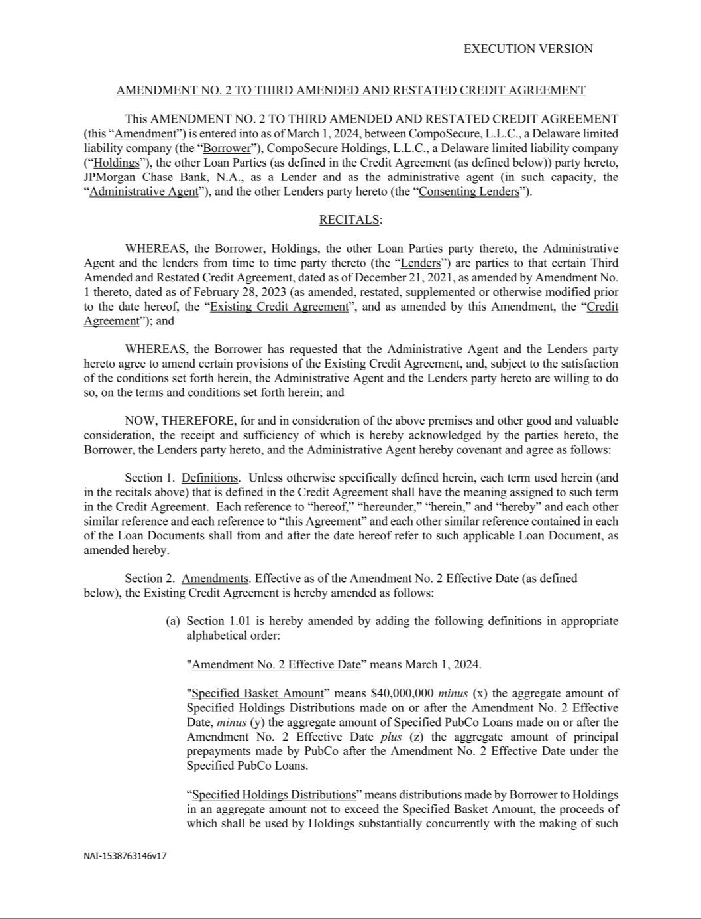

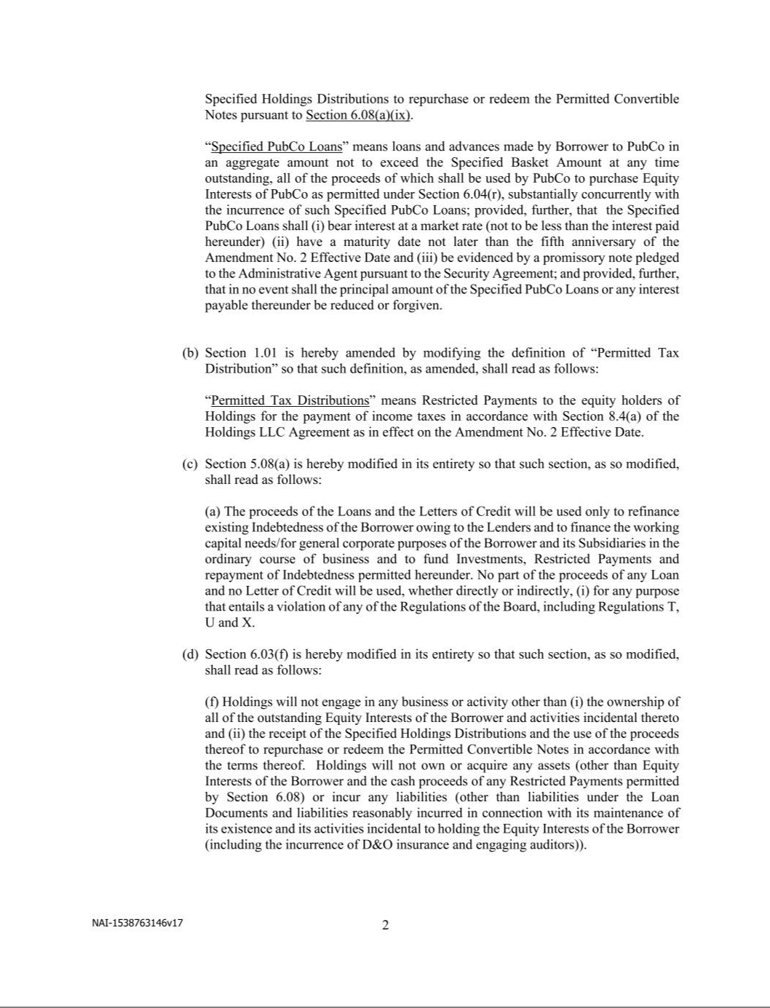

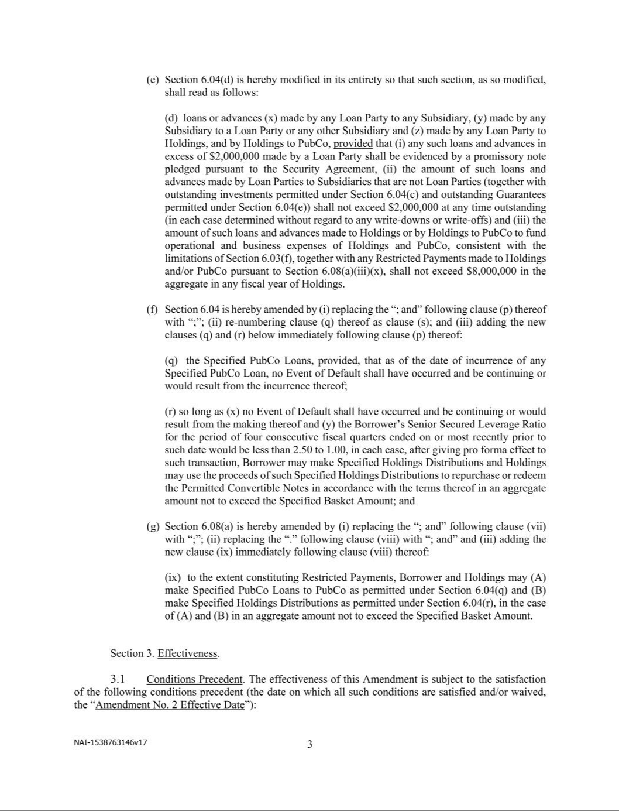

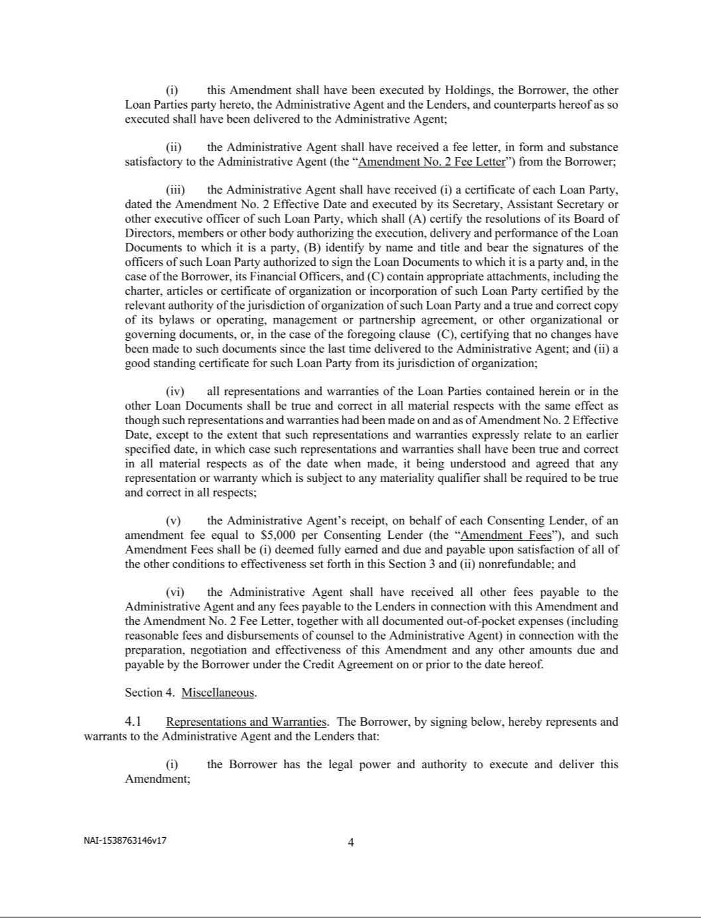

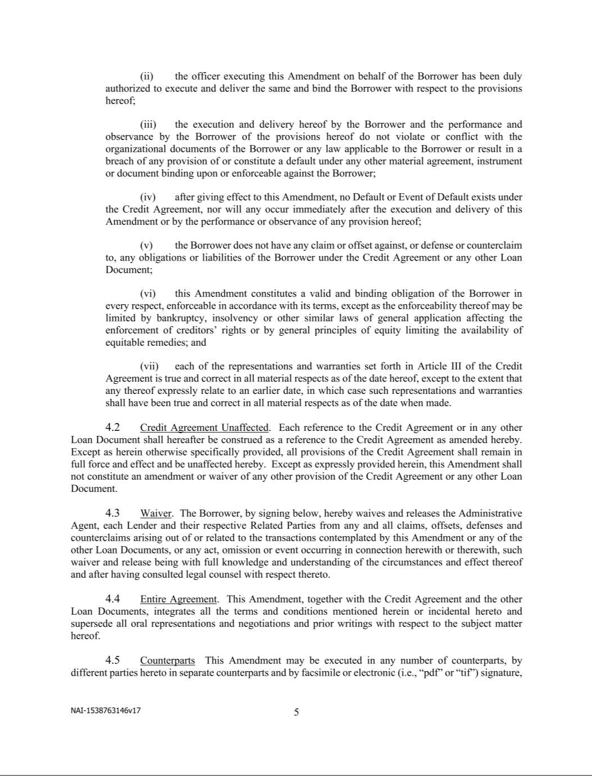

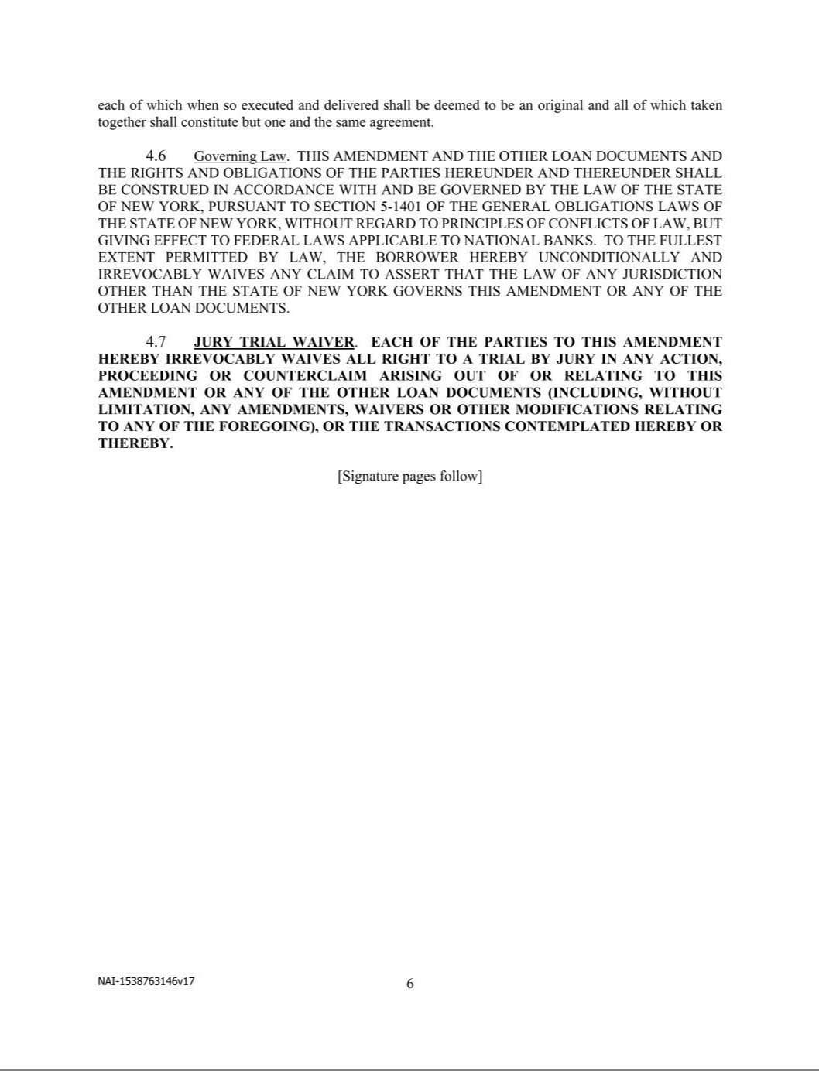

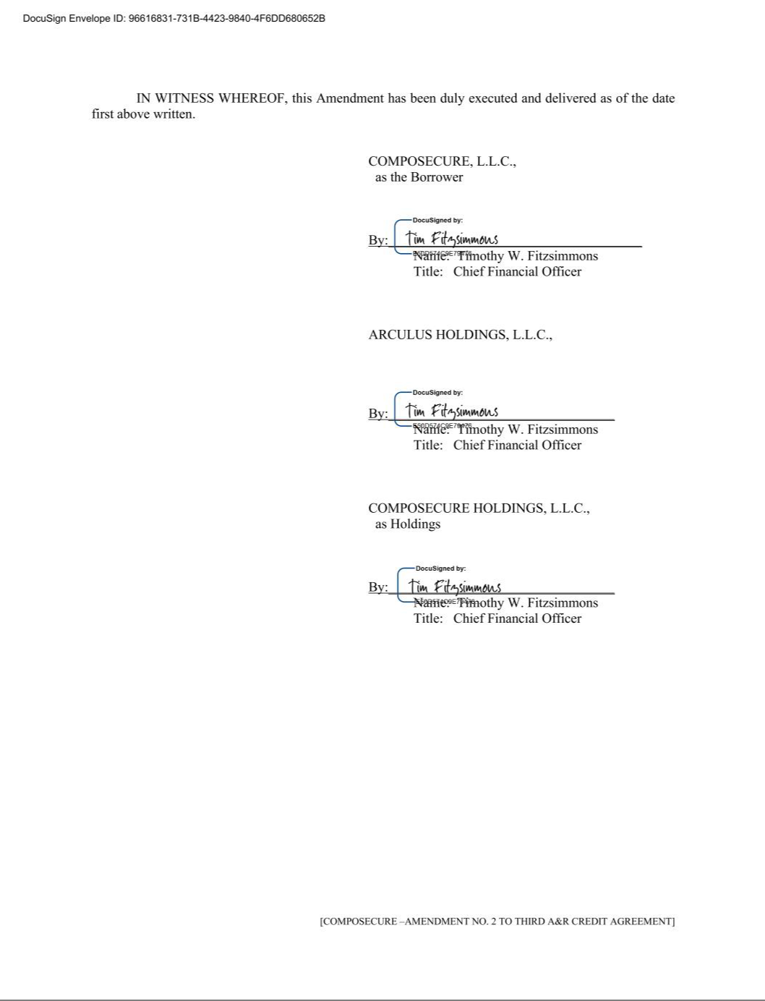









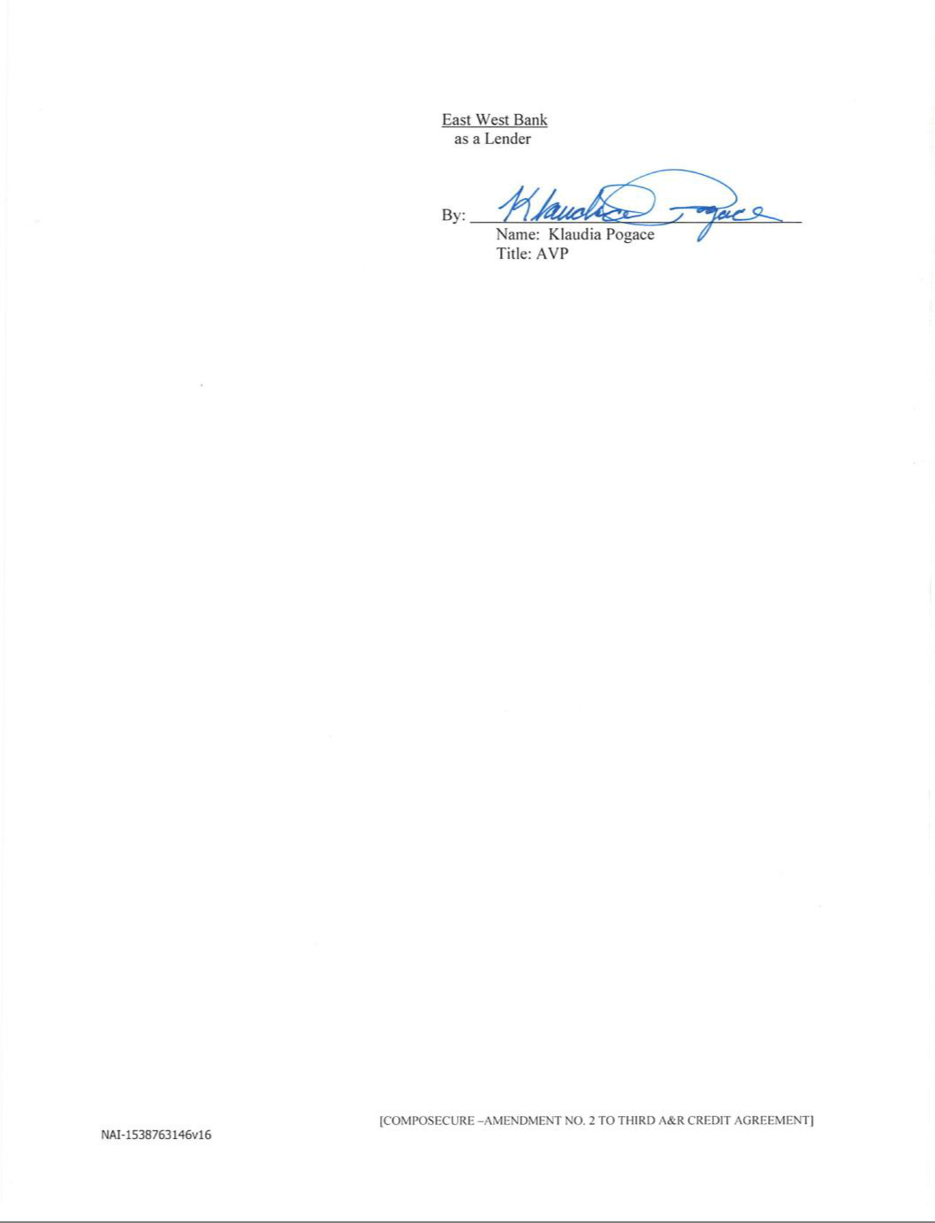

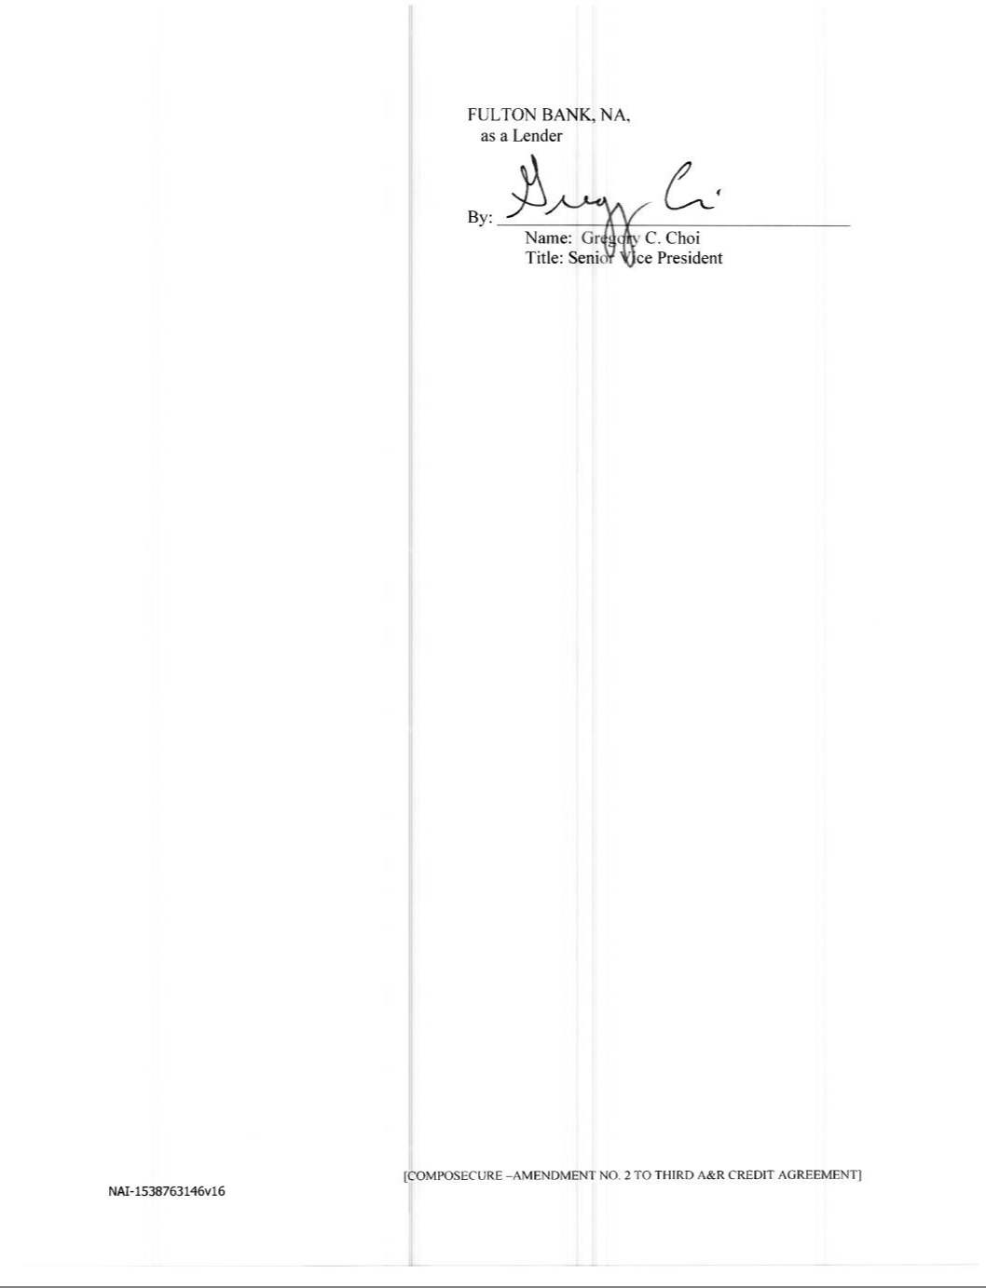







Exhibit 31.1

CERTIFICATION OF THE PRINCIPAL EXECUTIVE OFFICER

PURSUANT TO SECTION 302 OF THE SARBANES-OXLEY ACT OF 2002

I, Jonathan C. Wilk, certify that:

- I have reviewed this Quarterly Report on Form 10-Q of CompoSecure, Inc.

- Based on my knowledge, this report does not contain any untrue statement of a material fact or omit to state a material fact necessary to make the statements made, in light of the circumstances under which such statements were made, not misleading with respect to the period covered by this report;
- Based on my knowledge, the financial statements, and other financial information included in this report, fairly present in all material respects the financial condition, results of operations and cash flows of the registrant as of, and for, the periods presented in this report;
- The registrant’s other certifying officer and I are responsible for establishing and maintaining disclosure controls and procedures (as defined in Exchange Act Rules 13a-15(e) and 15d-15(e)) and internal control over financial reporting (as defined in Exchange Act Rules 13a-15(f) and 15d-15(f)) for the registrant and have:
  - Designed such disclosure controls and procedures, or caused such disclosure controls and procedures to be designed under our supervision, to ensure that material information relating to the registrant, including its consolidated subsidiaries, is made known to us by others within those entities, particularly during the period in which this report is being prepared;
  - Designed such internal control over financial reporting, or caused such internal control over financial reporting to be designed under our supervision, to provide reasonable assurance regarding the reliability of financial reporting and the preparation of financial statements for external purposes in accordance with generally accepted accounting principles;
  - Evaluated the effectiveness of the registrant’s disclosure controls and procedures and presented in this report our conclusions about the effectiveness of the disclosure controls and procedures, as of the end of the period covered by this report based on such evaluation; and
  - Disclosed in this report any change in the registrant’s internal control over financial reporting that occurred during the registrant’s most recent fiscal quarter (the registrant’s fourth fiscal quarter in the case of an annual report) that has materially affected, or is reasonably likely to materially affect, the registrant’s internal control over financial reporting; and
- The registrant’s other certifying officer and I have disclosed, based on our most recent evaluation of internal control over financial reporting, to the registrant’s auditors and the audit committee of the registrant’s board of directors (or persons performing the equivalent functions):
  - All significant deficiencies and material weaknesses in the design or operation of internal control over financial reporting which are reasonably likely to adversely affect the registrant’s ability to record, process, summarize and report financial information; and
  - Any fraud, whether or not material, that involves management or other employees who have a significant role in the registrant’s internal control over financial reporting.

Date: May 6, 2024 By: /s/ Jonathan C. Wilk

Name: Jonathan C. Wilk

Title: President and Chief Executive Officer

(Principal Executive Officer)

Exhibit 31.2

CERTIFICATION OF THE PRINCIPAL FINANCIAL OFFICER

PURSUANT TO SECTION 302 OF THE SARBANES-OXLEY ACT OF 2002

I, Timothy Fitzsimmons, certify that:

- I have reviewed this Quarterly Report on Form 10-Q of CompoSecure, Inc.

- Based on my knowledge, this report does not contain any untrue statement of a material fact or omit to state a material fact necessary to make the statements made, in light of the circumstances under which such statements were made, not misleading with respect to the period covered by this report;
- Based on my knowledge, the financial statements, and other financial information included in this report, fairly present in all material respects the financial condition, results of operations and cash flows of the registrant as of, and for, the periods presented in this report;
- The registrant’s other certifying officer and I are responsible for establishing and maintaining disclosure controls and procedures (as defined in Exchange Act Rules 13a-15(e) and 15d-15(e)) and internal control over financial reporting (as defined in Exchange Act Rules 13a-15(f) and 15d-15(f)) for the registrant and have:
  - Designed such disclosure controls and procedures, or caused such disclosure controls and procedures to be designed under our supervision, to ensure that material information relating to the registrant, including its consolidated subsidiaries, is made known to us by others within those entities, particularly during the period in which this report is being prepared;
  - Designed such internal control over financial reporting, or caused such internal control over financial reporting to be designed under our supervision, to provide reasonable assurance regarding the reliability of financial reporting and the preparation of financial statements for external purposes in accordance with generally accepted accounting principles;
  - Evaluated the effectiveness of the registrant’s disclosure controls and procedures and presented in this report our conclusions about the effectiveness of the disclosure controls and procedures, as of the end of the period covered by this report based on such evaluation; and
  - Disclosed in this report any change in the registrant’s internal control over financial reporting that occurred during the registrant’s most recent fiscal quarter (the registrant’s fourth fiscal quarter in the case of an annual report) that has materially affected, or is reasonably likely to materially affect, the registrant’s internal control over financial reporting; and
- The registrant’s other certifying officer and I have disclosed, based on our most recent evaluation of internal control over financial reporting, to the registrant’s auditors and the audit committee of the registrant’s board of directors (or persons performing the equivalent functions):
  - All significant deficiencies and material weaknesses in the design or operation of internal control over financial reporting which are reasonably likely to adversely affect the registrant’s ability to record, process, summarize and report financial information; and
  - Any fraud, whether or not material, that involves management or other employees who have a significant role in the registrant’s internal control over financial reporting.

Date: May 6, 2024 By: /s/ Timothy Fitzsimmons

Name: Timothy Fitzsimmons

Title: Chief Financial Officer

(Principal Financial and Accounting Officer)

Exhibit 32.1

CERTIFICATION OF THE PRINCIPAL EXECUTIVE OFFICER

PURSUANT TO SECTION 906 OF THE SARBANES-OXLEY ACT OF 2002

In connection with the Quarterly Report of CompoSecure, Inc., a Delaware corporation (the “Company”), on Form 10-Q for the quarter ended March 31, 2024, as filed with the Securities and Exchange Commission on the date hereof (the “Report”), I, Jonathan C. Wilk, President and Chief Executive Officer of the Company, hereby certify, pursuant to 18 U.S.C. § 1350, as adopted pursuant to Section 906 of the Sarbanes-Oxley Act of 2002, that to my knowledge:

- The Report fully complies with the requirements of Section 13(a) or 15(d) of the Securities Exchange Act of 1934, as amended; and

- The information contained in the Report fairly presents, in all material respects, the financial condition and results of operations of the Company.

Date: May 6, 2024 By: /s/ Jonathan C. Wilk

Name: Jonathan C. Wilk

Title: President and Chief Executive Officer

(Principal Executive Officer)

Exhibit 32.2

CERTIFICATION OF THE PRINCIPAL FINANCIAL OFFICER

PURSUANT TO SECTION 906 OF THE SARBANES-OXLEY ACT OF 2002

In connection with the Quarterly Report of CompoSecure, Inc., a Delaware corporation (the “Company”), on Form 10-Q for the quarter ended March 31, 2024, as filed with the Securities and Exchange Commission on the date hereof (the “Report”), I, Timothy Fitzsimmons, Chief Financial Officer of the Company, hereby certify, pursuant to 18 U.S.C. § 1350, as adopted pursuant to Section 906 of the Sarbanes-Oxley Act of 2002, that to my knowledge:

- The Report fully complies with the requirements of Section 13(a) or 15(d) of the Securities Exchange Act of 1934, as amended; and

- The information contained in the Report fairly presents, in all material respects, the financial condition and results of operations of the Company.

Date: May 6, 2024 By: /s/ Timothy Fitzsimmons

Name: Timothy Fitzsimmons

Title: Chief Financial Officer

(Principal Financial and Accounting Officer)

