UNITED STATES
SECURITIES AND EXCHANGE COMMISSION
Washington, D.C. 20549

FORM 8-K

CURRENT REPORT
Pursuant to Section 13 or 15(d)
of the Securities Exchange Act of 1934

Date of Report (Date of earliest event reported): August 6, 2026

GPGI, Inc.
(Exact Name of Registrant as Specified in its Charter)

Nevada |  |  |  |  |  | 001-39687 |  |  |  |  |  | 85-2749902
(State or Other Jurisdiction  of Incorporation) |  |  |  |  |  | (Commission  File Number) |  |  |  |  |  | (IRS Employer  Identification No.)

309 Pierce Street  Somerset, New Jersey |  |  |  |  |  | 08873
(Address of Principal Executive Offices) |  |  |  |  |  | (Zip Code)
(908) 518-0500
(Registrant’s telephone number, including area code)

Not Applicable
(Former name or former address, if changed since last report)

Check the appropriate box below if the Form 8-K filing is intended to simultaneously satisfy the filing obligation of the registrant under any of the following provisions:
 |  |  | ☐ |  |  | Written communications pursuant to Rule 425 under the Securities Act (17 CFR 230.425)
 |  |  | ☐ |  |  | Soliciting material pursuant to Rule 14a-12 under the Exchange Act (17 CFR 240.14a-12)
 |  |  | ☐ |  |  | Pre-commencement communications pursuant to Rule 14d-2(b) under the Exchange Act (17 CFR 240.14d-2(b))
 |  |  | ☐ |  |  | Pre-commencement communications pursuant to Rule 13e-4(c) under the Exchange Act (17 CFR 240.13e-4(c))
Securities registered pursuant to Section 12(b) of the Act:
Title of each class |  |  |  |  |  | Trading  Symbol(s) |  |  |  |  |  | Name of each exchange on  which registered
Class A Common Stock, par value $0.0001 per share |  |  |  |  |  | GPGI |  |  |  |  |  | New York Stock Exchange
Indicate by check mark whether the registrant is an emerging growth company as defined in Rule 405 of the Securities Act of 1933 (§ 230.405 of this chapter) or Rule 12b-2 of the Securities Exchange Act of 1934 (§ 240.12b-2 of this chapter).

Emerging growth company ☐

If an emerging growth company, indicate by check mark if the registrant has elected not to use the extended transition period for complying with any new or revised financial accounting standards provided pursuant to Section 13(a) of the Exchange Act. ☐

Item 2.02 Results of Operations and Financial Condition

On August 6, 2026, GPGI, Inc. (the “Company”) issued a press release announcing its financial results for the three and six months ended June 30, 2026, and provided an investor presentation to accompany the press release. Copies of the press release and the investor presentation are furnished herewith as Exhibits 99.1 and 99.2, respectively.

The information in Item 2.02 of this Form 8-K, including the information set forth in Exhibits 99.1 and 99.2, shall not be deemed “filed” for purposes of Section 18 of the Securities Exchange Act of 1934, as amended (the “Exchange Act”) or otherwise subject to the liabilities of that section, nor shall it be deemed incorporated by reference in any filing under the Securities Act of 1933, as amended, or the Exchange Act, except as expressly set forth by specific reference in such a filing.

Item 8.01 Other Events

The Company’s board of directors has declared a quarterly cash dividend in the amount of $0.0025 per share of Class A common stock of the Company, payable on September 1, 2026 to all holders of record as of August 17, 2026.

Item 9.01 (d) Financial Statements and Exhibits

Exhibit No. |  |  | Exhibit Description
99.1 |  |  | Press Release of GPGI, Inc. dated August 6. 2026
99.2 |  |  | Investor Presentation of GPGI, Inc. dated August 6, 2026
104 |  |  | Cover Page Interactive Data File (embedded within the Inline XBRL document)

SIGNATURE

Pursuant to the requirements of the Securities Exchange Act of 1934, the registrant has duly caused this report to be signed on its behalf by the undersigned, hereunto duly authorized.

 |  |  | GPGI, Inc.
Date: August 6, 2026 |  |  | By: |  |  | /s/ Kurt Schoen
 |  |  | Name: |  |  | Kurt Schoen
 |  |  | Title: |  |  | Principal Financial Officer

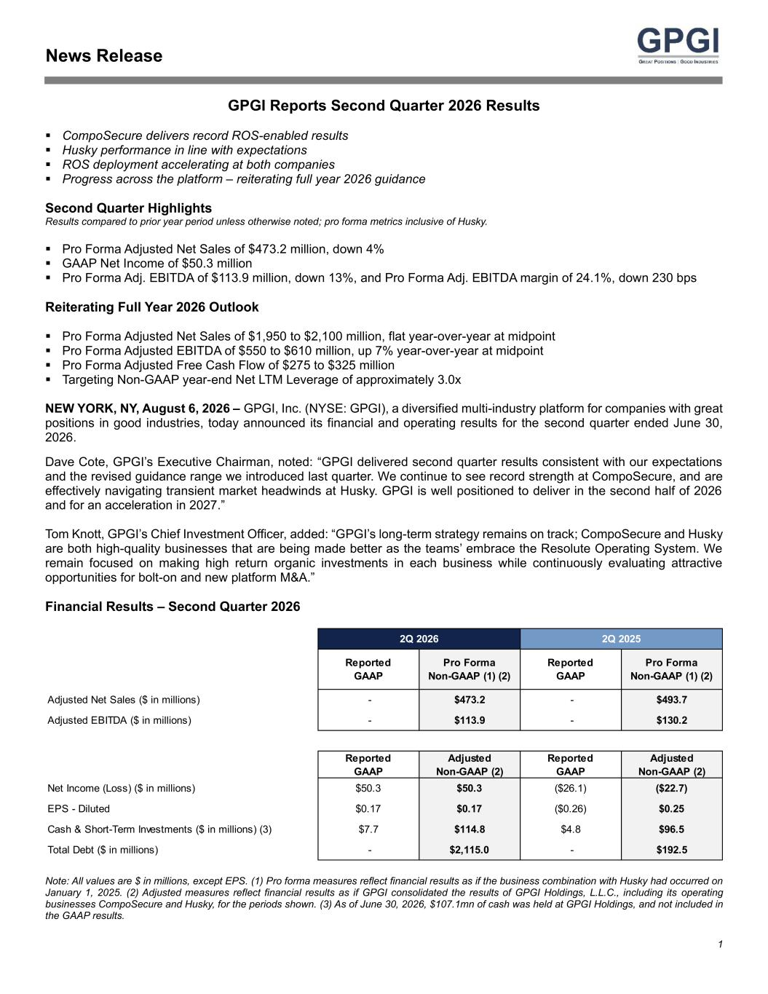

1 News Release GPGI Reports Second Quarter 2026 Results ▪ CompoSecure delivers record ROS-enabled results ▪ Husky performance in line with expectations ▪ ROS deployment accelerating at both companies ▪ Progress across the platform – reiterating full year 2026 guidance Second Quarter Highlights Results compared to prior year period unless otherwise noted; pro forma metrics inclusive of Husky. ▪ Pro Forma Adjusted Net Sales of $473.2 million, down 4% ▪ GAAP Net Income of $50.3 million ▪ Pro Forma Adj. EBITDA of $113.9 million, down 13%, and Pro Forma Adj. EBITDA margin of 24.1%, down 230 bps Reiterating Full Year 2026 Outlook ▪ Pro Forma Adjusted Net Sales of $1,950 to $2,100 million, flat year-over-year at midpoint ▪ Pro Forma Adjusted EBITDA of $550 to $610 million, up 7% year-over-year at midpoint ▪ Pro Forma Adjusted Free Cash Flow of $275 to $325 million ▪ Targeting Non-GAAP year-end Net LTM Leverage of approximately 3.0x NEW YORK, NY, August 6, 2026 – GPGI, Inc. (NYSE: GPGI), a diversified multi-industry platform for companies with great positions in good industries, today announced its financial and operating results for the second quarter ended June 30, 2026. Dave Cote, GPGI’s Executive Chairman, noted: “GPGI delivered second quarter results consistent with our expectations and the revised guidance range we introduced last quarter. We continue to see record strength at CompoSecure, and are effectively navigating transient market headwinds at Husky. GPGI is well positioned to deliver in the second half of 2026 and for an acceleration in 2027.” Tom Knott, GPGI’s Chief Investment Officer, added: “GPGI’s long-term strategy remains on track; CompoSecure and Husky are both high-quality businesses that are being made better as the teams’ embrace the Resolute Operating System. We remain focused on making high return organic investments in each business while continuously evaluating attractive opportunities for bolt-on and new platform M&A.” Financial Results – Second Quarter 2026 Note: All values are $ in millions, except EPS. (1) Pro forma measures reflect financial results as if the business combination with Husky had occurred on January 1, 2025. (2) Adjusted measures reflect financial results as if GPGI consolidated the results of GPGI Holdings, L.L.C., including its operating businesses CompoSecure and Husky, for the periods shown. (3) As of June 30, 2026, $107.1mn of cash was held at GPGI Holdings, and not included in the GAAP results. Reported GAAP Pro Forma Non-GAAP (1) (2) Reported GAAP Pro Forma Non-GAAP (1) (2) Adjusted Net Sales ($ in millions) - $473.2 - $493.7 Adjusted EBITDA ($ in millions) - $113.9 - $130.2 Reported GAAP Adjusted Non-GAAP (2) Reported GAAP Adjusted Non-GAAP (2) Net Income (Loss) ($ in millions) $50.3 $50.3 ($26.1) ($22.7) EPS - Diluted $0.17 $0.17 ($0.26) $0.25 Cash & Short-Term Investments ($ in millions) (3) $7.7 $114.8 $4.8 $96.5 Total Debt ($ in millions) - $2,115.0 - $192.5 2Q 2026 2Q 2025

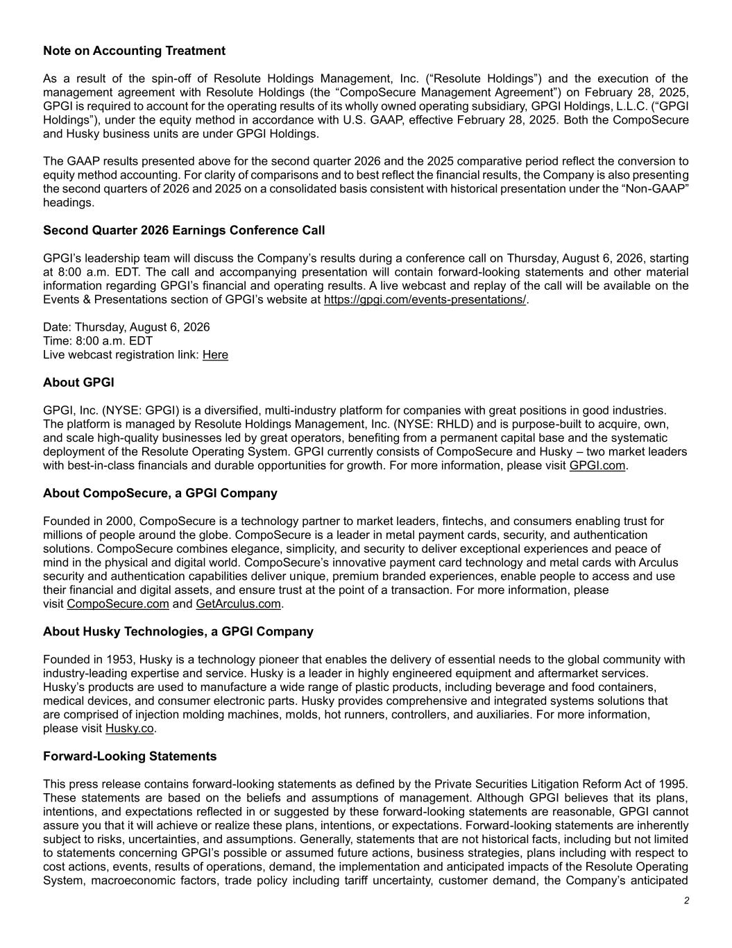
2 Note on Accounting Treatment As a result of the spin-off of Resolute Holdings Management, Inc. (“Resolute Holdings”) and the execution of the management agreement with Resolute Holdings (the “CompoSecure Management Agreement”) on February 28, 2025, GPGI is required to account for the operating results of its wholly owned operating subsidiary, GPGI Holdings, L.L.C. (“GPGI Holdings”), under the equity method in accordance with U.S. GAAP, effective February 28, 2025. Both the CompoSecure and Husky business units are under GPGI Holdings. The GAAP results presented above for the second quarter 2026 and the 2025 comparative period reflect the conversion to equity method accounting. For clarity of comparisons and to best reflect the financial results, the Company is also presenting the second quarters of 2026 and 2025 on a consolidated basis consistent with historical presentation under the “Non-GAAP” headings. Second Quarter 2026 Earnings Conference Call GPGI’s leadership team will discuss the Company’s results during a conference call on Thursday, August 6, 2026, starting at 8:00 a.m. EDT. The call and accompanying presentation will contain forward-looking statements and other material information regarding GPGI’s financial and operating results. A live webcast and replay of the call will be available on the Events & Presentations section of GPGI’s website at https://gpgi.com/events-presentations/. Date: Thursday, August 6, 2026 Time: 8:00 a.m. EDT Live webcast registration link: Here About GPGI GPGI, Inc. (NYSE: GPGI) is a diversified, multi-industry platform for companies with great positions in good industries. The platform is managed by Resolute Holdings Management, Inc. (NYSE: RHLD) and is purpose-built to acquire, own, and scale high-quality businesses led by great operators, benefiting from a permanent capital base and the systematic deployment of the Resolute Operating System. GPGI currently consists of CompoSecure and Husky – two market leaders with best-in-class financials and durable opportunities for growth. For more information, please visit GPGI.com. About CompoSecure, a GPGI Company Founded in 2000, CompoSecure is a technology partner to market leaders, fintechs, and consumers enabling trust for millions of people around the globe. CompoSecure is a leader in metal payment cards, security, and authentication solutions. CompoSecure combines elegance, simplicity, and security to deliver exceptional experiences and peace of mind in the physical and digital world. CompoSecure’s innovative payment card technology and metal cards with Arculus security and authentication capabilities deliver unique, premium branded experiences, enable people to access and use their financial and digital assets, and ensure trust at the point of a transaction. For more information, please visit CompoSecure.com and GetArculus.com. About Husky Technologies, a GPGI Company Founded in 1953, Husky is a technology pioneer that enables the delivery of essential needs to the global community with industry-leading expertise and service. Husky is a leader in highly engineered equipment and aftermarket services. Husky’s products are used to manufacture a wide range of plastic products, including beverage and food containers, medical devices, and consumer electronic parts. Husky provides comprehensive and integrated systems solutions that are comprised of injection molding machines, molds, hot runners, controllers, and auxiliaries. For more information, please visit Husky.co. Forward-Looking Statements This press release contains forward-looking statements as defined by the Private Securities Litigation Reform Act of 1995. These statements are based on the beliefs and assumptions of management. Although GPGI believes that its plans, intentions, and expectations reflected in or suggested by these forward-looking statements are reasonable, GPGI cannot assure you that it will achieve or realize these plans, intentions, or expectations. Forward-looking statements are inherently subject to risks, uncertainties, and assumptions. Generally, statements that are not historical facts, including but not limited to statements concerning GPGI’s possible or assumed future actions, business strategies, plans including with respect to cost actions, events, results of operations, demand, the implementation and anticipated impacts of the Resolute Operating System, macroeconomic factors, trade policy including tariff uncertainty, customer demand, the Company’s anticipated

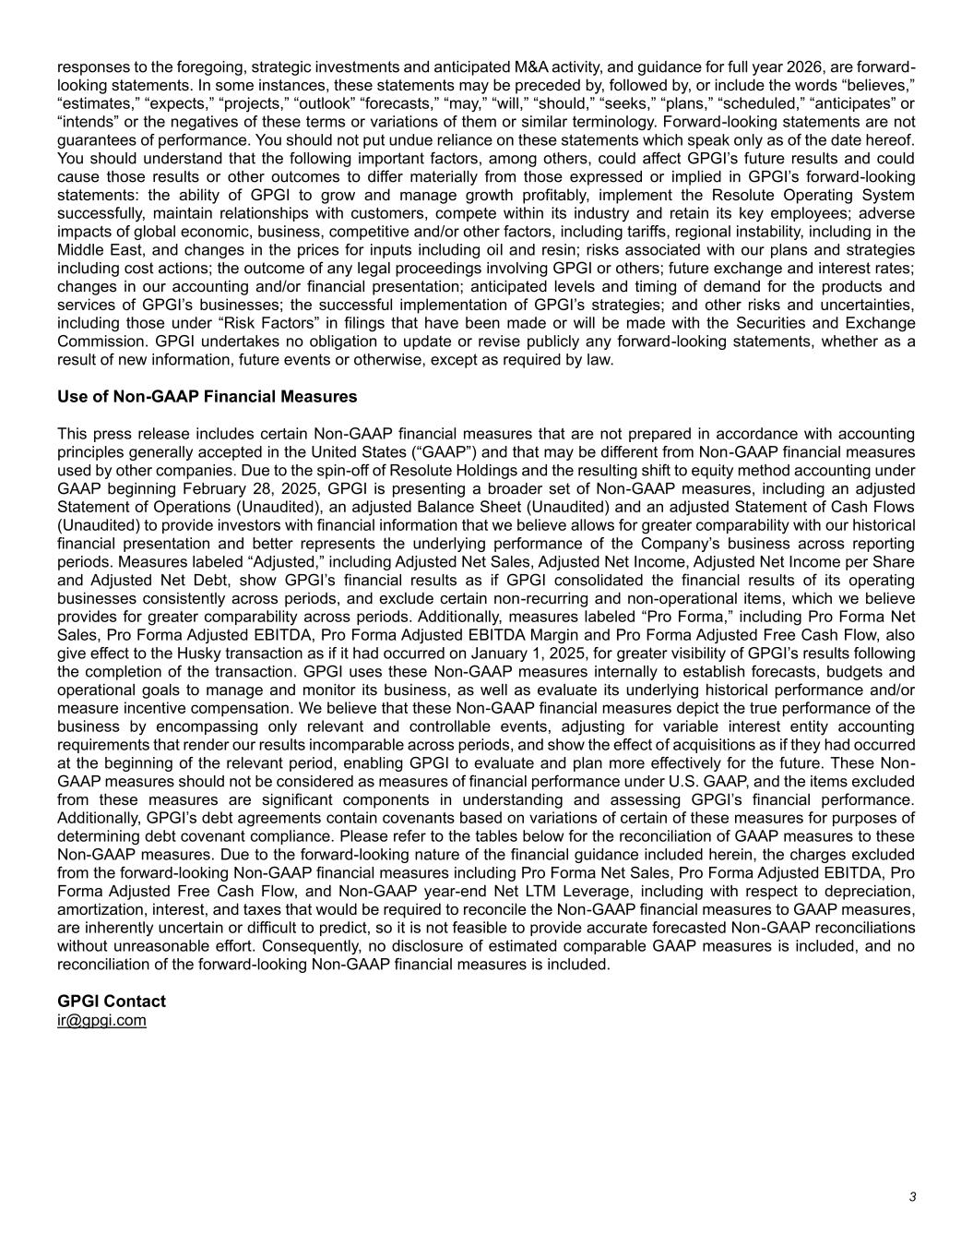
3 responses to the foregoing, strategic investments and anticipated M&A activity, and guidance for full year 2026, are forward- looking statements. In some instances, these statements may be preceded by, followed by, or include the words “believes,” “estimates,” “expects,” “projects,” “outlook” “forecasts,” “may,” “will,” “should,” “seeks,” “plans,” “scheduled,” “anticipates” or “intends” or the negatives of these terms or variations of them or similar terminology. Forward-looking statements are not guarantees of performance. You should not put undue reliance on these statements which speak only as of the date hereof. You should understand that the following important factors, among others, could affect GPGI’s future results and could cause those results or other outcomes to differ materially from those expressed or implied in GPGI’s forward-looking statements: the ability of GPGI to grow and manage growth profitably, implement the Resolute Operating System successfully, maintain relationships with customers, compete within its industry and retain its key employees; adverse impacts of global economic, business, competitive and/or other factors, including tariffs, regional instability, including in the Middle East, and changes in the prices for inputs including oil and resin; risks associated with our plans and strategies including cost actions; the outcome of any legal proceedings involving GPGI or others; future exchange and interest rates; changes in our accounting and/or financial presentation; anticipated levels and timing of demand for the products and services of GPGI’s businesses; the successful implementation of GPGI’s strategies; and other risks and uncertainties, including those under “Risk Factors” in filings that have been made or will be made with the Securities and Exchange Commission. GPGI undertakes no obligation to update or revise publicly any forward-looking statements, whether as a result of new information, future events or otherwise, except as required by law. Use of Non-GAAP Financial Measures This press release includes certain Non-GAAP financial measures that are not prepared in accordance with accounting principles generally accepted in the United States (“GAAP”) and that may be different from Non-GAAP financial measures used by other companies. Due to the spin-off of Resolute Holdings and the resulting shift to equity method accounting under GAAP beginning February 28, 2025, GPGI is presenting a broader set of Non-GAAP measures, including an adjusted Statement of Operations (Unaudited), an adjusted Balance Sheet (Unaudited) and an adjusted Statement of Cash Flows (Unaudited) to provide investors with financial information that we believe allows for greater comparability with our historical financial presentation and better represents the underlying performance of the Company’s business across reporting periods. Measures labeled “Adjusted,” including Adjusted Net Sales, Adjusted Net Income, Adjusted Net Income per Share and Adjusted Net Debt, show GPGI’s financial results as if GPGI consolidated the financial results of its operating businesses consistently across periods, and exclude certain non-recurring and non-operational items, which we believe provides for greater comparability across periods. Additionally, measures labeled “Pro Forma,” including Pro Forma Net Sales, Pro Forma Adjusted EBITDA, Pro Forma Adjusted EBITDA Margin and Pro Forma Adjusted Free Cash Flow, also give effect to the Husky transaction as if it had occurred on January 1, 2025, for greater visibility of GPGI’s results following the completion of the transaction. GPGI uses these Non-GAAP measures internally to establish forecasts, budgets and operational goals to manage and monitor its business, as well as evaluate its underlying historical performance and/or measure incentive compensation. We believe that these Non-GAAP financial measures depict the true performance of the business by encompassing only relevant and controllable events, adjusting for variable interest entity accounting requirements that render our results incomparable across periods, and show the effect of acquisitions as if they had occurred at the beginning of the relevant period, enabling GPGI to evaluate and plan more effectively for the future. These Non- GAAP measures should not be considered as measures of financial performance under U.S. GAAP, and the items excluded from these measures are significant components in understanding and assessing GPGI’s financial performance. Additionally, GPGI’s debt agreements contain covenants based on variations of certain of these measures for purposes of determining debt covenant compliance. Please refer to the tables below for the reconciliation of GAAP measures to these Non-GAAP measures. Due to the forward-looking nature of the financial guidance included herein, the charges excluded from the forward-looking Non-GAAP financial measures including Pro Forma Net Sales, Pro Forma Adjusted EBITDA, Pro Forma Adjusted Free Cash Flow, and Non-GAAP year-end Net LTM Leverage, including with respect to depreciation, amortization, interest, and taxes that would be required to reconcile the Non-GAAP financial measures to GAAP measures, are inherently uncertain or difficult to predict, so it is not feasible to provide accurate forecasted Non-GAAP reconciliations without unreasonable effort. Consequently, no disclosure of estimated comparable GAAP measures is included, and no reconciliation of the forward-looking Non-GAAP financial measures is included. GPGI Contact ir@gpgi.com

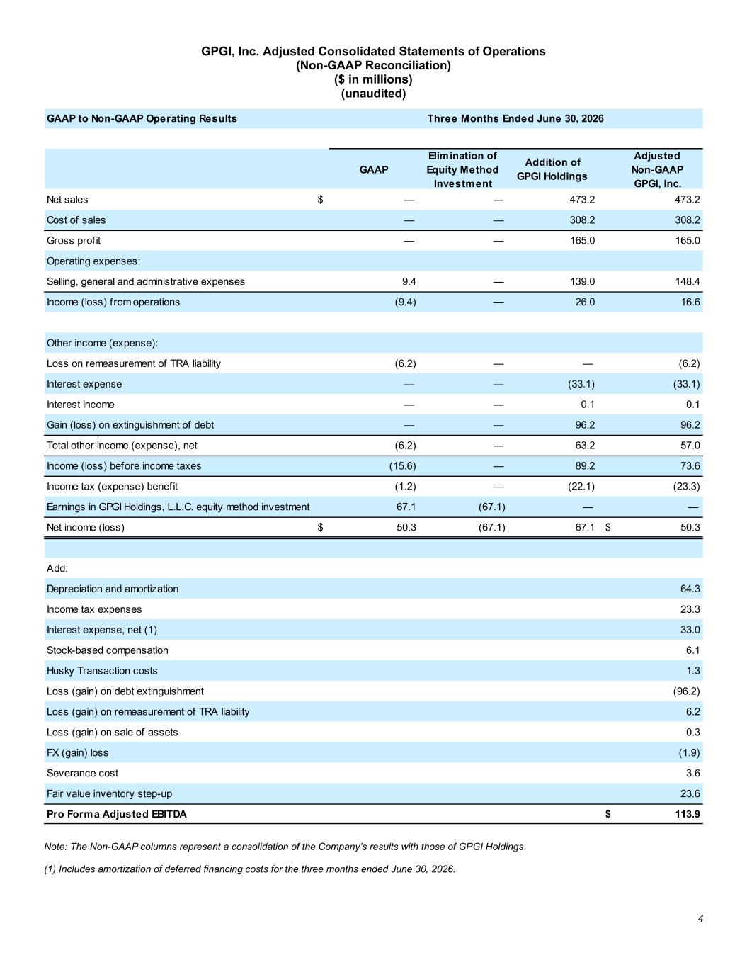
4 GPGI, Inc. Adjusted Consolidated Statements of Operations (Non-GAAP Reconciliation) ($ in millions) (unaudited) Note: The Non-GAAP columns represent a consolidation of the Company’s results with those of GPGI Holdings. (1) Includes amortization of deferred financing costs for the three months ended June 30, 2026. GAAP to Non-GAAP Operating Results GAAP Elimination of Equity Method Investment Addition of GPGI Holdings Adjusted Non-GAAP GPGI, Inc. Net sales $ — — 473.2 473.2 Cost of sales — — 308.2 308.2 Gross profit — — 165.0 165.0 Operating expenses: Selling, general and administrative expenses 9.4 — 139.0 148.4 Income (loss) from operations (9.4) — 26.0 16.6 Other income (expense): Loss on remeasurement of TRA liability (6.2) — — (6.2) Interest expense — — (33.1) (33.1) Interest income — — 0.1 0.1 Gain (loss) on extinguishment of debt — — 96.2 96.2 Total other income (expense), net (6.2) — 63.2 57.0 Income (loss) before income taxes (15.6) — 89.2 73.6 Income tax (expense) benefit (1.2) — (22.1) (23.3) Earnings in GPGI Holdings, L.L.C. equity method investment 67.1 (67.1) — — Net income (loss) $ 50.3 (67.1) 67.1 $ 50.3 Add: Depreciation and amortization 64.3 Income tax expenses 23.3 Interest expense, net (1) 33.0 Stock-based compensation 6.1 Husky Transaction costs 1.3 Loss (gain) on debt extinguishment (96.2) Loss (gain) on remeasurement of TRA liability 6.2 Loss (gain) on sale of assets 0.3 FX (gain) loss (1.9) Severance cost 3.6 Fair value inventory step-up 23.6 Pro Forma Adjusted EBITDA $ 113.9 Three Months Ended June 30, 2026

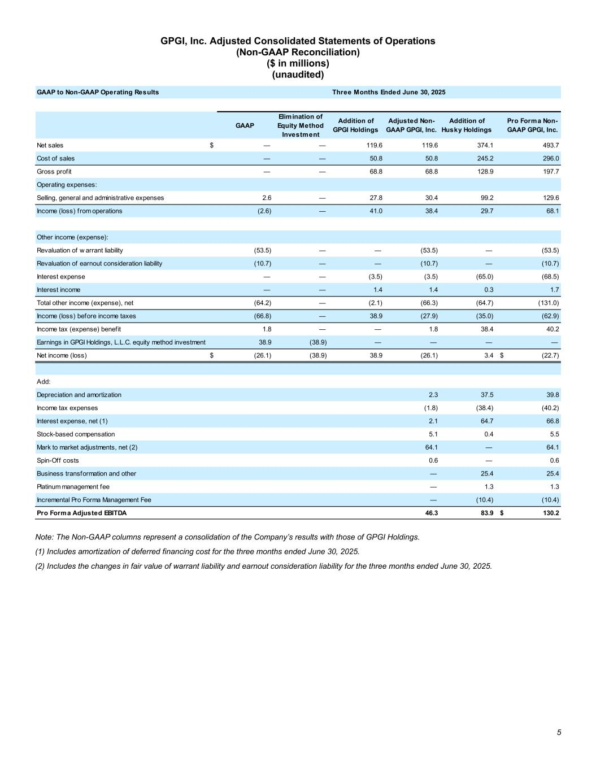
5 GPGI, Inc. Adjusted Consolidated Statements of Operations (Non-GAAP Reconciliation) ($ in millions) (unaudited) Note: The Non-GAAP columns represent a consolidation of the Company’s results with those of GPGI Holdings. (1) Includes amortization of deferred financing cost for the three months ended June 30, 2025. (2) Includes the changes in fair value of warrant liability and earnout consideration liability for the three months ended June 30, 2025. GAAP to Non-GAAP Operating Results GAAP Elimination of Equity Method Investment Addition of GPGI Holdings Adjusted Non- GAAP GPGI, Inc. Addition of Husky Holdings Pro Forma Non- GAAP GPGI, Inc. Net sales $ — — 119.6 119.6 374.1 493.7 Cost of sales — — 50.8 50.8 245.2 296.0 Gross profit — — 68.8 68.8 128.9 197.7 Operating expenses: Selling, general and administrative expenses 2.6 — 27.8 30.4 99.2 129.6 Income (loss) from operations (2.6) — 41.0 38.4 29.7 68.1 Other income (expense): Revaluation of w arrant liability (53.5) — — (53.5) — (53.5) Revaluation of earnout consideration liability (10.7) — — (10.7) — (10.7) Interest expense — — (3.5) (3.5) (65.0) (68.5) Interest income — — 1.4 1.4 0.3 1.7 Total other income (expense), net (64.2) — (2.1) (66.3) (64.7) (131.0) Income (loss) before income taxes (66.8) — 38.9 (27.9) (35.0) (62.9) Income tax (expense) benefit 1.8 — — 1.8 38.4 40.2 Earnings in GPGI Holdings, L.L.C. equity method investment 38.9 (38.9) — — — — Net income (loss) $ (26.1) (38.9) 38.9 (26.1) 3.4 $ (22.7) Add: Depreciation and amortization 2.3 37.5 39.8 Income tax expenses (1.8) (38.4) (40.2) Interest expense, net (1) 2.1 64.7 66.8 Stock-based compensation 5.1 0.4 5.5 Mark to market adjustments, net (2) 64.1 — 64.1 Spin-Off costs 0.6 — 0.6 Business transformation and other — 25.4 25.4 Platinum management fee — 1.3 1.3 Incremental Pro Forma Management Fee — (10.4) (10.4) Pro Forma Adjusted EBITDA 46.3 83.9 $ 130.2 Three Months Ended June 30, 2025

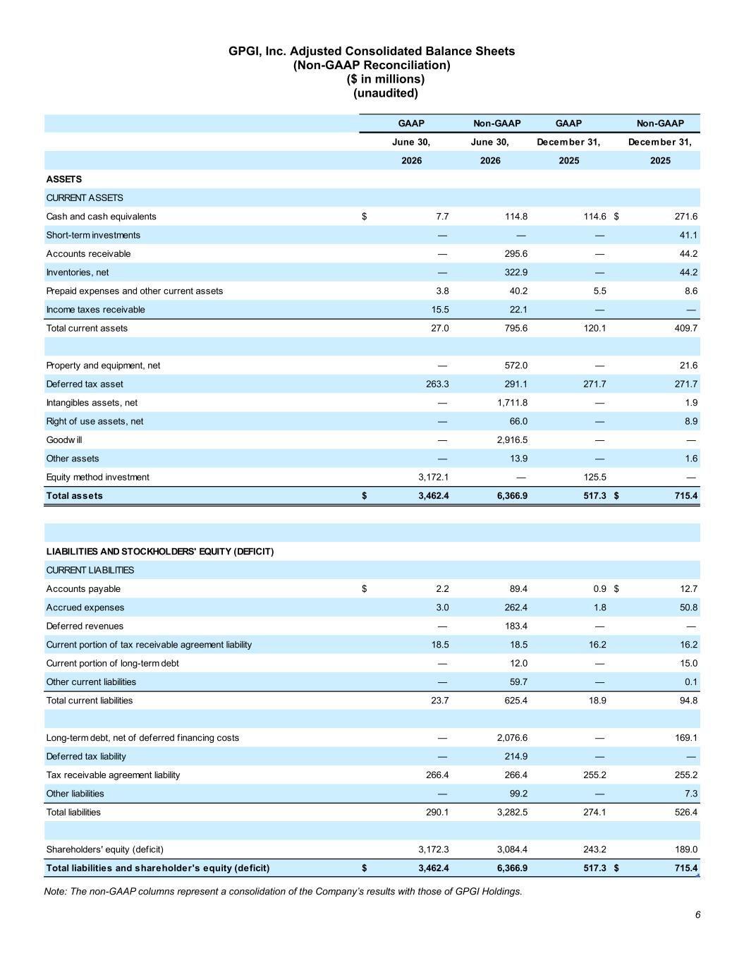
6 GPGI, Inc. Adjusted Consolidated Balance Sheets (Non-GAAP Reconciliation) ($ in millions) (unaudited) Note: The non-GAAP columns represent a consolidation of the Company’s results with those of GPGI Holdings. GAAP Non-GAAP GAAP Non-GAAP June 30, June 30, December 31, December 31, 2026 2026 2025 2025 ASSETS CURRENT ASSETS Cash and cash equivalents $ 7.7 114.8 114.6 $ 271.6 Short-term investments — — — 41.1 Accounts receivable — 295.6 — 44.2 Inventories, net — 322.9 — 44.2 Prepaid expenses and other current assets 3.8 40.2 5.5 8.6 Income taxes receivable 15.5 22.1 — — Total current assets 27.0 795.6 120.1 409.7 Property and equipment, net — 572.0 — 21.6 Deferred tax asset 263.3 291.1 271.7 271.7 Intangibles assets, net — 1,711.8 — 1.9 Right of use assets, net — 66.0 — 8.9 Goodw ill — 2,916.5 — — Other assets — 13.9 — 1.6 Equity method investment 3,172.1 — 125.5 — Total assets $ 3,462.4 6,366.9 517.3 $ 715.4 LIABILITIES AND STOCKHOLDERS' EQUITY (DEFICIT) CURRENT LIABILITIES Accounts payable $ 2.2 89.4 0.9 $ 12.7 Accrued expenses 3.0 262.4 1.8 50.8 Deferred revenues — 183.4 — — Current portion of tax receivable agreement liability 18.5 18.5 16.2 16.2 Current portion of long-term debt — 12.0 — 15.0 Other current liabilities — 59.7 — 0.1 Total current liabilities 23.7 625.4 18.9 94.8 Long-term debt, net of deferred f inancing costs — 2,076.6 — 169.1 Deferred tax liability — 214.9 — — Tax receivable agreement liability 266.4 266.4 255.2 255.2 Other liabilities — 99.2 — 7.3 Total liabilities 290.1 3,282.5 274.1 526.4 Shareholders' equity (deficit) 3,172.3 3,084.4 243.2 189.0 Total liabilities and shareholder's equity (deficit) $ 3,462.4 6,366.9 517.3 $ 715.4

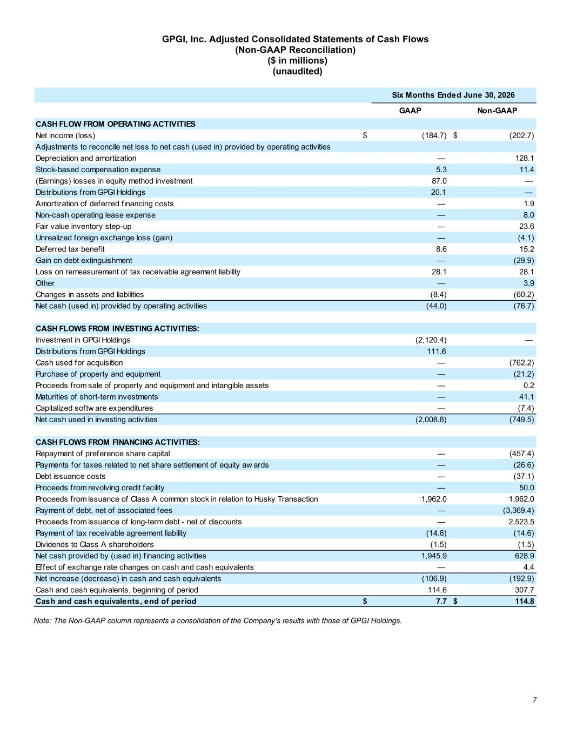
7 GPGI, Inc. Adjusted Consolidated Statements of Cash Flows (Non-GAAP Reconciliation) ($ in millions) (unaudited) Note: The Non-GAAP column represents a consolidation of the Company’s results with those of GPGI Holdings. GAAP Non-GAAP CASH FLOW FROM OPERATING ACTIVITIES Net income (loss) $ (184.7) $ (202.7) Adjustments to reconcile net loss to net cash (used in) provided by operating activities Depreciation and amortization — 128.1 Stock-based compensation expense 5.3 11.4 (Earnings) losses in equity method investment 87.0 — Distributions from GPGI Holdings 20.1 — Amortization of deferred f inancing costs — 1.9 Non-cash operating lease expense — 8.0 Fair value inventory step-up — 23.6 Unrealized foreign exchange loss (gain) — (4.1) Deferred tax benefit 8.6 15.2 Gain on debt extinguishment — (29.9) Loss on remeasurement of tax receivable agreement liability 28.1 28.1 Other — 3.9 Changes in assets and liabilities (8.4) (60.2) Net cash (used in) provided by operating activities (44.0) (76.7) CASH FLOWS FROM INVESTING ACTIVITIES: Investment in GPGI Holdings (2,120.4) — Distributions from GPGI Holdings 111.6 Cash used for acquisition — (762.2) Purchase of property and equipment — (21.2) Proceeds from sale of property and equipment and intangible assets — 0.2 Maturities of short-term investments — 41.1 Capitalized softw are expenditures — (7.4) Net cash used in investing activities (2,008.8) (749.5) CASH FLOWS FROM FINANCING ACTIVITIES: Repayment of preference share capital — (457.4) Payments for taxes related to net share settlement of equity aw ards — (26.6) Debt issuance costs — (37.1) Proceeds from revolving credit facility — 50.0 Proceeds from issuance of Class A common stock in relation to Husky Transaction 1,962.0 1,962.0 Payment of debt, net of associated fees — (3,369.4) Proceeds from issuance of long-term debt - net of discounts — 2,523.5 Payment of tax receivable agreement liability (14.6) (14.6) Dividends to Class A shareholders (1.5) (1.5) Net cash provided by (used in) f inancing activities 1,945.9 628.9 Effect of exchange rate changes on cash and cash equivalents — 4.4 Net increase (decrease) in cash and cash equivalents (106.9) (192.9) Cash and cash equivalents, beginning of period 114.6 307.7 Cash and cash equivalents, end of period $ 7.7 $ 114.8 Six Months Ended June 30, 2026

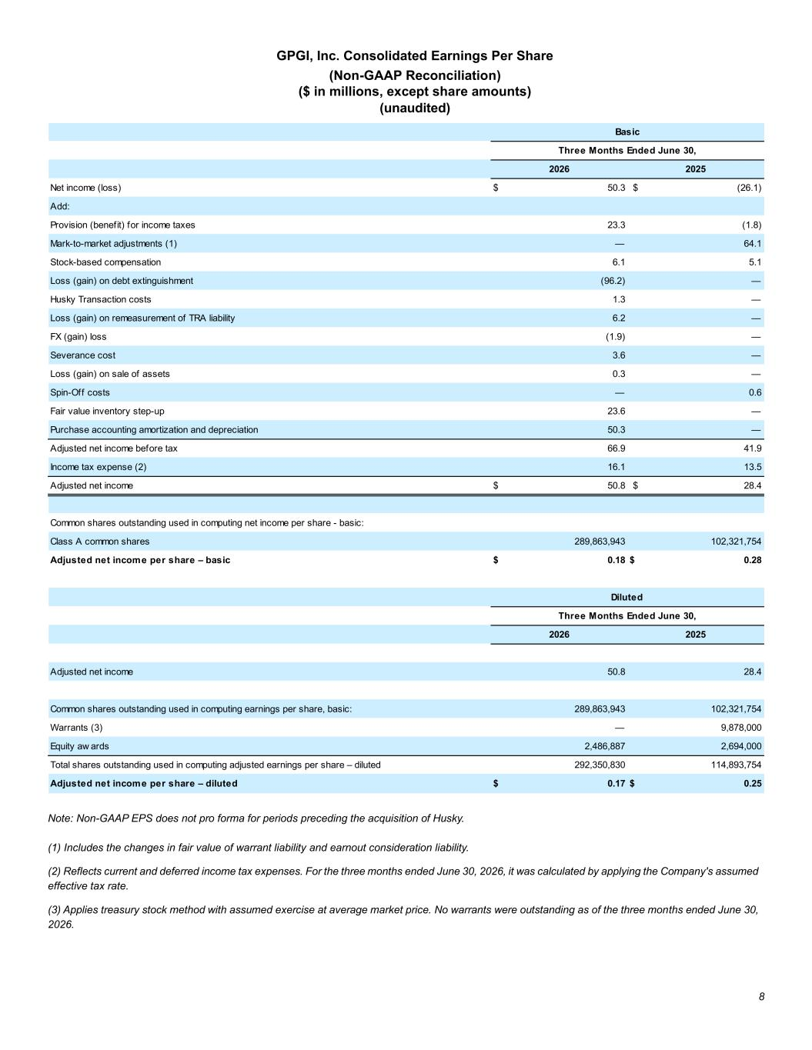
8 GPGI, Inc. Consolidated Earnings Per Share (Non-GAAP Reconciliation) ($ in millions, except share amounts) (unaudited) Note: Non-GAAP EPS does not pro forma for periods preceding the acquisition of Husky. (1) Includes the changes in fair value of warrant liability and earnout consideration liability. (2) Reflects current and deferred income tax expenses. For the three months ended June 30, 2026, it was calculated by applying the Company's assumed effective tax rate. (3) Applies treasury stock method with assumed exercise at average market price. No warrants were outstanding as of the three months ended June 30, 2026. Net income (loss) $ 50.3 $ (26.1) Add: Provision (benefit) for income taxes 23.3 (1.8) Mark-to-market adjustments (1) — 64.1 Stock-based compensation 6.1 5.1 Loss (gain) on debt extinguishment (96.2) — Husky Transaction costs 1.3 — Loss (gain) on remeasurement of TRA liability 6.2 — FX (gain) loss (1.9) — Severance cost 3.6 — Loss (gain) on sale of assets 0.3 — Spin-Off costs — 0.6 Fair value inventory step-up 23.6 — Purchase accounting amortization and depreciation 50.3 — Adjusted net income before tax 66.9 41.9 Income tax expense (2) 16.1 13.5 Adjusted net income $ 50.8 $ 28.4 Common shares outstanding used in computing net income per share - basic: Class A common shares 289,863,943 102,321,754 Adjusted net income per share – basic $ 0.18 $ 0.28 Adjusted net income 50.8 28.4 Common shares outstanding used in computing earnings per share, basic: 289,863,943 102,321,754 Warrants (3) — 9,878,000 Equity aw ards 2,486,887 2,694,000 Total shares outstanding used in computing adjusted earnings per share – diluted 292,350,830 114,893,754 Adjusted net income per share – diluted $ 0.17 $ 0.25 Diluted Three Months Ended June 30, 2026 2025 Basic Three Months Ended June 30, 2026 2025

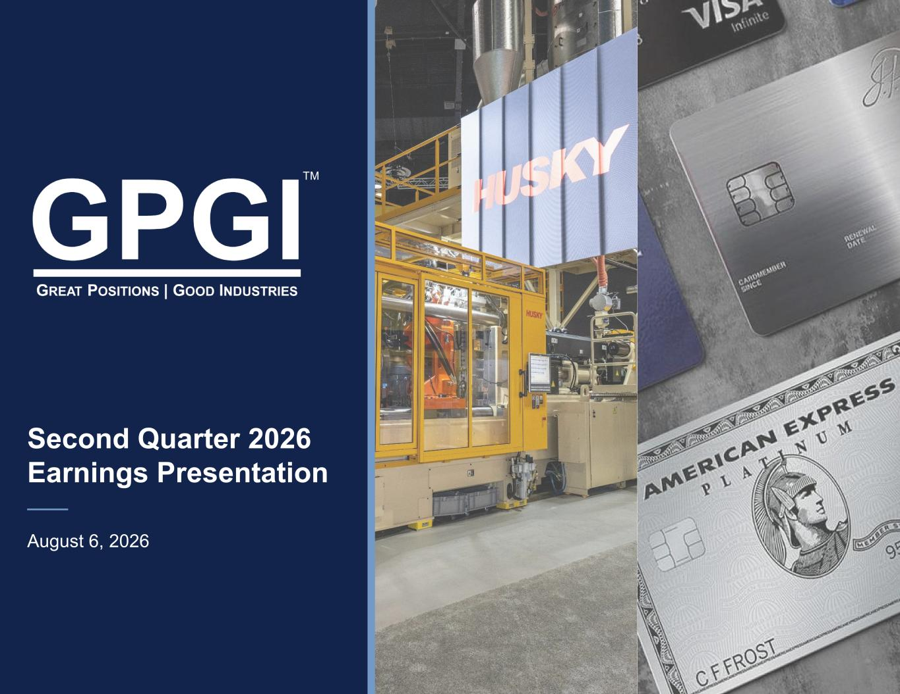
Second Quarter 2026 Earnings Presentation August 6, 2026 TM

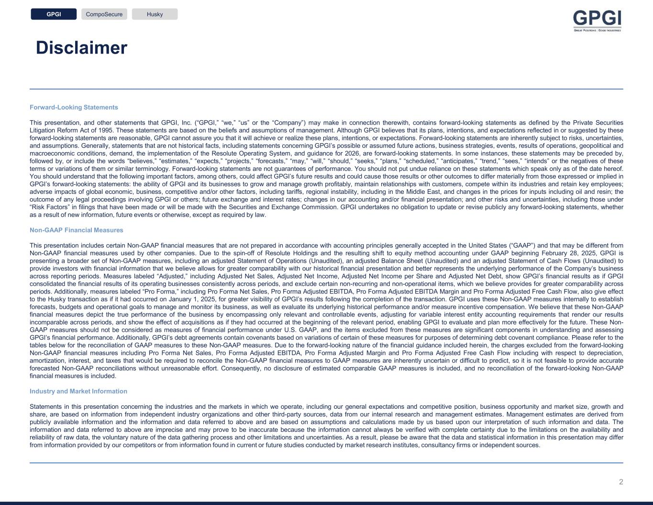
Disclaimer 2 Forward-Looking Statements This presentation, and other statements that GPGI, Inc. (“GPGI,” “we,” “us” or the “Company”) may make in connection therewith, contains forward-looking statements as defined by the Private Securities Litigation Reform Act of 1995. These statements are based on the beliefs and assumptions of management. Although GPGI believes that its plans, intentions, and expectations reflected in or suggested by these forward-looking statements are reasonable, GPGI cannot assure you that it will achieve or realize these plans, intentions, or expectations. Forward-looking statements are inherently subject to risks, uncertainties, and assumptions. Generally, statements that are not historical facts, including statements concerning GPGI’s possible or assumed future actions, business strategies, events, results of operations, geopolitical and macroeconomic conditions, demand, the implementation of the Resolute Operating System, and guidance for 2026, are forward-looking statements. In some instances, these statements may be preceded by, followed by, or include the words “believes,” “estimates,” “expects,” “projects,” “forecasts,” “may,” “will,” “should,” “seeks,” “plans,” “scheduled,” “anticipates,” “trend,” “sees,” “intends” or the negatives of these terms or variations of them or similar terminology. Forward-looking statements are not guarantees of performance. You should not put undue reliance on these statements which speak only as of the date hereof. You should understand that the following important factors, among others, could affect GPGI’s future results and could cause those results or other outcomes to differ materially from those expressed or implied in GPGI’s forward-looking statements: the ability of GPGI and its businesses to grow and manage growth profitably, maintain relationships with customers, compete within its industries and retain key employees; adverse impacts of global economic, business, competitive and/or other factors, including tariffs, regional instability, including in the Middle East, and changes in the prices for inputs including oil and resin; the outcome of any legal proceedings involving GPGI or others; future exchange and interest rates; changes in our accounting and/or financial presentation; and other risks and uncertainties, including those under “Risk Factors” in filings that have been made or will be made with the Securities and Exchange Commission. GPGI undertakes no obligation to update or revise publicly any forward-looking statements, whether as a result of new information, future events or otherwise, except as required by law. Non-GAAP Financial Measures This presentation includes certain Non-GAAP financial measures that are not prepared in accordance with accounting principles generally accepted in the United States (“GAAP”) and that may be different from Non-GAAP financial measures used by other companies. Due to the spin-off of Resolute Holdings and the resulting shift to equity method accounting under GAAP beginning February 28, 2025, GPGI is presenting a broader set of Non-GAAP measures, including an adjusted Statement of Operations (Unaudited), an adjusted Balance Sheet (Unaudited) and an adjusted Statement of Cash Flows (Unaudited) to provide investors with financial information that we believe allows for greater comparability with our historical financial presentation and better represents the underlying performance of the Company’s business across reporting periods. Measures labeled “Adjusted,” including Adjusted Net Sales, Adjusted Net Income, Adjusted Net Income per Share and Adjusted Net Debt, show GPGI’s financial results as if GPGI consolidated the financial results of its operating businesses consistently across periods, and exclude certain non-recurring and non-operational items, which we believe provides for greater comparability across periods. Additionally, measures labeled “Pro Forma,” including Pro Forma Net Sales, Pro Forma Adjusted EBITDA, Pro Forma Adjusted EBITDA Margin and Pro Forma Adjusted Free Cash Flow, also give effect to the Husky transaction as if it had occurred on January 1, 2025, for greater visibility of GPGI’s results following the completion of the transaction. GPGI uses these Non-GAAP measures internally to establish forecasts, budgets and operational goals to manage and monitor its business, as well as evaluate its underlying historical performance and/or measure incentive compensation. We believe that these Non-GAAP financial measures depict the true performance of the business by encompassing only relevant and controllable events, adjusting for variable interest entity accounting requirements that render our results incomparable across periods, and show the effect of acquisitions as if they had occurred at the beginning of the relevant period, enabling GPGI to evaluate and plan more effectively for the future. These Non- GAAP measures should not be considered as measures of financial performance under U.S. GAAP, and the items excluded from these measures are significant components in understanding and assessing GPGI’s financial performance. Additionally, GPGI’s debt agreements contain covenants based on variations of certain of these measures for purposes of determining debt covenant compliance. Please refer to the tables below for the reconciliation of GAAP measures to these Non-GAAP measures. Due to the forward-looking nature of the financial guidance included herein, the charges excluded from the forward-looking Non-GAAP financial measures including Pro Forma Net Sales, Pro Forma Adjusted EBITDA, Pro Forma Adjusted Margin and Pro Forma Adjusted Free Cash Flow including with respect to depreciation, amortization, interest, and taxes that would be required to reconcile the Non-GAAP financial measures to GAAP measures are inherently uncertain or difficult to predict, so it is not feasible to provide accurate forecasted Non-GAAP reconciliations without unreasonable effort. Consequently, no disclosure of estimated comparable GAAP measures is included, and no reconciliation of the forward-looking Non-GAAP financial measures is included. Industry and Market Information Statements in this presentation concerning the industries and the markets in which we operate, including our general expectations and competitive position, business opportunity and market size, growth and share, are based on information from independent industry organizations and other third-party sources, data from our internal research and management estimates. Management estimates are derived from publicly available information and the information and data referred to above and are based on assumptions and calculations made by us based upon our interpretation of such information and data. The information and data referred to above are imprecise and may prove to be inaccurate because the information cannot always be verified with complete certainty due to the limitations on the availability and reliability of raw data, the voluntary nature of the data gathering process and other limitations and uncertainties. As a result, please be aware that the data and statistical information in this presentation may differ from information provided by our competitors or from information found in current or future studies conducted by market research institutes, consultancy firms or independent sources. GPGI CompoSecure Husky

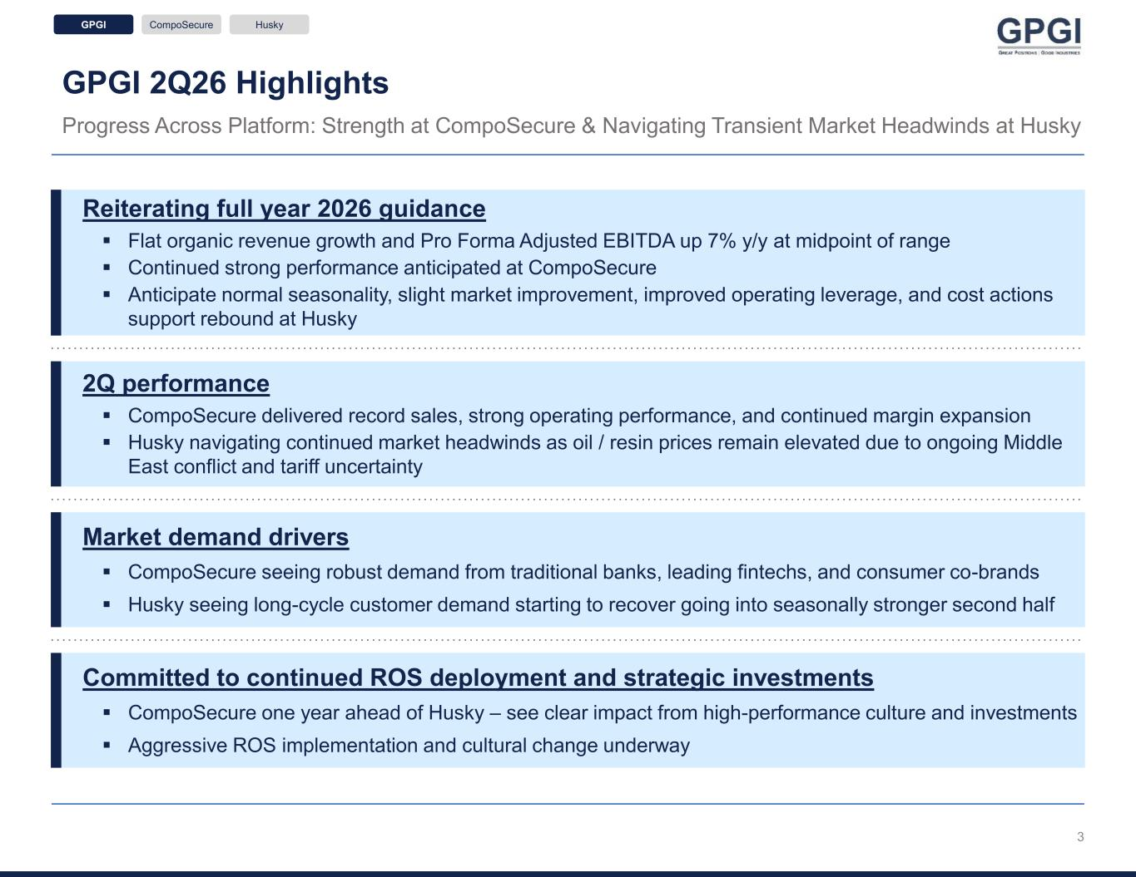
GPGI 2Q26 Highlights Progress Across Platform: Strength at CompoSecure & Navigating Transient Market Headwinds at Husky Reiterating full year 2026 guidance ▪ Flat organic revenue growth and Pro Forma Adjusted EBITDA up 7% y/y at midpoint of range ▪ Continued strong performance anticipated at CompoSecure ▪ Anticipate normal seasonality, slight market improvement, improved operating leverage, and cost actions support rebound at Husky Market demand drivers ▪ CompoSecure seeing robust demand from traditional banks, leading fintechs, and consumer co-brands ▪ Husky seeing long-cycle customer demand starting to recover going into seasonally stronger second half Committed to continued ROS deployment and strategic investments ▪ CompoSecure one year ahead of Husky – see clear impact from high-performance culture and investments ▪ Aggressive ROS implementation and cultural change underway GPGI CompoSecure Husky 2Q performance ▪ CompoSecure delivered record sales, strong operating performance, and continued margin expansion ▪ Husky navigating continued market headwinds as oil / resin prices remain elevated due to ongoing Middle East conflict and tariff uncertainty 3

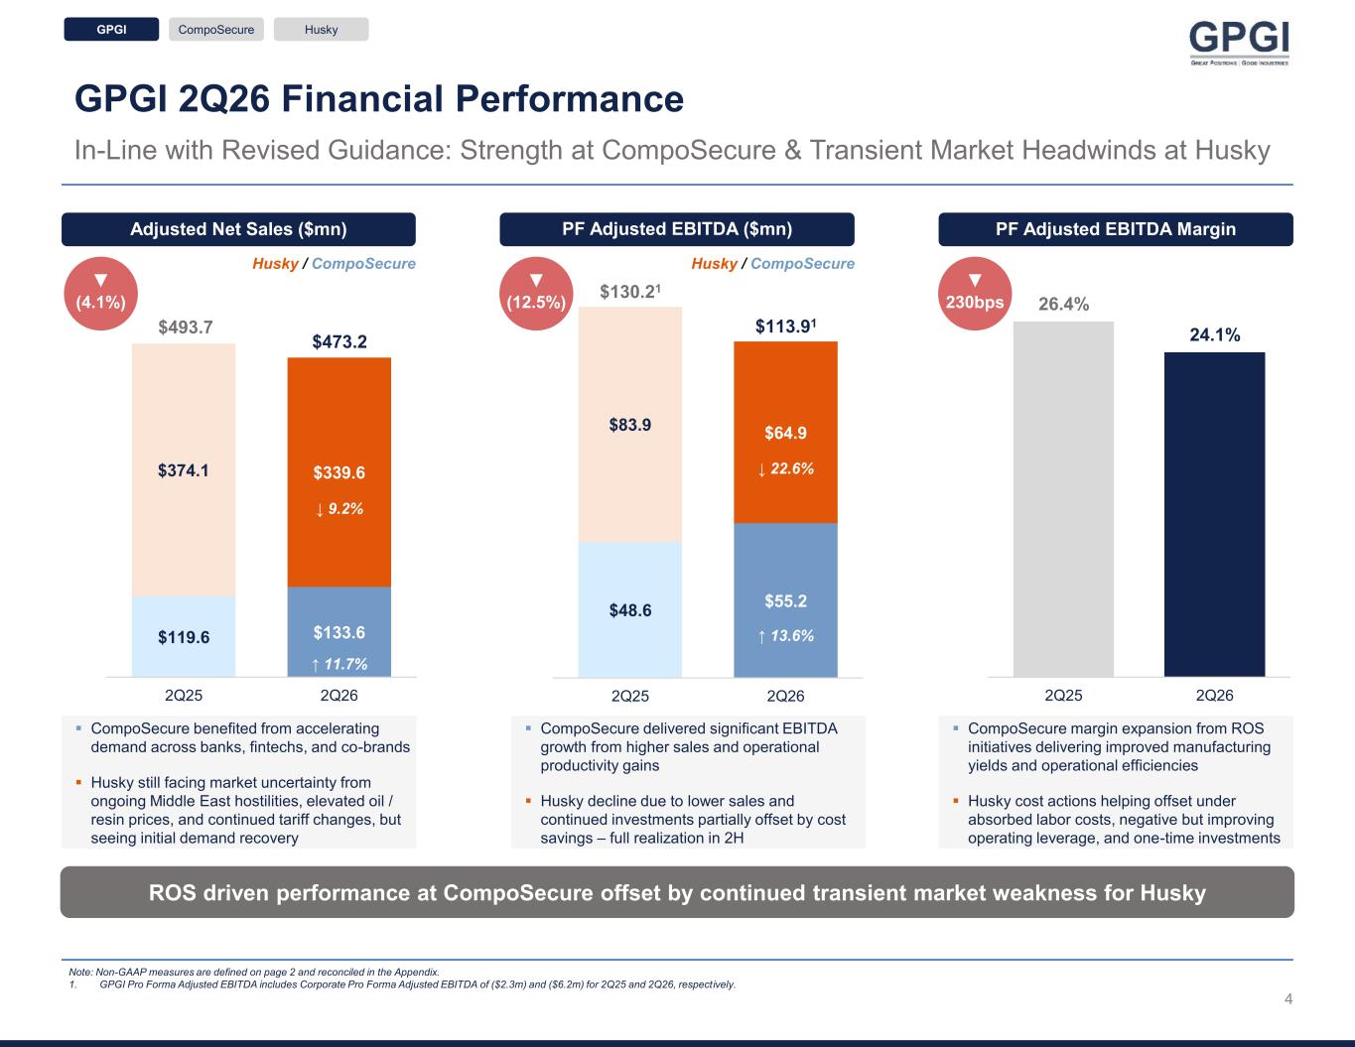
$48.6 $55.2 $83.9 $64.9 2Q25 2Q26 $119.6 $133.6 $374.1 $339.6 2Q25 2Q26 GPGI 2Q26 Financial Performance In-Line with Revised Guidance: Strength at CompoSecure & Transient Market Headwinds at Husky ROS driven performance at CompoSecure offset by continued transient market weakness for Husky Note: Non-GAAP measures are defined on page 2 and reconciled in the Appendix. 1. GPGI Pro Forma Adjusted EBITDA includes Corporate Pro Forma Adjusted EBITDA of ($2.3m) and ($6.2m) for 2Q25 and 2Q26, respectively. Adjusted Net Sales ($mn) PF Adjusted EBITDA MarginPF Adjusted EBITDA ($mn) ▼ 230bps ▼ (12.5%) $493.7 $473.2 ↓ 9.2% ↑ 11.7% $130.21 $113.91 ↓ 22.6% ↑ 13.6% Husky / CompoSecure Husky / CompoSecure ▪ CompoSecure benefited from accelerating demand across banks, fintechs, and co-brands ▪ Husky still facing market uncertainty from ongoing Middle East hostilities, elevated oil / resin prices, and continued tariff changes, but seeing initial demand recovery ▪ CompoSecure delivered significant EBITDA growth from higher sales and operational productivity gains ▪ Husky decline due to lower sales and continued investments partially offset by cost savings – full realization in 2H ▪ CompoSecure margin expansion from ROS initiatives delivering improved manufacturing yields and operational efficiencies ▪ Husky cost actions helping offset under absorbed labor costs, negative but improving operating leverage, and one-time investments ▼ (4.1%) 26.4% 24.1% 2Q25 2Q26 GPGI CompoSecure Husky 4

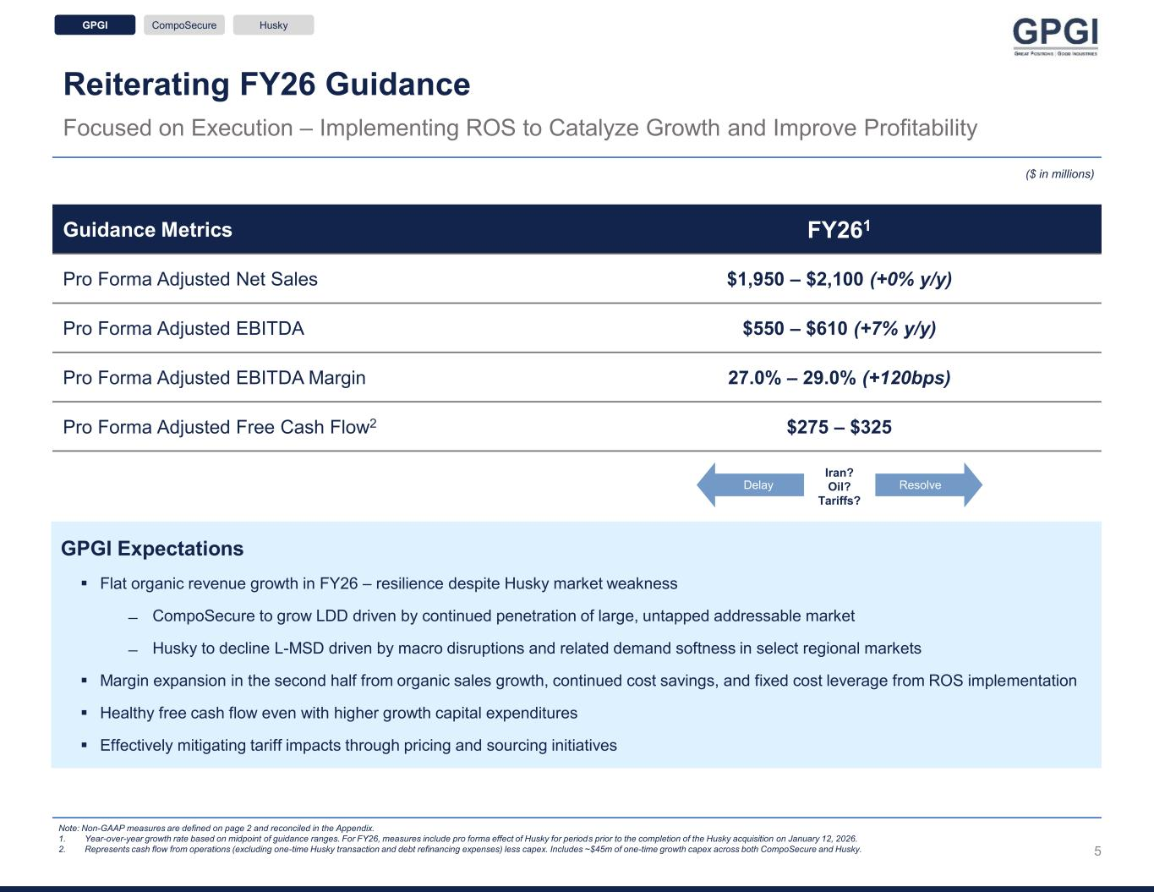
Reiterating FY26 Guidance Focused on Execution – Implementing ROS to Catalyze Growth and Improve Profitability Note: Non-GAAP measures are defined on page 2 and reconciled in the Appendix. 1. Year-over-year growth rate based on midpoint of guidance ranges. For FY26, measures include pro forma effect of Husky for periods prior to the completion of the Husky acquisition on January 12, 2026. 2. Represents cash flow from operations (excluding one-time Husky transaction and debt refinancing expenses) less capex. Includes ~$45m of one-time growth capex across both CompoSecure and Husky. GPGI Expectations ▪ Flat organic revenue growth in FY26 – resilience despite Husky market weakness ̶ CompoSecure to grow LDD driven by continued penetration of large, untapped addressable market ̶ Husky to decline L-MSD driven by macro disruptions and related demand softness in select regional markets ▪ Margin expansion in the second half from organic sales growth, continued cost savings, and fixed cost leverage from ROS implementation ▪ Healthy free cash flow even with higher growth capital expenditures ▪ Effectively mitigating tariff impacts through pricing and sourcing initiatives Guidance Metrics FY261 Pro Forma Adjusted Net Sales $1,950 – $2,100 (+0% y/y) Pro Forma Adjusted EBITDA $550 – $610 (+7% y/y) Pro Forma Adjusted EBITDA Margin 27.0% – 29.0% (+120bps) Pro Forma Adjusted Free Cash Flow2 $275 – $325 ($ in millions) Iran? Oil? Tariffs? Delay Resolve GPGI CompoSecure Husky 5

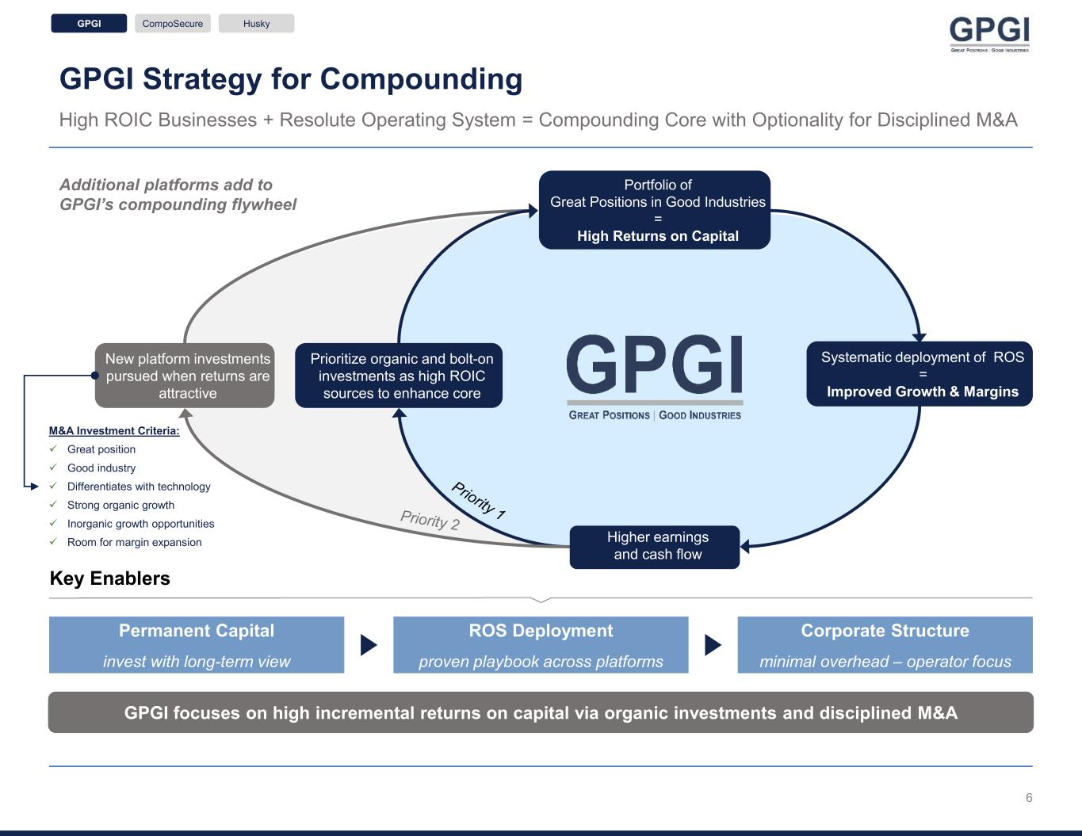
GPGI Strategy for Compounding High ROIC Businesses + Resolute Operating System = Compounding Core with Optionality for Disciplined M&A GPGI focuses on high incremental returns on capital via organic investments and disciplined M&A GPGI CompoSecure Husky Key Enablers Additional platforms add to GPGI’s compounding flywheel Permanent Capital invest with long-term view ROS Deployment proven playbook across platforms Corporate Structure minimal overhead – operator focus M&A Investment Criteria: ✓ Great position ✓ Good industry ✓ Differentiates with technology ✓ Strong organic growth ✓ Inorganic growth opportunities ✓ Room for margin expansion Prioritize organic and bolt-on investments as high ROIC sources to enhance core New platform investments pursued when returns are attractive Portfolio of Great Positions in Good Industries = High Returns on Capital Higher earnings and cash flow Systematic deployment of ROS = Improved Growth & Margins 6

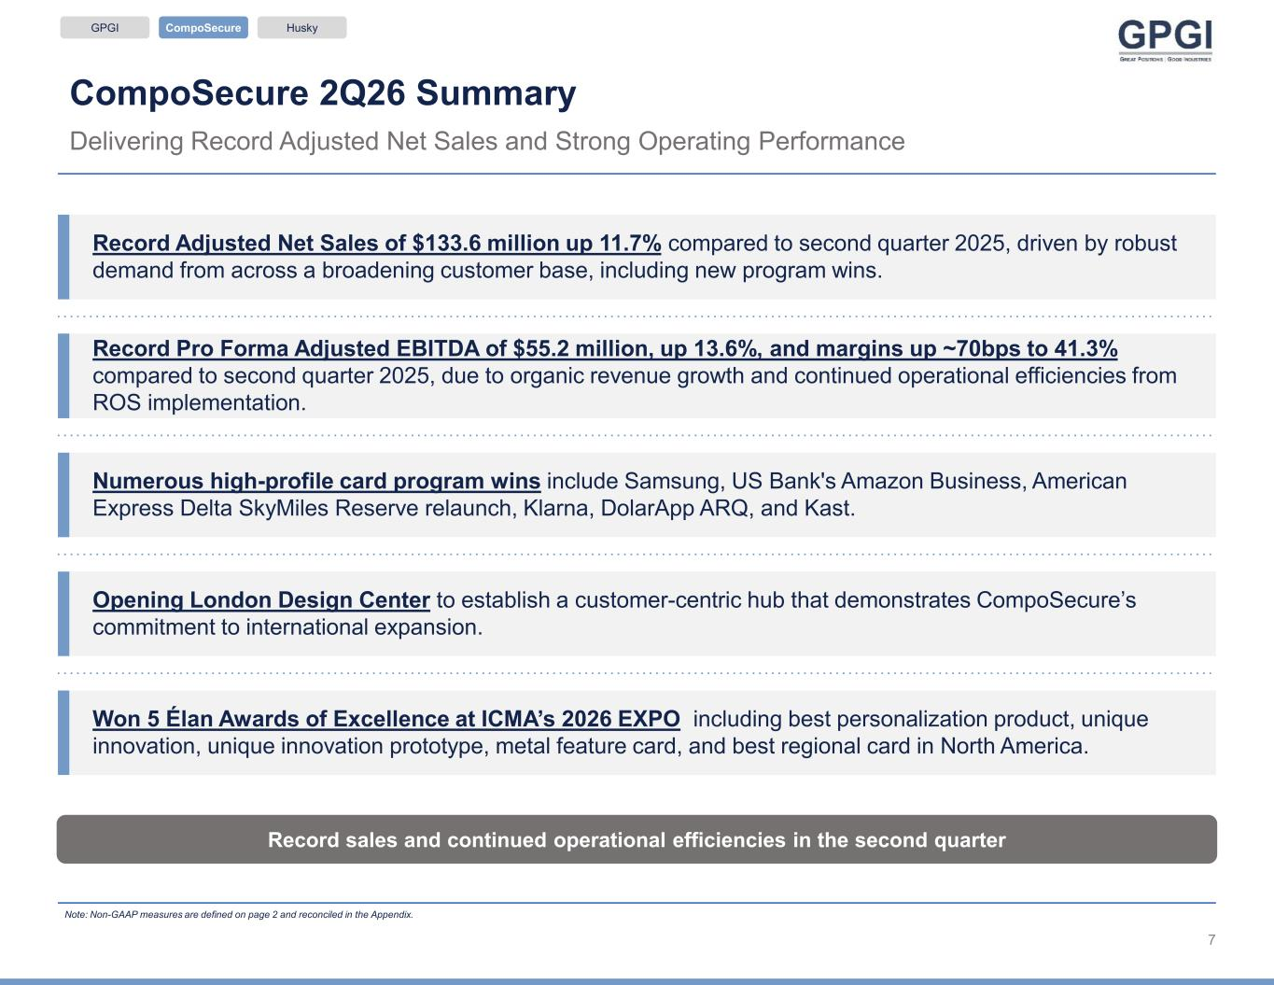
CompoSecure 2Q26 Summary Delivering Record Adjusted Net Sales and Strong Operating Performance Note: Non-GAAP measures are defined on page 2 and reconciled in the Appendix. Record sales and continued operational efficiencies in the second quarter Record Adjusted Net Sales of $133.6 million up 11.7% compared to second quarter 2025, driven by robust demand from across a broadening customer base, including new program wins. Record Pro Forma Adjusted EBITDA of $55.2 million, up 13.6%, and margins up ~70bps to 41.3% compared to second quarter 2025, due to organic revenue growth and continued operational efficiencies from ROS implementation. Won 5 Élan Awards of Excellence at ICMA’s 2026 EXPO including best personalization product, unique innovation, unique innovation prototype, metal feature card, and best regional card in North America. GPGI CompoSecure Husky Numerous high-profile card program wins include Samsung, US Bank's Amazon Business, American Express Delta SkyMiles Reserve relaunch, Klarna, DolarApp ARQ, and Kast. Opening London Design Center to establish a customer-centric hub that demonstrates CompoSecure’s commitment to international expansion. 7

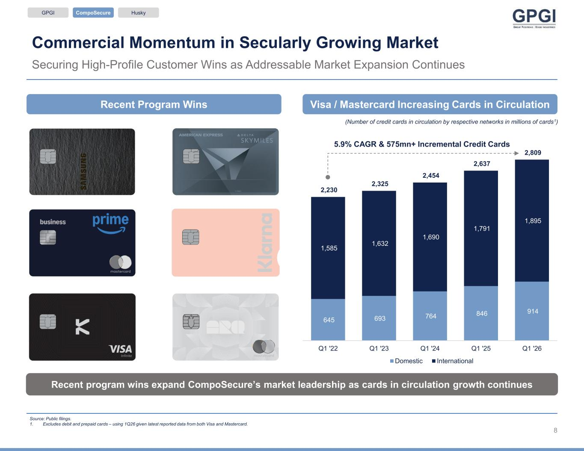
Commercial Momentum in Secularly Growing Market Securing High-Profile Customer Wins as Addressable Market Expansion Continues Source: Public filings. 1. Excludes debit and prepaid cards – using 1Q26 given latest reported data from both Visa and Mastercard. Recent program wins expand CompoSecure’s market leadership as cards in circulation growth continues GPGI CompoSecure Husky (Number of credit cards in circulation by respective networks in millions of cards1) 5.9% CAGR & 575mn+ Incremental Credit Cards Visa / Mastercard Increasing Cards in CirculationRecent Program Wins 8 645 693 764 846 914 1,585 1,632 1,690 1,791 1,895 2,230 2,325 2,454 2,637 2,809 Q1 '22 Q1 '23 Q1 '24 Q1 '25 Q1 '26 Domestic International

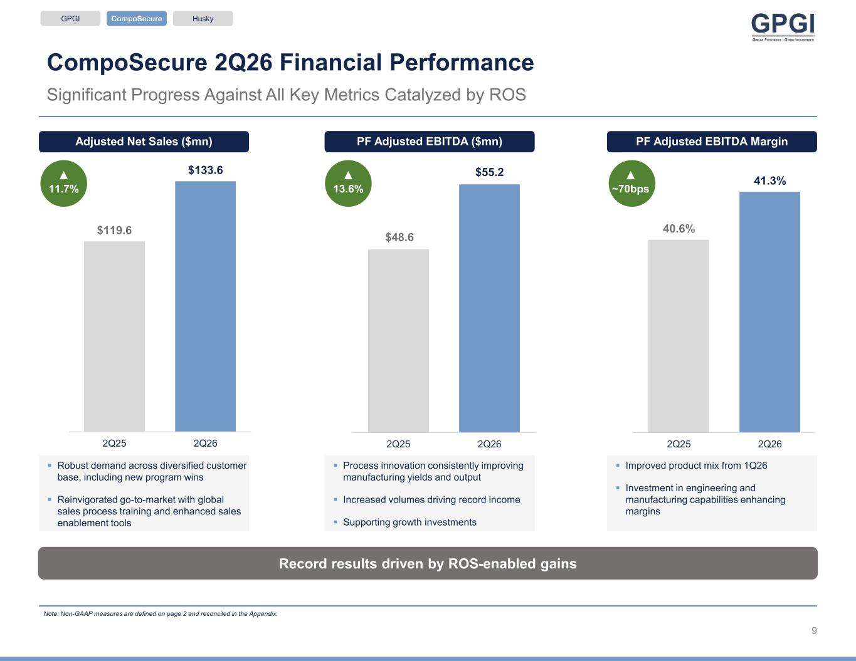
CompoSecure 2Q26 Financial Performance Significant Progress Against All Key Metrics Catalyzed by ROS Record results driven by ROS-enabled gains ▪ Robust demand across diversified customer base, including new program wins ▪ Reinvigorated go-to-market with global sales process training and enhanced sales enablement tools ▪ Process innovation consistently improving manufacturing yields and output ▪ Increased volumes driving record income ▪ Supporting growth investments ▪ Improved product mix from 1Q26 ▪ Investment in engineering and manufacturing capabilities enhancing margins Note: Non-GAAP measures are defined on page 2 and reconciled in the Appendix. Adjusted Net Sales ($mn) ▲ 11.7% PF Adjusted EBITDA ($mn) ▲ 13.6% PF Adjusted EBITDA Margin ▲ ~70bps $119.6 $133.6 2Q25 2Q26 $48.6 $55.2 2Q25 2Q26 40.6% 41.3% 2Q25 2Q26 GPGI CompoSecure Husky 9

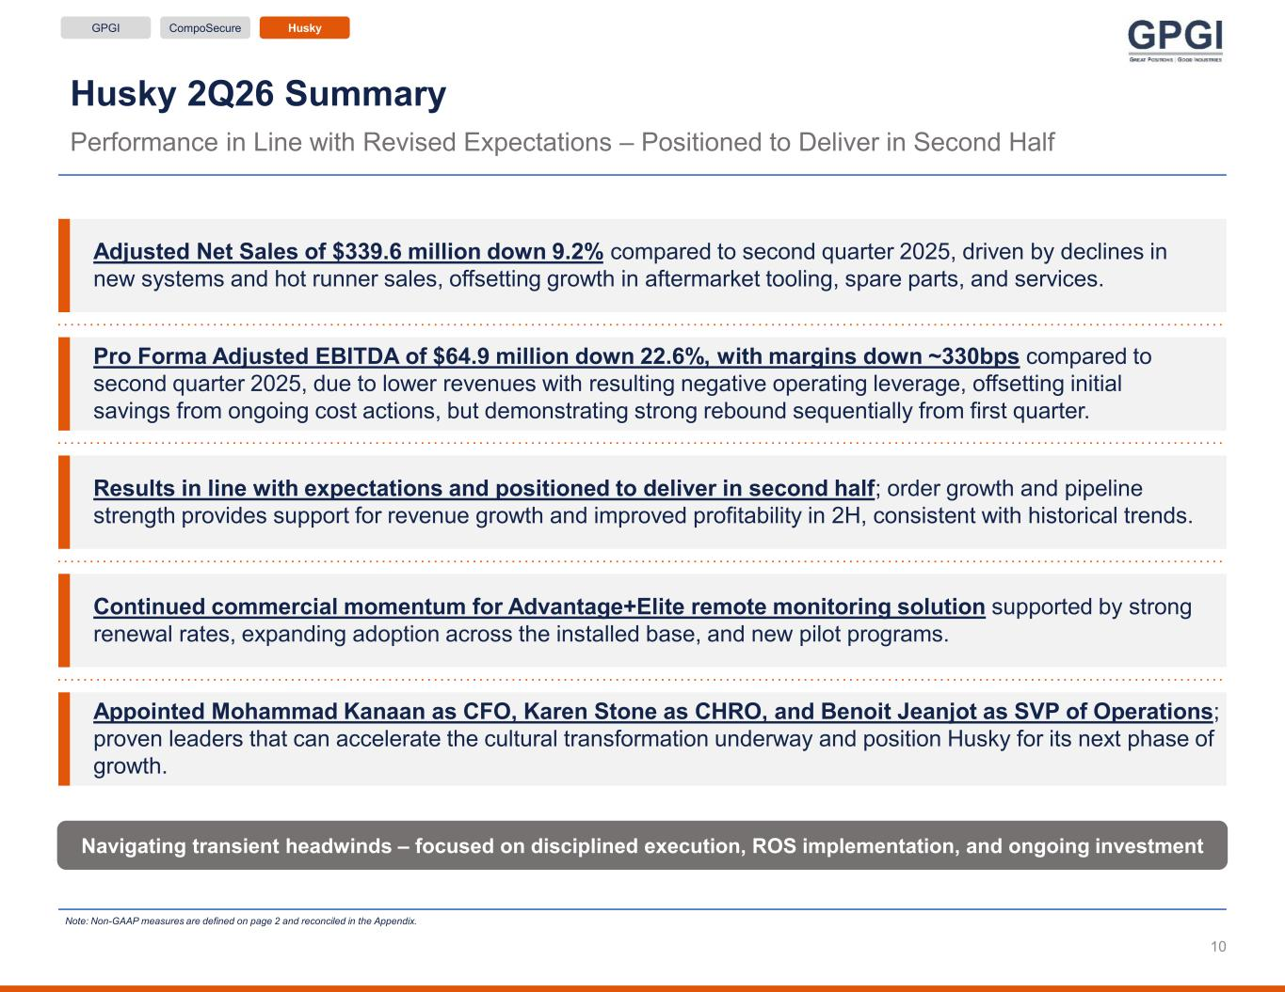
Husky 2Q26 Summary Performance in Line with Revised Expectations – Positioned to Deliver in Second Half Note: Non-GAAP measures are defined on page 2 and reconciled in the Appendix. Navigating transient headwinds – focused on disciplined execution, ROS implementation, and ongoing investment Adjusted Net Sales of $339.6 million down 9.2% compared to second quarter 2025, driven by declines in new systems and hot runner sales, offsetting growth in aftermarket tooling, spare parts, and services. Pro Forma Adjusted EBITDA of $64.9 million down 22.6%, with margins down ~330bps compared to second quarter 2025, due to lower revenues with resulting negative operating leverage, offsetting initial savings from ongoing cost actions, but demonstrating strong rebound sequentially from first quarter. Results in line with expectations and positioned to deliver in second half; order growth and pipeline strength provides support for revenue growth and improved profitability in 2H, consistent with historical trends. Appointed Mohammad Kanaan as CFO, Karen Stone as CHRO, and Benoit Jeanjot as SVP of Operations; proven leaders that can accelerate the cultural transformation underway and position Husky for its next phase of growth. GPGI CompoSecure Husky Continued commercial momentum for Advantage+Elite remote monitoring solution supported by strong renewal rates, expanding adoption across the installed base, and new pilot programs. 10

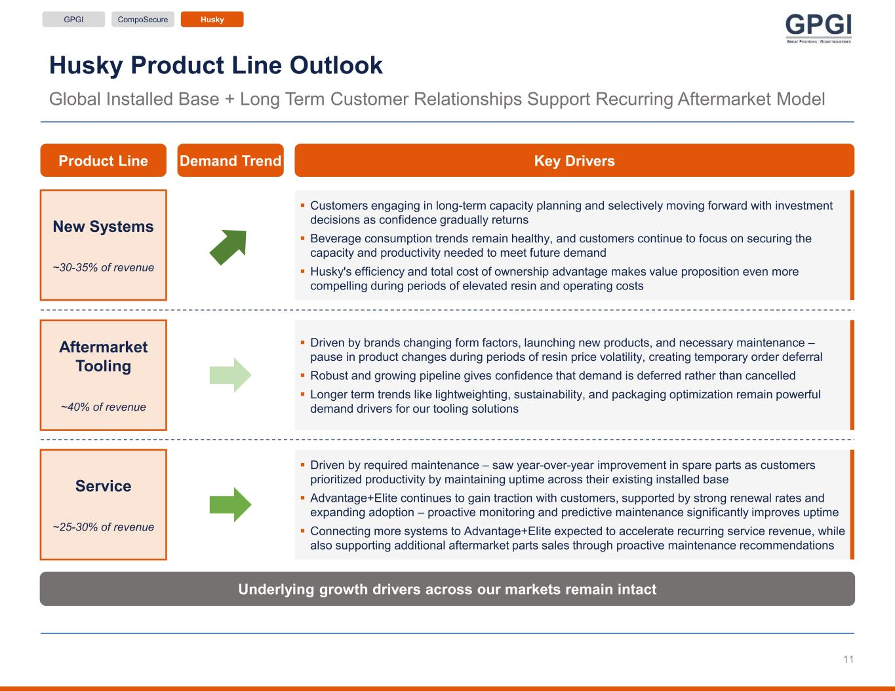
Husky Product Line Outlook Global Installed Base + Long Term Customer Relationships Support Recurring Aftermarket Model Underlying growth drivers across our markets remain intact GPGI CompoSecure Husky Demand Trend Key Drivers New Systems ~30-35% of revenue ▪ Customers engaging in long-term capacity planning and selectively moving forward with investment decisions as confidence gradually returns ▪ Beverage consumption trends remain healthy, and customers continue to focus on securing the capacity and productivity needed to meet future demand ▪ Husky's efficiency and total cost of ownership advantage makes value proposition even more compelling during periods of elevated resin and operating costs Aftermarket Tooling ~40% of revenue Service ~25-30% of revenue ▪ Driven by required maintenance – saw year-over-year improvement in spare parts as customers prioritized productivity by maintaining uptime across their existing installed base ▪ Advantage+Elite continues to gain traction with customers, supported by strong renewal rates and expanding adoption – proactive monitoring and predictive maintenance significantly improves uptime ▪ Connecting more systems to Advantage+Elite expected to accelerate recurring service revenue, while also supporting additional aftermarket parts sales through proactive maintenance recommendations ▪ Driven by brands changing form factors, launching new products, and necessary maintenance – pause in product changes during periods of resin price volatility, creating temporary order deferral ▪ Robust and growing pipeline gives confidence that demand is deferred rather than cancelled ▪ Longer term trends like lightweighting, sustainability, and packaging optimization remain powerful demand drivers for our tooling solutions Product Line 11

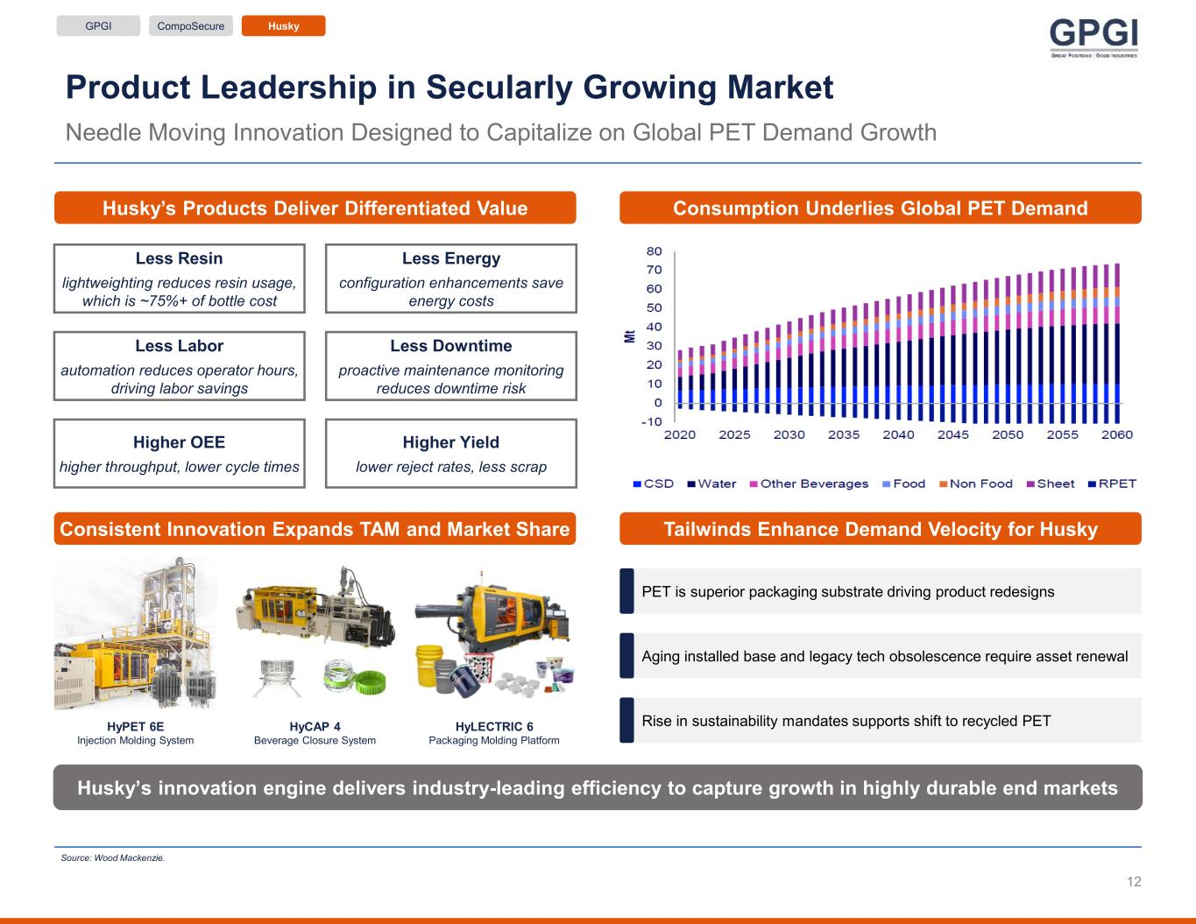
Product Leadership in Secularly Growing Market Needle Moving Innovation Designed to Capitalize on Global PET Demand Growth GPGI CompoSecure Husky Consumption Underlies Global PET DemandHusky’s Products Deliver Differentiated Value Husky’s innovation engine delivers industry-leading efficiency to capture growth in highly durable end markets Less Resin lightweighting reduces resin usage, which is ~75%+ of bottle cost Less Energy configuration enhancements save energy costs Less Labor automation reduces operator hours, driving labor savings Less Downtime proactive maintenance monitoring reduces downtime risk Higher OEE higher throughput, lower cycle times Higher Yield lower reject rates, less scrap Source: Wood Mackenzie. Tailwinds Enhance Demand Velocity for Husky PET is superior packaging substrate driving product redesigns Aging installed base and legacy tech obsolescence require asset renewal Rise in sustainability mandates supports shift to recycled PET Consistent Innovation Expands TAM and Market Share HyPET 6E Injection Molding System HyCAP 4 Beverage Closure System HyLECTRIC 6 Packaging Molding Platform 12

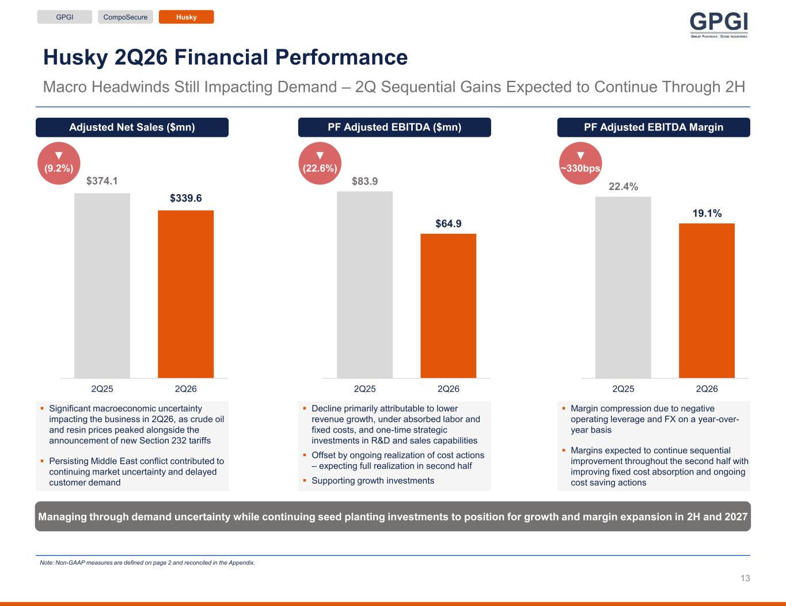
▼ (9.2%) Husky 2Q26 Financial Performance Macro Headwinds Still Impacting Demand – 2Q Sequential Gains Expected to Continue Through 2H Adjusted Net Sales ($mn) ▪ Significant macroeconomic uncertainty impacting the business in 2Q26, as crude oil and resin prices peaked alongside the announcement of new Section 232 tariffs ▪ Persisting Middle East conflict contributed to continuing market uncertainty and delayed customer demand PF Adjusted EBITDA ($mn) ▪ Decline primarily attributable to lower revenue growth, under absorbed labor and fixed costs, and one-time strategic investments in R&D and sales capabilities ▪ Offset by ongoing realization of cost actions – expecting full realization in second half ▪ Supporting growth investments ▼ (22.6%) PF Adjusted EBITDA Margin ▪ Margin compression due to negative operating leverage and FX on a year-over- year basis ▪ Margins expected to continue sequential improvement throughout the second half with improving fixed cost absorption and ongoing cost saving actions ▼ ~330bps Note: Non-GAAP measures are defined on page 2 and reconciled in the Appendix. Managing through demand uncertainty while continuing seed planting investments to position for growth and margin expansion in 2H and 2027 $374.1 $339.6 2Q25 2Q26 $83.9 $64.9 2Q25 2Q26 22.4% 19.1% 2Q25 2Q26 GPGI CompoSecure Husky 13

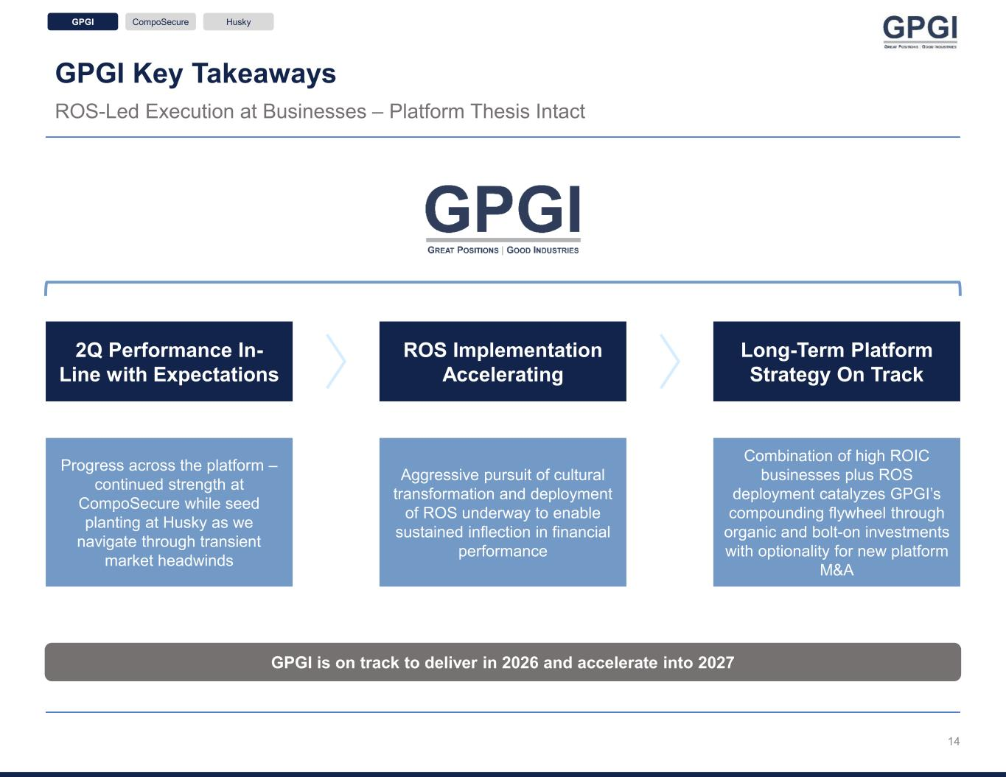
GPGI Key Takeaways ROS-Led Execution at Businesses – Platform Thesis Intact GPGI is on track to deliver in 2026 and accelerate into 2027 GPGI CompoSecure Husky 2Q Performance In- Line with Expectations ROS Implementation Accelerating Long-Term Platform Strategy On Track Progress across the platform – continued strength at CompoSecure while seed planting at Husky as we navigate through transient market headwinds Aggressive pursuit of cultural transformation and deployment of ROS underway to enable sustained inflection in financial performance Combination of high ROIC businesses plus ROS deployment catalyzes GPGI’s compounding flywheel through organic and bolt-on investments with optionality for new platform M&A 14

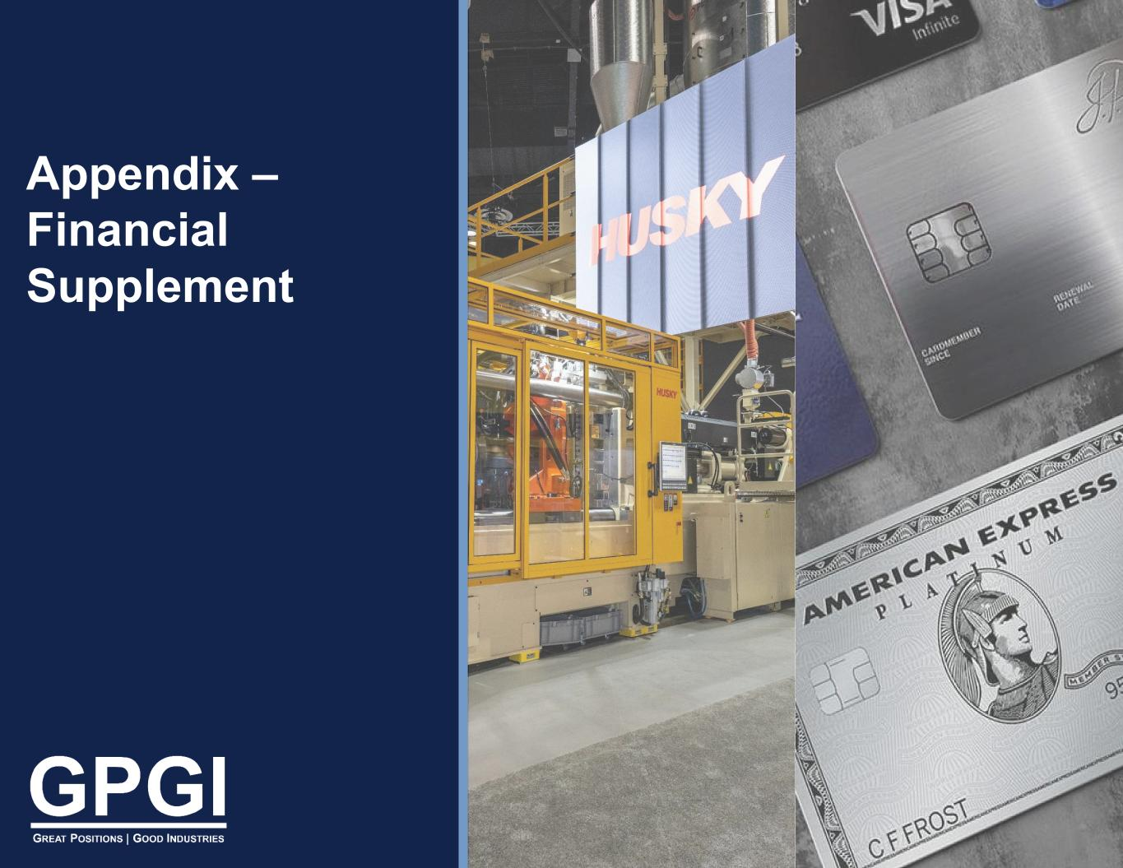
Appendix – Financial Supplement

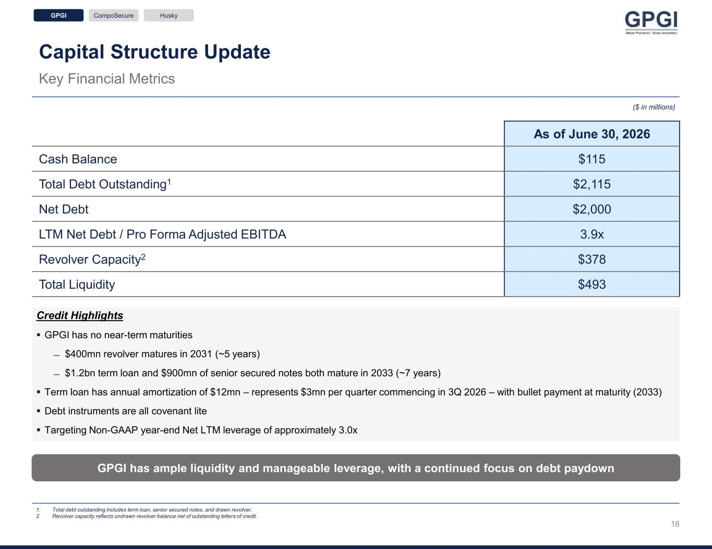
Capital Structure Update Key Financial Metrics ($ in millions) As of June 30, 2026 Cash Balance $115 Total Debt Outstanding1 $2,115 Net Debt $2,000 LTM Net Debt / Pro Forma Adjusted EBITDA 3.9x Revolver Capacity2 $378 Total Liquidity $493 1. Total debt outstanding includes term loan, senior secured notes, and drawn revolver. 2. Revolver capacity reflects undrawn revolver balance net of outstanding letters of credit. GPGI has ample liquidity and manageable leverage, with a continued focus on debt paydown Credit Highlights ▪ GPGI has no near-term maturities ̶ $400mn revolver matures in 2031 (~5 years) ̶ $1.2bn term loan and $900mn of senior secured notes both mature in 2033 (~7 years) ▪ Term loan has annual amortization of $12mn – represents $3mn per quarter commencing in 3Q 2026 – with bullet payment at maturity (2033) ▪ Debt instruments are all covenant lite ▪ Targeting Non-GAAP year-end Net LTM leverage of approximately 3.0x GPGI CompoSecure Husky 16

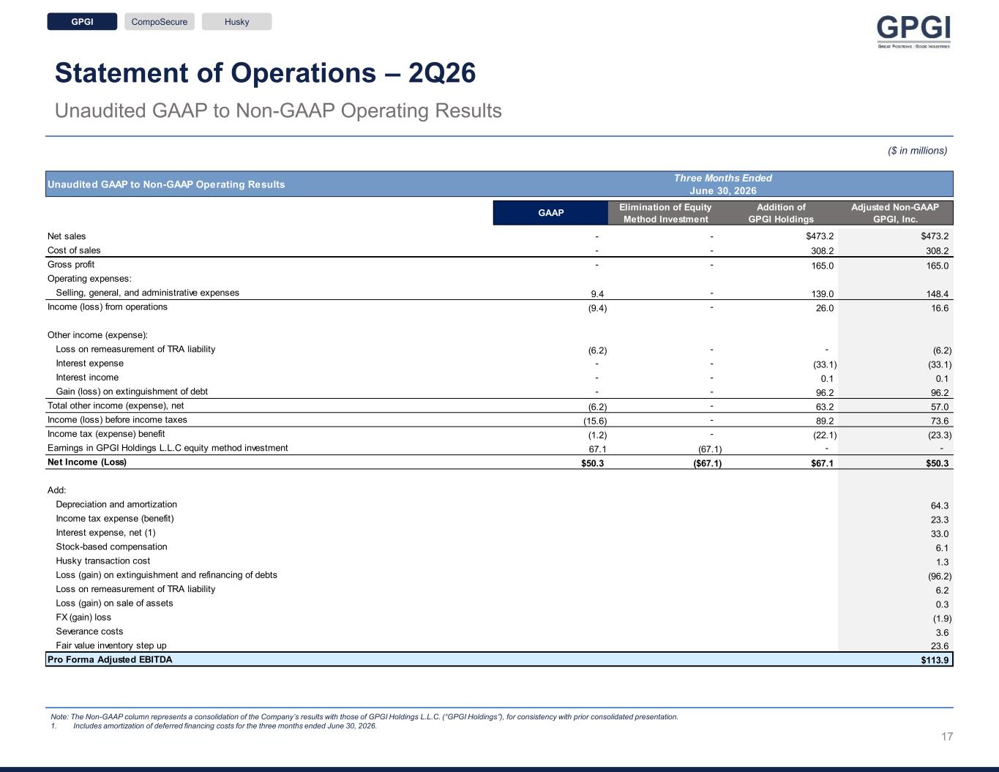
Statement of Operations – 2Q26 Unaudited GAAP to Non-GAAP Operating Results ($ in millions) Note: The Non-GAAP column represents a consolidation of the Company’s results with those of GPGI Holdings L.L.C. (“GPGI Holdings”), for consistency with prior consolidated presentation. 1. Includes amortization of deferred financing costs for the three months ended June 30, 2026. + = GPGI CompoSecure Husky 17 Unaudited GAAP to Non-GAAP Operating Results GAAP Elimination of Equity Method Investment Addition of GPGI Holdings Adjusted Non-GAAP GPGI, Inc. Net sales - - $473.2 $473.2 Cost of sales - - 308.2 308.2 Gross profit - - 165.0 165.0 Operating expenses: Selling, general, and administrative expenses 9.4 - 139.0 148.4 Income (loss) from operations (9.4) - 26.0 16.6 Other income (expense): Loss on remeasurement of TRA liability (6.2) - - (6.2) Interest expense - - (33.1) (33.1) Interest income - - 0.1 0.1 Gain (loss) on extinguishment of debt - - 96.2 96.2 Total other income (expense), net (6.2) - 63.2 57.0 Income (loss) before income taxes (15.6) - 89.2 73.6 Income tax (expense) benefit (1.2) - (22.1) (23.3) Earnings in GPGI Holdings L.L.C equity method investment 67.1 (67.1) - - Net Income (Loss) $50.3 ($67.1) $67.1 $50.3 Add: Depreciation and amortization 64.3 Income tax expense (benefit) 23.3 Interest expense, net (1) 33.0 Stock-based compensation 6.1 Husky transaction cost 1.3 Loss (gain) on extinguishment and refinancing of debts (96.2) Loss on remeasurement of TRA liability 6.2 Loss (gain) on sale of assets 0.3 FX (gain) loss (1.9) Severance costs 3.6 Fair value inventory step up 23.6 Pro Forma Adjusted EBITDA $113.9 Three Months Ended June 30, 2026

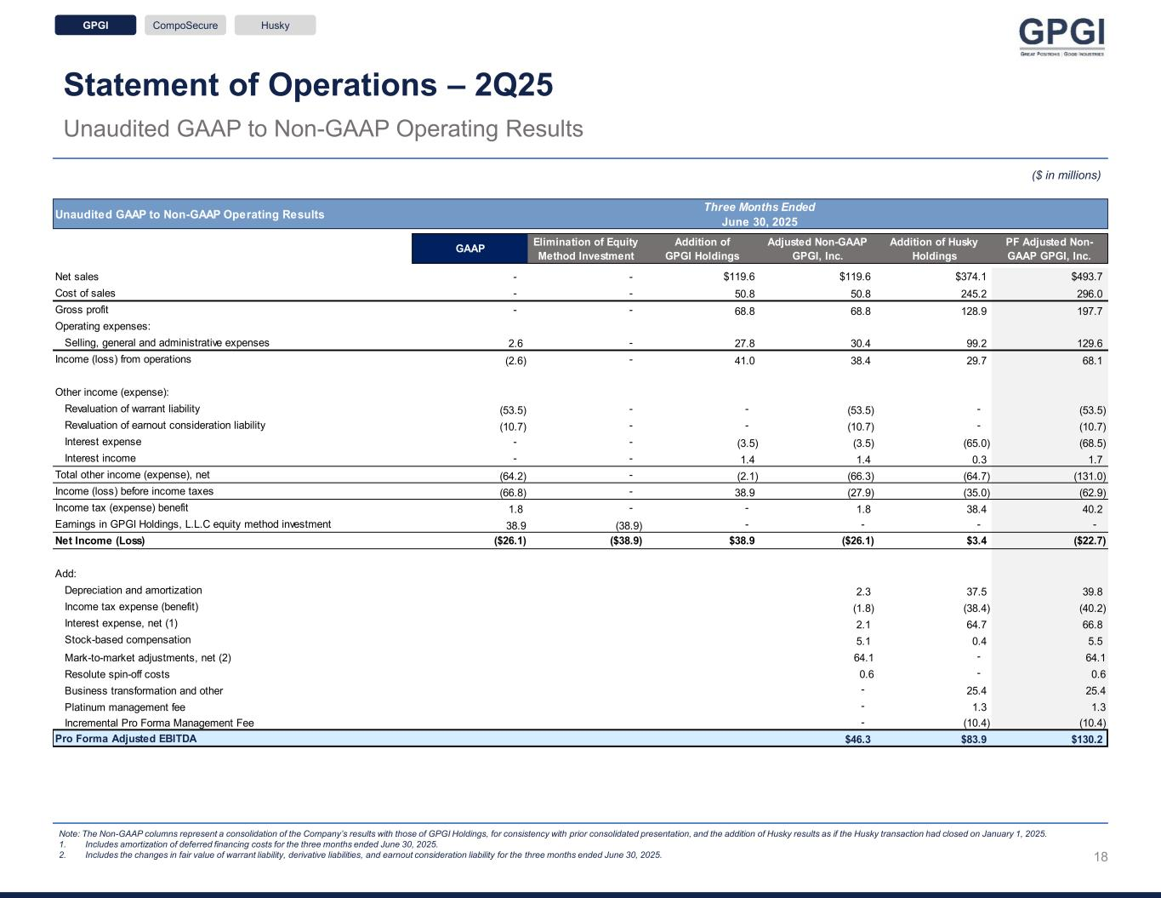
Statement of Operations – 2Q25 Unaudited GAAP to Non-GAAP Operating Results ($ in millions) Note: The Non-GAAP columns represent a consolidation of the Company’s results with those of GPGI Holdings, for consistency with prior consolidated presentation, and the addition of Husky results as if the Husky transaction had closed on January 1, 2025. 1. Includes amortization of deferred financing costs for the three months ended June 30, 2025. 2. Includes the changes in fair value of warrant liability, derivative liabilities, and earnout consideration liability for the three months ended June 30, 2025. + = GPGI CompoSecure Husky 18 Unaudited GAAP to Non-GAAP Operating Results GAAP Elimination of Equity Method Investment Addition of GPGI Holdings Adjusted Non-GAAP GPGI, Inc. Addition of Husky Holdings PF Adjusted Non- GAAP GPGI, Inc. Net sales - - $119.6 $119.6 $374.1 $493.7 Cost of sales - - 50.8 50.8 245.2 296.0 Gross profit - - 68.8 68.8 128.9 197.7 Operating expenses: Selling, general and administrative expenses 2.6 - 27.8 30.4 99.2 129.6 Income (loss) from operations (2.6) - 41.0 38.4 29.7 68.1 Other income (expense): Revaluation of warrant liability (53.5) - - (53.5) - (53.5) Revaluation of earnout consideration liability (10.7) - - (10.7) - (10.7) Interest expense - - (3.5) (3.5) (65.0) (68.5) Interest income - - 1.4 1.4 0.3 1.7 Total other income (expense), net (64.2) - (2.1) (66.3) (64.7) (131.0) Income (loss) before income taxes (66.8) - 38.9 (27.9) (35.0) (62.9) Income tax (expense) benefit 1.8 - - 1.8 38.4 40.2 Earnings in GPGI Holdings, L.L.C equity method investment 38.9 (38.9) - - - - Net Income (Loss) ($26.1) ($38.9) $38.9 ($26.1) $3.4 ($22.7) Add: Depreciation and amortization 2.3 37.5 39.8 Income tax expense (benefit) (1.8) (38.4) (40.2) Interest expense, net (1) 2.1 64.7 66.8 Stock-based compensation 5.1 0.4 5.5 Mark-to-market adjustments, net (2) 64.1 - 64.1 Resolute spin-off costs 0.6 - 0.6 Business transformation and other - 25.4 25.4 Platinum management fee - 1.3 1.3 Incremental Pro Forma Management Fee - (10.4) (10.4) Pro Forma Adjusted EBITDA $46.3 $83.9 $130.2 Three Months Ended June 30, 2025

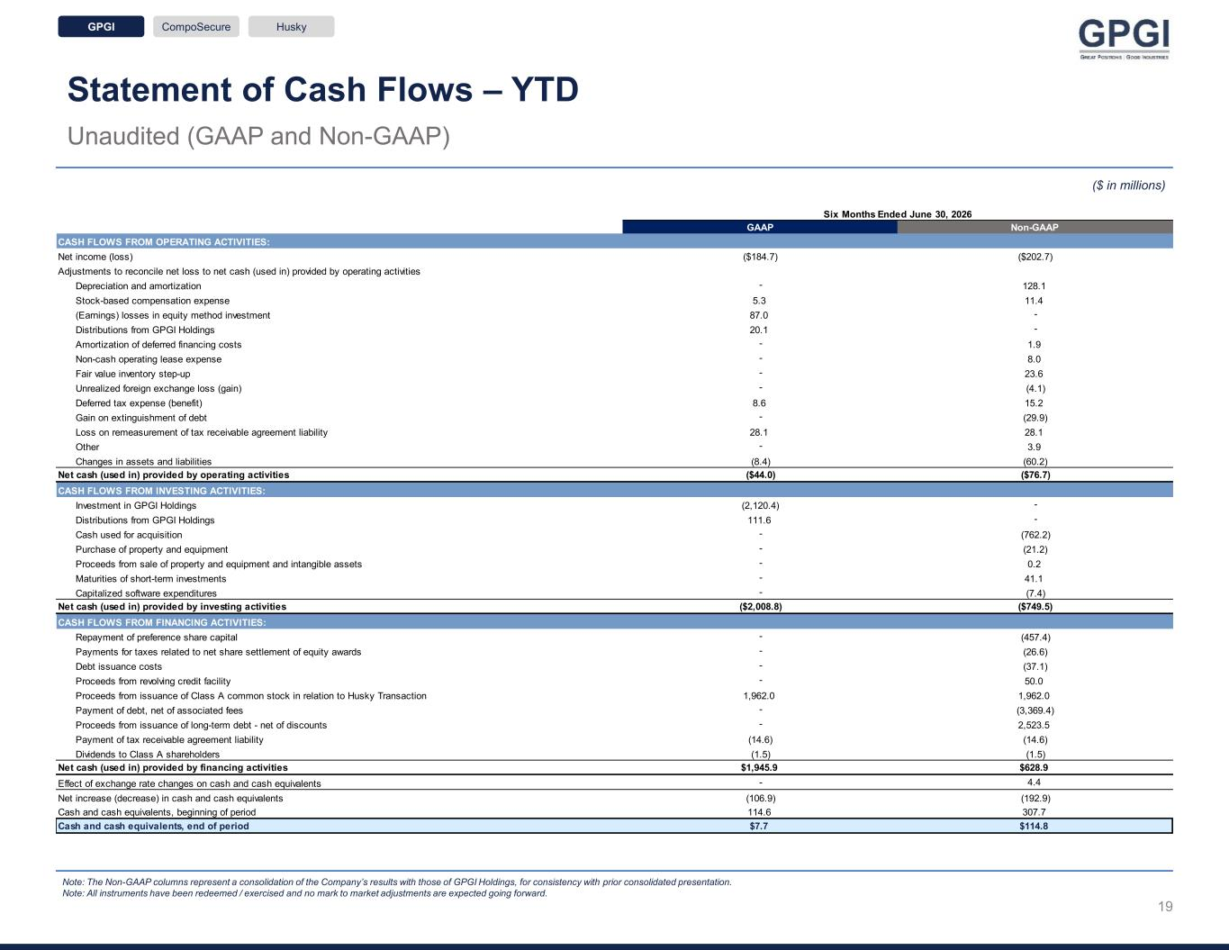
Statement of Cash Flows – YTD Unaudited (GAAP and Non-GAAP) Note: The Non-GAAP columns represent a consolidation of the Company’s results with those of GPGI Holdings, for consistency with prior consolidated presentation. Note: All instruments have been redeemed / exercised and no mark to market adjustments are expected going forward. ($ in millions) GPGI CompoSecure Husky 19 GAAP Non-GAAP CASH FLOWS FROM OPERATING ACTIVITIES: Net income (loss) ($184.7) ($202.7) Adjustments to reconcile net loss to net cash (used in) provided by operating activities Depreciation and amortization - 128.1 Stock-based compensation expense 5.3 11.4 (Earnings) losses in equity method investment 87.0 - Distributions from GPGI Holdings 20.1 - Amortization of deferred financing costs - 1.9 Non-cash operating lease expense - 8.0 Fair value inventory step-up - 23.6 Unrealized foreign exchange loss (gain) - (4.1) Deferred tax expense (benefit) 8.6 15.2 Gain on extinguishment of debt - (29.9) Loss on remeasurement of tax receivable agreement liability 28.1 28.1 Other - 3.9 Changes in assets and liabilities (8.4) (60.2) Net cash (used in) provided by operating activities ($44.0) ($76.7) CASH FLOWS FROM INVESTING ACTIVITIES: Investment in GPGI Holdings (2,120.4) - Distributions from GPGI Holdings 111.6 - Cash used for acquisition - (762.2) Purchase of property and equipment - (21.2) Proceeds from sale of property and equipment and intangible assets - 0.2 Maturities of short-term investments - 41.1 Capitalized software expenditures - (7.4) Net cash (used in) provided by investing activities ($2,008.8) ($749.5) CASH FLOWS FROM FINANCING ACTIVITIES: Repayment of preference share capital - (457.4) Payments for taxes related to net share settlement of equity awards - (26.6) Debt issuance costs - (37.1) Proceeds from revolving credit facility - 50.0 Proceeds from issuance of Class A common stock in relation to Husky Transaction 1,962.0 1,962.0 Payment of debt, net of associated fees - (3,369.4) Proceeds from issuance of long-term debt - net of discounts - 2,523.5 Payment of tax receivable agreement liability (14.6) (14.6) Dividends to Class A shareholders (1.5) (1.5) Net cash (used in) provided by financing activities $1,945.9 $628.9 Effect of exchange rate changes on cash and cash equivalents - 4.4 Net increase (decrease) in cash and cash equivalents (106.9) (192.9) Cash and cash equivalents, beginning of period 114.6 307.7 Cash and cash equivalents, end of period $7.7 $114.8 Six Months Ended June 30, 2026

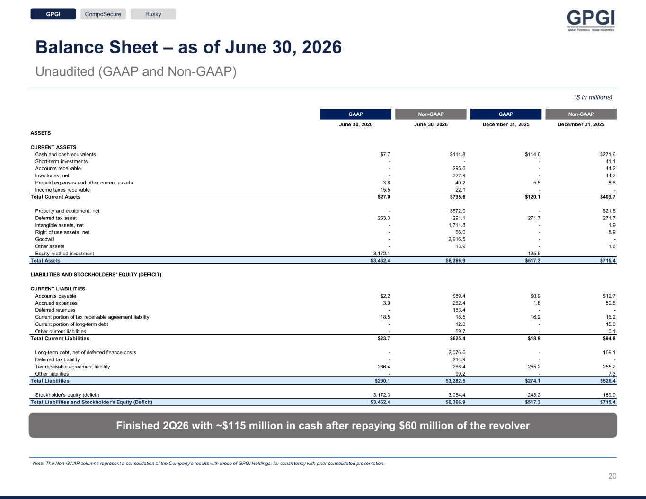
Balance Sheet – as of June 30, 2026 Unaudited (GAAP and Non-GAAP) Finished 2Q26 with ~$115 million in cash after repaying $60 million of the revolver Note: The Non-GAAP columns represent a consolidation of the Company’s results with those of GPGI Holdings, for consistency with prior consolidated presentation. ($ in millions) GPGI CompoSecure Husky 20 GAAP Non-GAAP GAAP Non-GAAP June 30, 2026 June 30, 2026 December 31, 2025 December 31, 2025 ASSETS CURRENT ASSETS Cash and cash equivalents $7.7 $114.8 $114.6 $271.6 Short-term investments - - - 41.1 Accounts receivable - 295.6 - 44.2 Inventories, net - 322.9 - 44.2 Prepaid expenses and other current assets 3.8 40.2 5.5 8.6 Income taxes receivable 15.5 22.1 - - Total Current Assets $27.0 $795.6 $120.1 $409.7 Property and equipment, net - $572.0 - $21.6 Deferred tax asset 263.3 291.1 271.7 271.7 Intangible assets, net - 1,711.8 - 1.9 Right of use assets, net - 66.0 - 8.9 Goodwill - 2,916.5 - - Other assets - 13.9 - 1.6 Equity method investment 3,172.1 - 125.5 - Total Assets $3,462.4 $6,366.9 $517.3 $715.4 LIABILITIES AND STOCKHOLDERS' EQUITY (DEFICIT) CURRENT LIABILITIES Accounts payable $2.2 $89.4 $0.9 $12.7 Accrued expenses 3.0 262.4 1.8 50.8 Deferred revenues - 183.4 - - Current portion of tax receivable agreement liability 18.5 18.5 16.2 16.2 Current portion of long-term debt - 12.0 - 15.0 Other current liabilities - 59.7 - 0.1 Total Current Liabilities $23.7 $625.4 $18.9 $94.8 Long-term debt, net of deferred finance costs - 2,076.6 - 169.1 Deferred tax liability - 214.9 - - Tax receivable agreement liability 266.4 266.4 255.2 255.2 Other liabilities - 99.2 - 7.3 Total Liabilities $290.1 $3,282.5 $274.1 $526.4 Stockholder's equity (deficit) 3,172.3 3,084.4 243.2 189.0 Total Liabilities and Stockholder's Equity (Deficit) $3,462.4 $6,366.9 $517.3 $715.4

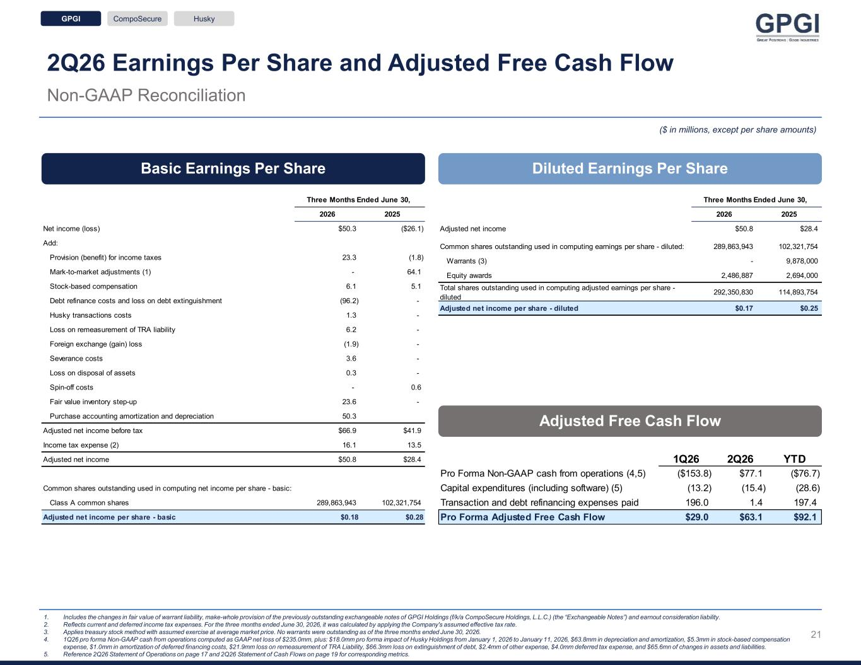
2Q26 Earnings Per Share and Adjusted Free Cash Flow Non-GAAP Reconciliation Basic Earnings Per Share Diluted Earnings Per Share ($ in millions, except per share amounts) 1. Includes the changes in fair value of warrant liability, make-whole provision of the previously outstanding exchangeable notes of GPGI Holdings (f/k/a CompoSecure Holdings, L.L.C.) (the “Exchangeable Notes”) and earnout consideration liability. 2. Reflects current and deferred income tax expenses. For the three months ended June 30, 2026, it was calculated by applying the Company's assumed effective tax rate. 3. Applies treasury stock method with assumed exercise at average market price. No warrants were outstanding as of the three months ended June 30, 2026. 4. 1Q26 pro forma Non-GAAP cash from operations computed as GAAP net loss of $235.0mm, plus: $18.0mm pro forma impact of Husky Holdings from January 1, 2026 to January 11, 2026, $63.8mm in depreciation and amortization, $5.3mm in stock-based compensation expense, $1.0mm in amortization of deferred financing costs, $21.9mm loss on remeasurement of TRA Liability, $66.3mm loss on extinguishment of debt, $2.4mm of other expense, $4.0mm deferred tax expense, and $65.6mn of changes in assets and liabilities. 5. Reference 2Q26 Statement of Operations on page 17 and 2Q26 Statement of Cash Flows on page 19 for corresponding metrics. Adjusted Free Cash Flow GPGI CompoSecure Husky 2026 2025 Net income (loss) $50.3 ($26.1) Add: Provision (benefit) for income taxes 23.3 (1.8) Mark-to-market adjustments (1) - 64.1 Stock-based compensation 6.1 5.1 Debt refinance costs and loss on debt extinguishment (96.2) - Husky transactions costs 1.3 - Loss on remeasurement of TRA liability 6.2 - Foreign exchange (gain) loss (1.9) - Severance costs 3.6 - Loss on disposal of assets 0.3 - Spin-off costs - 0.6 Fair value inventory step-up 23.6 - Purchase accounting amortization and depreciation 50.3 Adjusted net income before tax $66.9 $41.9 Income tax expense (2) 16.1 13.5 Adjusted net income $50.8 $28.4 Common shares outstanding used in computing net income per share - basic: Class A common shares 289,863,943 102,321,754 Adjusted net income per share - basic $0.18 $0.28 Three Months Ended June 30, 21 2026 2025 Adjusted net income $50.8 $28.4 Common shares outstanding used in computing earnings per share - diluted: 289,863,943 102,321,754 Warrants (3) - 9,878,000 Equity awards 2,486,887 2,694,000 Total shares outstanding used in computing adjusted earnings per share - diluted 292,350,830 114,893,754 Adjusted net income per share - diluted $0.17 $0.25 Three Months Ended June 30, 1Q26 2Q26 YTD Pro Forma Non-GAAP cash from operations (4,5) ($153.8) $77.1 ($76.7) Capital expenditures (including software) (5) (13.2) (15.4) (28.6) Transaction and debt refinancing expenses paid 196.0 1.4 197.4 Pro Forma Adjusted Free Cash Flow $29.0 $63.1 $92.1

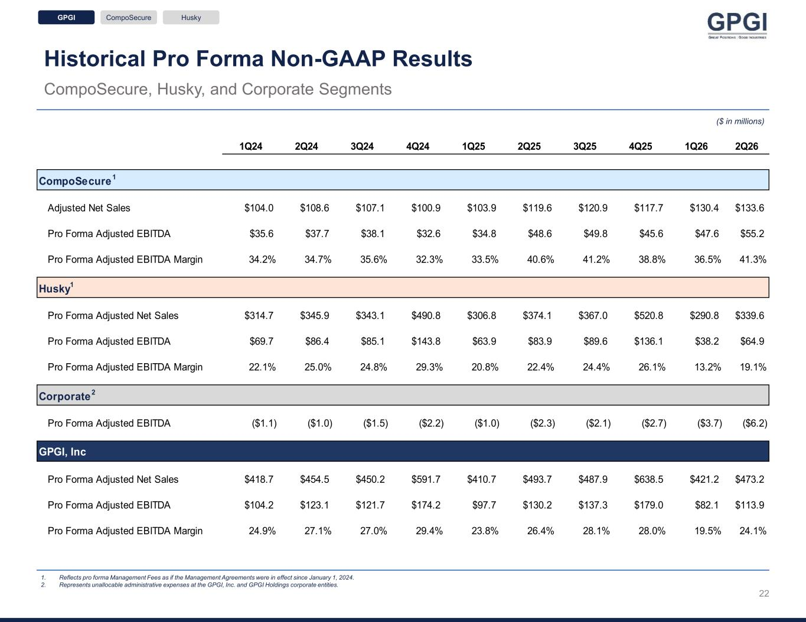
Historical Pro Forma Non-GAAP Results 1. Reflects pro forma Management Fees as if the Management Agreements were in effect since January 1, 2024. 2. Represents unallocable administrative expenses at the GPGI, Inc. and GPGI Holdings corporate entities. CompoSecure, Husky, and Corporate Segments ($ in millions) GPGI CompoSecure Husky 22 1Q24 2Q24 3Q24 4Q24 1Q25 2Q25 3Q25 4Q25 1Q26 2Q26 CompoSecure 1 Adjusted Net Sales $104.0 $108.6 $107.1 $100.9 $103.9 $119.6 $120.9 $117.7 $130.4 $133.6 Pro Forma Adjusted EBITDA $35.6 $37.7 $38.1 $32.6 $34.8 $48.6 $49.8 $45.6 $47.6 $55.2 Pro Forma Adjusted EBITDA Margin 34.2% 34.7% 35.6% 32.3% 33.5% 40.6% 41.2% 38.8% 36.5% 41.3% Husky 1 Pro Forma Adjusted Net Sales $314.7 $345.9 $343.1 $490.8 $306.8 $374.1 $367.0 $520.8 $290.8 $339.6 Pro Forma Adjusted EBITDA $69.7 $86.4 $85.1 $143.8 $63.9 $83.9 $89.6 $136.1 $38.2 $64.9 Pro Forma Adjusted EBITDA Margin 22.1% 25.0% 24.8% 29.3% 20.8% 22.4% 24.4% 26.1% 13.2% 19.1% Corporate 2 Pro Forma Adjusted EBITDA ($1.1) ($1.0) ($1.5) ($2.2) ($1.0) ($2.3) ($2.1) ($2.7) ($3.7) ($6.2) GPGI, Inc Pro Forma Adjusted Net Sales $418.7 $454.5 $450.2 $591.7 $410.7 $493.7 $487.9 $638.5 $421.2 $473.2 Pro Forma Adjusted EBITDA $104.2 $123.1 $121.7 $174.2 $97.7 $130.2 $137.3 $179.0 $82.1 $113.9 Pro Forma Adjusted EBITDA Margin 24.9% 27.1% 27.0% 29.4% 23.8% 26.4% 28.1% 28.0% 19.5% 24.1%

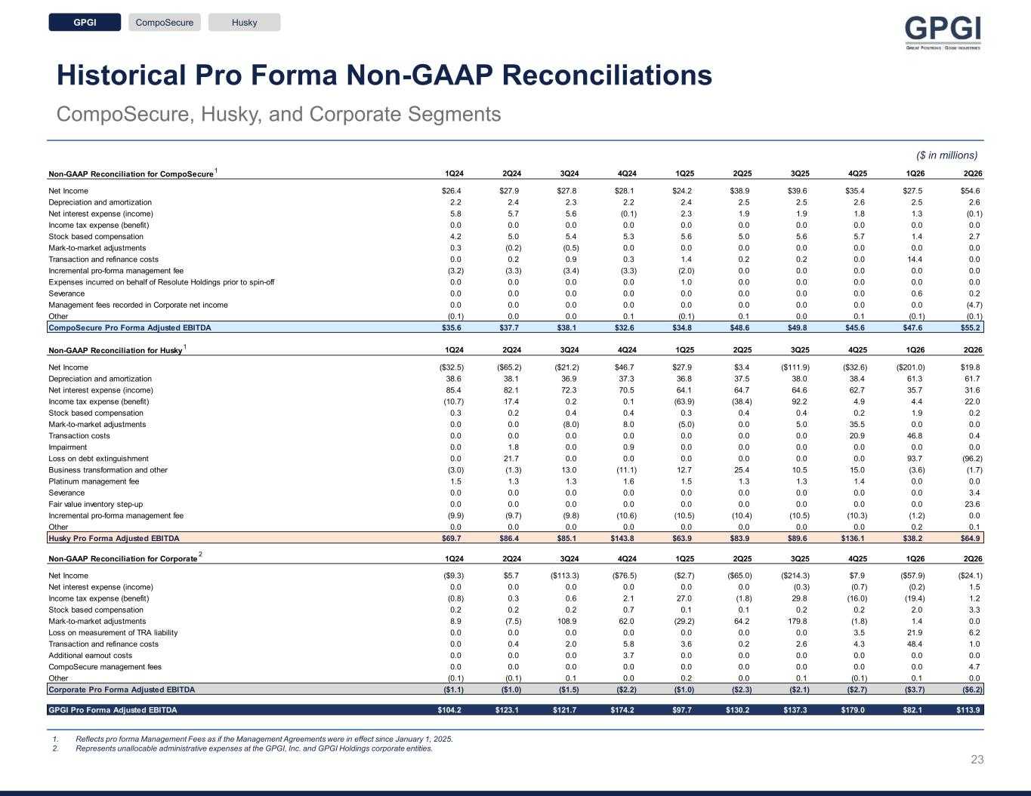
Historical Pro Forma Non-GAAP Reconciliations CompoSecure, Husky, and Corporate Segments ($ in millions) 1 1 2 1. Reflects pro forma Management Fees as if the Management Agreements were in effect since January 1, 2025. 2. Represents unallocable administrative expenses at the GPGI, Inc. and GPGI Holdings corporate entities. GPGI CompoSecure Husky Non-GAAP Reconciliation for CompoSecure 1Q24 2Q24 3Q24 4Q24 1Q25 2Q25 3Q25 4Q25 1Q26 2Q26 Net Income $26.4 $27.9 $27.8 $28.1 $24.2 $38.9 $39.6 $35.4 $27.5 $54.6 Depreciation and amortization 2.2 2.4 2.3 2.2 2.4 2.5 2.5 2.6 2.5 2.6 Net interest expense (income) 5.8 5.7 5.6 (0.1) 2.3 1.9 1.9 1.8 1.3 (0.1) Income tax expense (benefit) 0.0 0.0 0.0 0.0 0.0 0.0 0.0 0.0 0.0 0.0 Stock based compensation 4.2 5.0 5.4 5.3 5.6 5.0 5.6 5.7 1.4 2.7 Mark-to-market adjustments 0.3 (0.2) (0.5) 0.0 0.0 0.0 0.0 0.0 0.0 0.0 Transaction and refinance costs 0.0 0.2 0.9 0.3 1.4 0.2 0.2 0.0 14.4 0.0 Incremental pro-forma management fee (3.2) (3.3) (3.4) (3.3) (2.0) 0.0 0.0 0.0 0.0 0.0 Expenses incurred on behalf of Resolute Holdings prior to spin-off 0.0 0.0 0.0 0.0 1.0 0.0 0.0 0.0 0.0 0.0 Severance 0.0 0.0 0.0 0.0 0.0 0.0 0.0 0.0 0.6 0.2 Management fees recorded in Corporate net income 0.0 0.0 0.0 0.0 0.0 0.0 0.0 0.0 0.0 (4.7) Other (0.1) 0.0 0.0 0.1 (0.1) 0.1 0.0 0.1 (0.1) (0.1) CompoSecure Pro Forma Adjusted EBITDA $35.6 $37.7 $38.1 $32.6 $34.8 $48.6 $49.8 $45.6 $47.6 $55.2 Non-GAAP Reconciliation for Husky 1Q24 2Q24 3Q24 4Q24 1Q25 2Q25 3Q25 4Q25 1Q26 2Q26 Net Income ($32.5) ($65.2) ($21.2) $46.7 $27.9 $3.4 ($111.9) ($32.6) ($201.0) $19.8 Depreciation and amortization 38.6 38.1 36.9 37.3 36.8 37.5 38.0 38.4 61.3 61.7 Net interest expense (income) 85.4 82.1 72.3 70.5 64.1 64.7 64.6 62.7 35.7 31.6 Income tax expense (benefit) (10.7) 17.4 0.2 0.1 (63.9) (38.4) 92.2 4.9 4.4 22.0 Stock based compensation 0.3 0.2 0.4 0.4 0.3 0.4 0.4 0.2 1.9 0.2 Mark-to-market adjustments 0.0 0.0 (8.0) 8.0 (5.0) 0.0 5.0 35.5 0.0 0.0 Transaction costs 0.0 0.0 0.0 0.0 0.0 0.0 0.0 20.9 46.8 0.4 Impairment 0.0 1.8 0.0 0.9 0.0 0.0 0.0 0.0 0.0 0.0 Loss on debt extinguishment 0.0 21.7 0.0 0.0 0.0 0.0 0.0 0.0 93.7 (96.2) Business transformation and other (3.0) (1.3) 13.0 (11.1) 12.7 25.4 10.5 15.0 (3.6) (1.7) Platinum management fee 1.5 1.3 1.3 1.6 1.5 1.3 1.3 1.4 0.0 0.0 Severance 0.0 0.0 0.0 0.0 0.0 0.0 0.0 0.0 0.0 3.4 Fair value inventory step-up 0.0 0.0 0.0 0.0 0.0 0.0 0.0 0.0 0.0 23.6 Incremental pro-forma management fee (9.9) (9.7) (9.8) (10.6) (10.5) (10.4) (10.5) (10.3) (1.2) 0.0 Other 0.0 0.0 0.0 0.0 0.0 0.0 0.0 0.0 0.2 0.1 Husky Pro Forma Adjusted EBITDA $69.7 $86.4 $85.1 $143.8 $63.9 $83.9 $89.6 $136.1 $38.2 $64.9 Non-GAAP Reconciliation for Corporate 1Q24 2Q24 3Q24 4Q24 1Q25 2Q25 3Q25 4Q25 1Q26 2Q26 Net Income ($9.3) $5.7 ($113.3) ($76.5) ($2.7) ($65.0) ($214.3) $7.9 ($57.9) ($24.1) Net interest expense (income) 0.0 0.0 0.0 0.0 0.0 0.0 (0.3) (0.7) (0.2) 1.5 Income tax expense (benefit) (0.8) 0.3 0.6 2.1 27.0 (1.8) 29.8 (16.0) (19.4) 1.2 Stock based compensation 0.2 0.2 0.2 0.7 0.1 0.1 0.2 0.2 2.0 3.3 Mark-to-market adjustments 8.9 (7.5) 108.9 62.0 (29.2) 64.2 179.8 (1.8) 1.4 0.0 Loss on measurement of TRA liability 0.0 0.0 0.0 0.0 0.0 0.0 0.0 3.5 21.9 6.2 Transaction and refinance costs 0.0 0.4 2.0 5.8 3.6 0.2 2.6 4.3 48.4 1.0 Additional earnout costs 0.0 0.0 0.0 3.7 0.0 0.0 0.0 0.0 0.0 0.0 CompoSecure management fees 0.0 0.0 0.0 0.0 0.0 0.0 0.0 0.0 0.0 4.7 Other (0.1) (0.1) 0.1 0.0 0.2 0.0 0.1 (0.1) 0.1 0.0 Corporate Pro Forma Adjusted EBITDA ($1.1) ($1.0) ($1.5) ($2.2) ($1.0) ($2.3) ($2.1) ($2.7) ($3.7) ($6.2) GPGI Pro Forma Adjusted EBITDA $104.2 $123.1 $121.7 $174.2 $97.7 $130.2 $137.3 $179.0 $82.1 $113.9 23


Investor Relations Contact ir@gpgi.com

